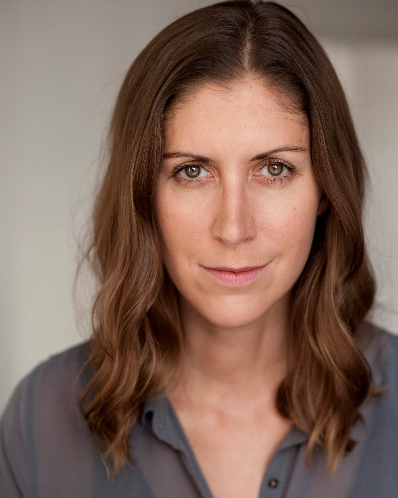**OLIVIA MURPHY**

07886468876

[oliviamurphy81@hotmail.com](mailto:oliviamurphy81@hotmail.com)

**Height:** 6’1

**Hair:** Light Brown

**Eyes:** Brown

**Equity:** M00237618

**Training:**

TRB Engage Theatre School Advanced

TRB Engage Theatre School

Postgraduate Certificate in the Advanced Teaching of Shakespeare, University of Warwick and the Royal Shakespeare Company

Qualified Teacher Status, Chichester University

Postgraduate Acting Diploma, The London Academy of Performing Arts

BA Honours Drama and Theatre Studies, University of Surrey Roehampton

**Theatre:**

Last Man in The 24 Hour Plays Rene Ustinov Studio Tim Bell & Emma Bettridge

All New People Emma Rondo Theatre William Jesmond Clermont

Lungs (Showcase) W Theatre Royal Bath Lee Lyford

Four: His Peers Hannah Ustinov Studio Lee Lyford

Dogs of War Ross Burdall’s Yard Bryn Holding

London 2012 Olympics Performer Olympic Stadium Kim Gavin

Closing Ceremony

**Film:**

BANG! Mary Screenology Tom Brereton Downs

Out of the Dark Anna Keith Wilhelm Kopp Keith Wilhelm Kopp

The Black Spot Jasmine’s Mother Bald n Hairy Films Oliver Rogers

Future Call Phoebe Klingfilms Gary Organ & Lloyd Sandall

Scanner , Return Customer Screenology Charlie Mason

The Day that Broke Zoe Screenology Tom Brereton Downs

Thy Name is Woman Helena Screenology Tom Brereton Downs

**Commercial:**

Philadelphia Couple L&L Pictures Jon Riche

**Other:**

DBS checked, qualified teacher with 9 years of teaching Drama and English to aged 11-18 as well as working with primary schools, full car driving licence, Irish dancing.