Abigail louise sinar
9 Hazel grove, Plymouth | Email: abigailsinarmodel@hotmail.com | Instagram: @littlemiss.daydream
Phone: 07473633360

Height: 5’4ft  Weight: 168lbs  Hair: Dark Blonde  Eyes: Grey  Build: Curvy  Age: 20  Role playing ages: 18-27  Location: Plymouth  Full driving licence: No | Accents: Posh British  Languages: English (native)  Singing: Musical theatre  Instruments: Ukulele, Piano  Sports: Running, Tennis, Swimming, Cycling, Badminton, Dance fitness | 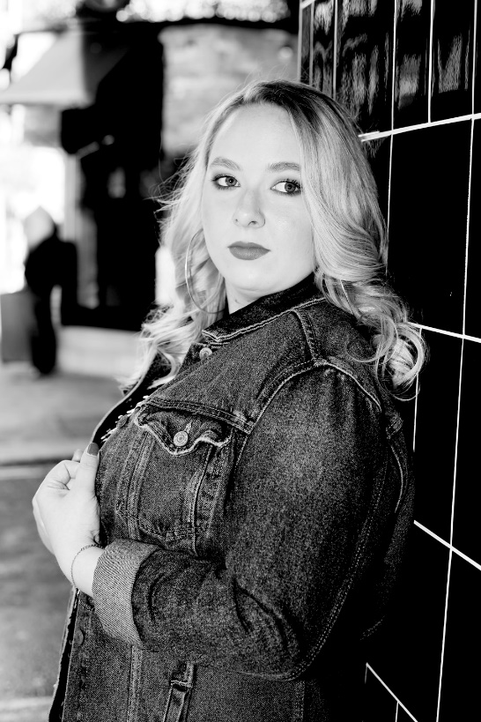
film
Thupparavalin 2 (2019) | Lead extra | Vishal Film factory
Losing your scissors (2020) | Voiceover | Plymouth fringe festival
television
Coming soon

commercials
Pops Ice cream (2020) | Lemon gin | Plymouth collage of ART

theatre
Terminal (2019) | Frankie (Lead) | Lecture theatre 1 - UoP
Mismatched (2020) | Helen | Lecture theatre 1 - UoP
The Happy Happy Show (2020) | Red | Lecture theatre 1 - UoP
A Winter’s tale (2018) | Servant, extras, Assistant director | Corn exchange Newbury
Peter pan (2017) | Liza and Ensemble | St Bartholomew’s school

training | 2017-2019 | Drama and theatre practice (A level) Grade C
 | 2016 | Acting classes once a week - Newbury
 | 2019 - Present | BA (Hons) Acting, University of Plymouth

