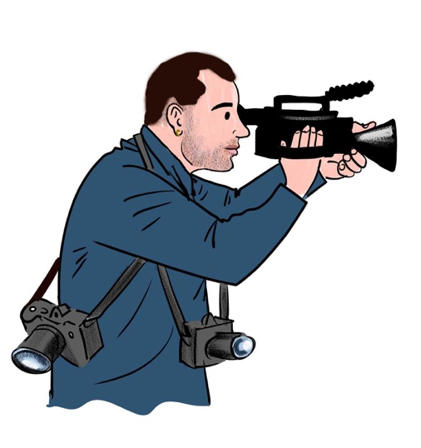

**EXPERIENCE**

* ‘There, They’re, Their’ – Channel 4 Random acts short film. Featured in Cardiff animation film festival and British Urban Film Festival. Role: Writer and Director.
* ‘Fine Iron art’ – 1st year university documentary about a female Bristol based Blacksmith. Role: Camera/Director
* ‘Unlikely Warriors’ – 5 Minute documentary on a female led boxing club in South London and the growing female squad of boxers. Role: Camera/Director
* Paid 2-minute commercial for ‘No Shouting Driving school’
* 2nd Camera operator working for MiloMulvaghVisuals on two separate wedding shoots and one music concert, using the Sony FS7.
* A paid EP release promotional video and show highlights for London based rapper TY Real.
* Paid freelance video editing for Annie Deadman Fitness. Included editing workout videos and teasers, whilst managing her YouTube account and uploads.
* Paid promotional highlights reel for ‘Ping Pong Fight Club’ 2019 – Camera/editor/Director
* 3 promotional videos shot for ‘Putney and Roehampton Boxing club’ which were advertised on socials for their upcoming events.
* 3 Cam setup of a school Nativity. 1st Camera/Editor
* Paid Launch event highlights video for ‘Rounders’ a London based rolling paper company. Role: Camera/Editor/Director

**KEY SKILLS**

* 3 years of driving experience with a clean UK driving license. I worked for Hermes for 4 months delivering parcels so I am a competent driver and can manage workload and have good organisation skills.
* Screen skills COVID awareness certificate. With an understanding of how to work safely in a work environment.
* Experienced with a range of Sony cameras. FS5, FS7, A7S
* I used to be a Junior Boxing coach and boxed myself for 6 years. I have the ability to help others learn and am a reliable punctual person who will always turn up no matter how horrible the weather or the circumstances.
* Attended BFI film academy in 2016

**PROFILE**

I’m a 2nd year UWE Bristol Filmmaking student and also a freelance videography on the side. My main interest lies within the Camera and Art department with an aspiration to become a DOP. I have experience working on film sets with a crew. But also working alone and fulfilling multiple roles on lower budget productions, working solely to produce content for a client. My biggest achievement to date is having written and Directed a Channel 4 Random acts spoken word piece which featured on their website and was in two film festivals. I hope to work on some bigger film productions and finesse my skills as a camera operator whilst learning from those with years of experience.

**Olly Blower**

Freelance Videographer

Tel: 07771998680

Email: [Ollyblower@gmail.com](mailto:Ollyblower@gmail.com)

Based in Bristol, London