xavio mui nthenge
5C Armada Street, PL4 8LS| Email: xaviodesanta@gmail.com | Website: N/A
Agent: N/A| N/A| 07823716630
Height: 5ft 11in  Weight: 95kgs  Hair: Black  Eyes: Brown  Build: Endomorph  Age: 19  Role playing ages: 18 - 22  Location: Plymouth  Full driving licence: N/A  Spotlight number: N/A  Equity no: N/A | Accents: General British, Kenyan  Languages: Swahili (native), English (fluent)  Singing: Tenor , musical theatre  Instruments: Guitar Grade 5  Sports: Football, Archery, Kayaking  Dance: Afro Beat | 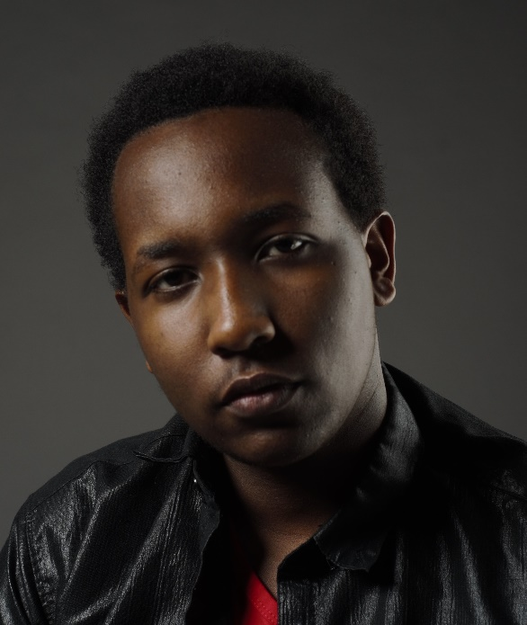
film
Trapped in Sideways 8’s | Ryan(Lead) | University of Plymouth
television
commercials
hosting
theatre

training | 2019- current | BA (Hons) Acting in University of Plymouth (Plymouth Conservatoire)

