Website: <https://www.seansumwalt.com>

IMDb: <https://www.imdb.com/name/nm4316020/?ref_=nv_sr_1>

2030 Holly Dr. Apt. 5

Los Angeles, CA 90068

(317) 694-5023

[sean.sumwalt@gmail.com](mailto:sean.sumwalt@gmail.com)

**Skills** _______________________________________________________

* Composing and orchestrating music professionally for 15 years
* Composing/producing/mixing music for film and television professionally for the past 8 years
* Creating unique sound design from self-made field recordings for use in projects
* Completed music for over 50 projects of various genres
* Composed and orchestrated for groups as large as 90 musicians
* Collaborated with over 30 film/game directors/producers

**Project Highlights** ____________________________________________

**SUMMIT (wind ensemble) – 2020**

* Commissioned by Dr. Michael Colburn, written for the 2020 Butler University Wind Ensemble Centennial Gala

**SPRINT (commissioned work for wind ensemble) – 2018**

* Wrote/orchestrated and conducted premier of a new 5’30” work for wind ensemble.

**Chef’s Table, Docudrama Netflix Series – 2015 - 2019**

* Wrote music for the hit Netflix series, orchestrated for up to 60 musicians, mixed and produced final music tracks used in the show, edited recordings to be mixed by composing team, the score went on to receive two Emmy nominations for Outstanding Music Composition for a Series (2015-2016).

**Surviving Theater 9, Medium-Length Docudrama – 2018**

* Completed over 30 minutes of original score for the documentary, consulted on final mix dub of film, film tackles improvement of mental health awareness in the wake of the 2012 shooting at a theater in Aurora, Colorado, receiving featured premier at the 17th Annual Tribeca Film Festival in early 2018.

**SARGE, Short Film – 2016**

* Scored, produced and recorded music for the short film, won “Best Music in a Film” at the 2016 Reading Film Festival, the film is about World War II veterans in hospice that suffer from dementia and PTSD.

**Off The Rails, Feature-Length Documentary – 2016**

* Composed and produced music for over half of this highly rated documentary.

**The Legacy (commissioned work for wind ensemble) – 2015**

* Wrote/orchestrated and conducted premier of a new 8’30” work for wind ensemble.

**Atlas Shrugged: Who Is John Galt?, Feature Film – 2014**

* Managed entire music budget totaling $150,000, coordinated with director, producer, music editors, score mixer and 4 different recording studios, cleaned midi for entire 50 minute score, screened all orchestrations before recording with the various ensembles.

**Two Life, Animated Short Film – 2012**

* First collaboration with the Ball State Animation and the Ball state Telecommunications Department, composed and orchestrated music for the animation, contracted 40-piece orchestra and 12-piece jazz ensemble comprised of professionals and students to facilitate a learning environment, conducted the ensembles and critiqued the recording sessions.

**Featured Film Festivals** _______________________________________

Tribeca Film Festival  
Heartland Film Festival  
Reading Film Festival  
California Independent Film Festival  
Dances With Films

The Catalina Film Festival

H.P. Lovecraft Film Festival

Indie Gathering

The Cleveland International Film Fest

Terror Film Festival

Big Island Film Festival  
Southwest Indiana Film Festival

Shriekfest

HollyShorts

**Demo Reel** __________________________________________________

<https://soundcloud.com/sumwalt-publishing/apollo-5200?in=sumwalt-publishing/sets/collective>  
  
<https://soundcloud.com/sumwalt-publishing/thethree?in=sumwalt-publishing/sets/collective>

<https://soundcloud.com/sumwalt-publishing/cerebral-intro>

<https://soundcloud.com/sumwalt-publishing/mors-ad-omnes?in=sumwalt-publishing/sets/the-usc-contribution>

<https://soundcloud.com/sumwalt-publishing/whosoever-holds-this-hammer?in=sumwalt-publishing/sets/the-usc-contribution>

**Schooling** __________________________________________________

**Scoring For Motion Pictures and Television**

2013 - University of Southern California, Los Angeles, CA

**Bachelors of Music in Composition**

2012 - Butler University, Indianapolis, IN

**References** __________________________________________________

**Carsten Kurpanek**  
Professional Director/Film Editor

Phone: (323)-557-3087

Email: [carsten.kurpanek@gmail.com](mailto:carsten.kurpanek@gmail.com)

**Benjamin Dewhurst**  
Independent Director

Phone: (765)-749-5263  
Email: [benjamin.dewhurst@gmail.com](mailto:benjamin.dewhurst@gmail.com)

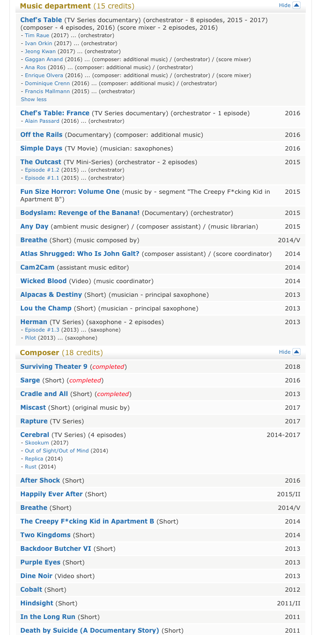

**Full List of Credits on IMDb**