**Stephen Mansey**

74 Broadway, Merriott, TA16 5QH

[StephenMansey20@outlook.com](mailto:StephenMansey20@outlook.com)

**Showreel:** https://youtu.be/PO1Ndc8n9p0 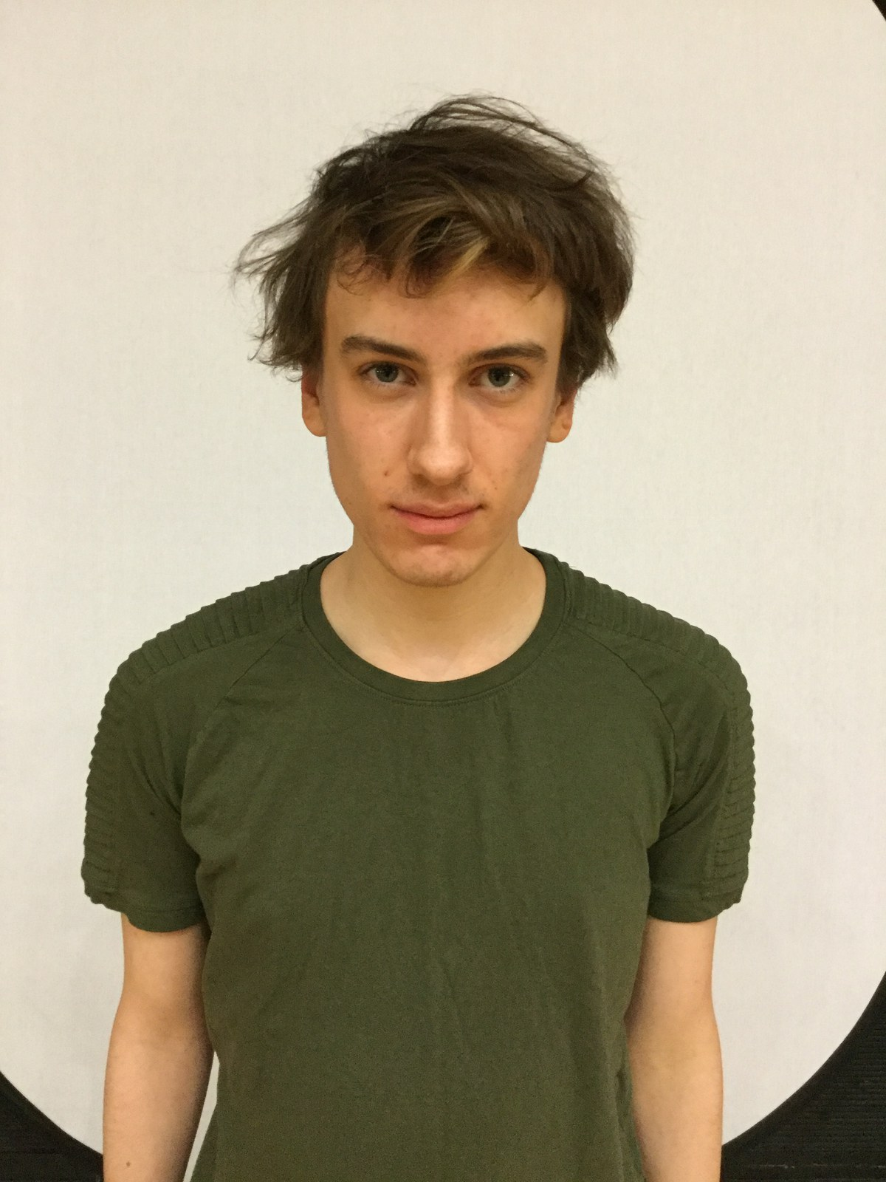

* Height: 5’ 11”
* Eyes: Hazel
* Weight: 9.8st/137.2Ibs
* Hair: Brown
* Range: 20-25 years

**Relevant Education & Training:**

**Bath Spa University, University Centre Weston, Weston-Super-Mare September 2017 – July 2019 Foundation Degree in Performing Arts**

Pass with Merit

**The SPACE, Taunton September 2015 – June 2017 BTEC Level 3 Extended Diploma: Performing Arts**

Distinction* Distinction* Distinction*

**Somerset School of Performing Arts (SSPA), Yeovil September 2016 - July 2017**

**Production Credits:**

Around the Bay Lead – Cornish Waiter Tacchi-Morris Arts Centre

Eventually Lead - Corwin Student Production

Doctor Who Banished Supporting – Doctor Plague Alliance Cinema Production

Taking Flight Supporting - Till Student Production

**Special Skills:**

**Accents and Dialects:** British Upper Class, West Country

**Stage Combat:** Martial Arts (Taekwondo), Street Fighting

**Music:** Singer, Piano

**Dance:** Freestyle, Street Jazz, Modern Stage