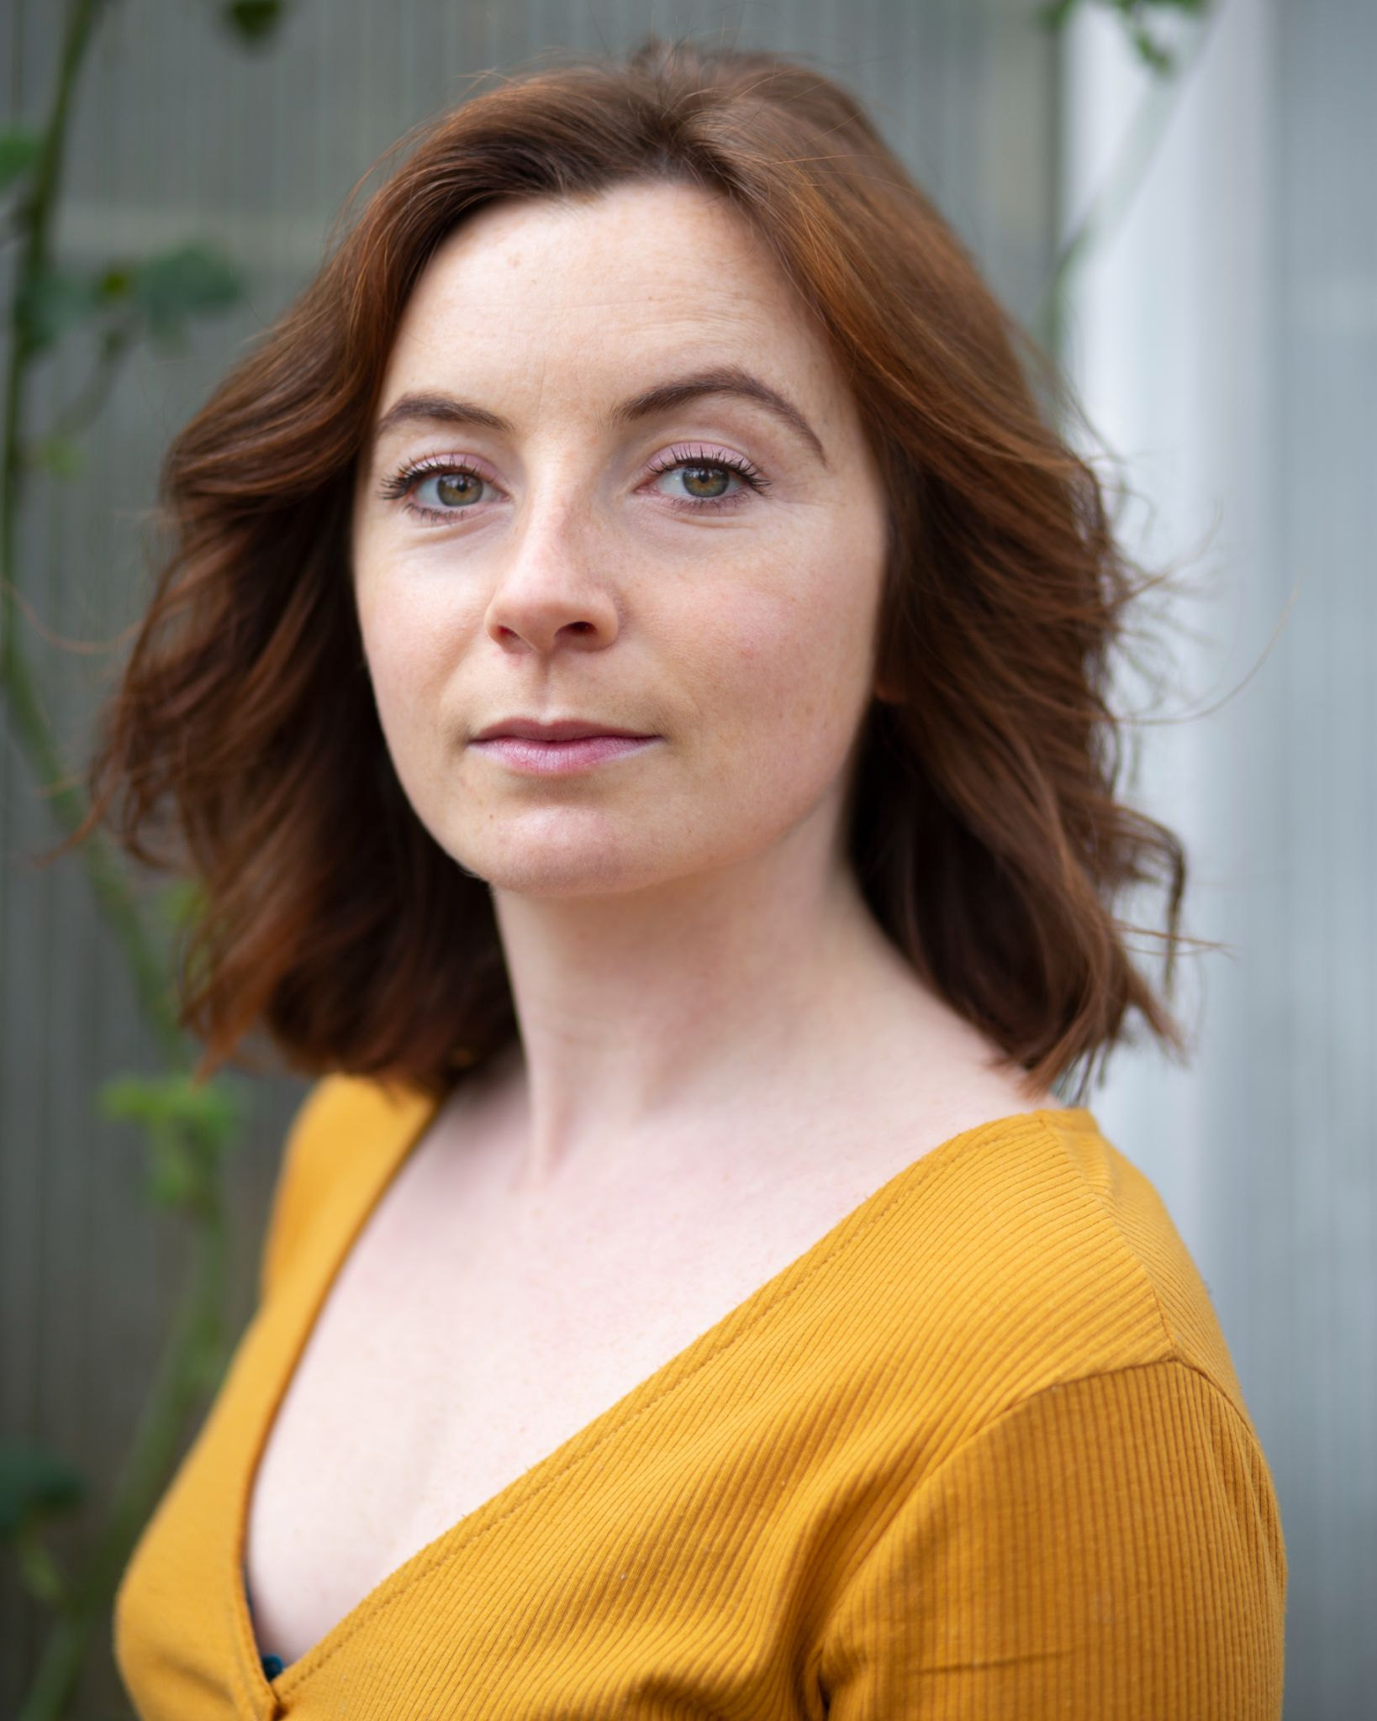

Height: 5”2

Hair: Auburn

Skin: White (Freckled)

Build: Small

Playing age: 21-35

Eyes: Hazel

Languages : English (mother tongue), Spanish B2 level.

Dialects: RP (Natural) Northern English, Scouse, Cockney. American; Texas, New York, East Coast.

Head = 23, Colar = 17, Neck = 12, Chest = 34,

Waist = 26, Hip = 37, Inside leg = 26

TV and Film Experience

| Year | Role | Production | Director | Company |
| --- | --- | --- | --- | --- |
| 2021 | Clown | Bottomless Pockets | Dan Evans, Jake Thomson, Andreas Kyrakides, Lloyd Hughes | University of South Wales (USW) |
| 2021 | Maria | Glass Canvas | Jake Thomson | USW |
| 2021 | April | Only | Dan McCadden | USW |
| 2021 | Tonya | The Box | Flavio Rocha | USW |
| 2021 | Paige | Year of Yes | Jamie Lee | Actors Workshop |

Theatre Experience *professional credits

| 2021 | Seed / Spirit | Different Fruitures * | Alys M Pearce | Action Movement Peace |
| --- | --- | --- | --- | --- |
| 2020 | Dancer | Dada Digidol * | Dan Wyn-Jones | NewCelf |
| 2020 | Holly | Enchanted Christmas * | Lucy Payne | Pytch |
| 2019 | Scientist | Museum Lates * | Beth Green | Tactile Bosch |
| 2019 | Dancer | Dansa en Casa | Alys M Pearce, Sara Trulio, Rebecca Noel, Eva Florez. | Cuerpaluna |
| 2019 | Womxn | Casa del calle | Alys M Pearce,  Jennifer Parra. | Valencia Acoge |
| 2016 | Ethel Rosenburg | Angels in America | Isobel Knight, Caroline Lang. | Exeter University Theatre Co. |
| 2015 | Maggie | Lovesong | Alice Fitzgerald, Cara Delaney | Exeter University Theatre Co. |

Special Skills

Intermediate: Dance (Contemporary, Improvised), Clowning, Singing (Soprano, Alto), Yoga

Beginner: Juggling, Rock Climbing, Ukulele, trampoline, hula hoop.

***

Workshop leading, Public Speaking, Children’s entertainer.

Training

| Actors Workshop | Online | February - March 2021 |
| --- | --- | --- |
| Dansa Contemporanea | Valencia | September 2018 - March 2021 |
| University of Exeter | Exeter | September 2013 - July 2016 |
| National Youth Theatre | Manchester | August 2012 |
| Sherman Youth Theatre | Sherman Theatre, Cardiff | 2008 - 2012 |

Personal Interests

Climate activism, Live Music, Upcycling materials, Growing food, Cycling, Watersports, Writing (fiction, poetry), Woodwork, Gardening, Traveling, Languages, Spirituality.