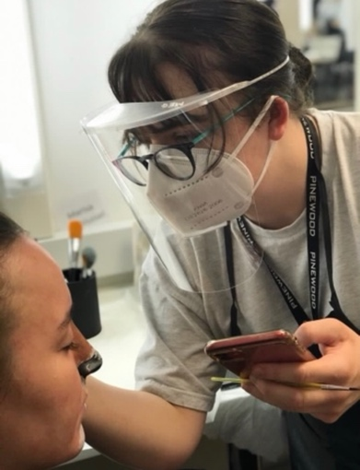  MG  ABOUT ME  I have recently Graduated from The Iver Make-up Academy based at Pinewood Film Studios; where I was trained in a variety of areas including period wig styling, SFX and media makeup. I originally worked as a Circus Performer which is where I further developed my time management and organizational skills. I have lots of experience in customer service and talking to a range of people through my previous jobs as well as experience both working alone and in groups. I have basic computer and software skills.  Skills  TV and media make up| Facial hair application| Character | SFX and Prosthetic application| Period hair and makeup| Wig work and knotting| Body painting| Theatre and performing arts| Basic Hairdressing and barbering| Further prosthetics| Advanced fashion hair and makeup| textured hair and diverse skin tones| Bald caps and Plastic Partings  Full clean drivers LICENCE  Available to travel for work | Megan Green  TRAINEE Hair and Make-up ARTIST  email: MEGANGREENMAKEUP@gmail.com  Tel: 07966054858  WORK EXPERIENCE  The Crown 5 – Netflix - November 2021  Crowd Hair and Make-Up Trainee Daily – Kings Unit  ‘Street Dogs’ – Netflix - November 2021 (4 Days)  Crowd Hair and Make-Up Trainee Daily  Dead Lions (Embankment) Jackson River Films (Apple TV) June – Nov 2021  Crowd Hair and Make-Up Trainee – Dailies  ‘Alpha’ – ITV - October 2021 (4 days)  Daily Hair and Make up Trainee  Grantchester 7 – ITV – October 2021 (2 Days)  Crowd Hair and Make-Up Trainee – Dailies  Untitled Paparazzi Project – NFTS Short – July 21’ - Make up Assistant  Terminus – NFTS Short – July 2021 - Make up Assistant  Two’s a Crowd – Flying Piglet Productions (Short Film) – June 2021  EDUCATION  The Iver Make up Academy August 2020 – June 2021  - Advanced Certificate in Make-up and Hair Artistry  Strode College September 2013 - June 2015  - BTEC Level 3 Extended Diploma Business  Wells Blue School September 2007 - June 2012 - 9 GCSE`s A*-B Grade  Other work experience  The Make Up Armoury – August 2021 – Present  John Lewis Partnership – Waitrose - March 2019 – Present  Aerial and Circus Artiste March 2018 – June 2018 - Self Employed  TUI Group - Plimmiri Resort, Rhodes, Greece - June 2018 - November 2018  - Job Role: Aerialist and Fitness Instructor  Wookey Hole Resort - Wookey Hole, Somerset - April 2007 - May 2018  - Job Role: Circus Performer and Coach  REFERENCES  Liz Tagg-Wooster – Liz.Tagg@iveracademy.co.uk (Principle, The Iver Makeup Academy)  Lesley Gardener – lesley@wookey.co.uk (Theatre Manager, Wookey Hole Circus)  (More References Available at Request)

