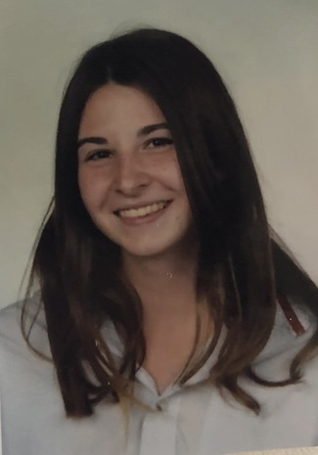

33 Magnolia Drive, Colchester, UK

21 years old Nationalities: Irish/French

# Education and Diplomas

**2019-2022** Undergraduate, Film studies, University of Essex

**June 2019** International Baccalaureate/ Leaving certificate

**2016-2019**  International school of Valbonne

**June 2015** National Diploma (Brevet des Colleges), France

# Languages and Hobbies

* English (Native language) > Passionate about the environment
* French (fluent) > Responsible for multiple beach clean-ups
* Spanish (school level) > Passionate about all forms of Art

# Professional Experiences

**2020-2022:** *AV tech crew in nightclub, Colchester, UK*

* Lighting desk, Sound check, Installing cables for DJ booth
* Decorations, Photobooth, Assisting DJ’s

**2019-2020**: *Short Films, University, Colchester, UK*

* Director, Producer, Camera Operator
* Lighting, Sound, Editor, Actress
* Screenwriter, Location Sound mixer

**2018-2019:** *Short film Project, CIV, France*

* Director, Producer
* Camera Operator

**2018-2019:** *Yearbook Team, CIV, France*

* Designer, Editor
* Photographer