**Stephen Mansey**

Somerset

StephenMansey20@outlook.com

**Showreel:** https://www.youtube.com/watch?v=WR8dt8yCDhI&t=1s&ab_channel=StephenMansey

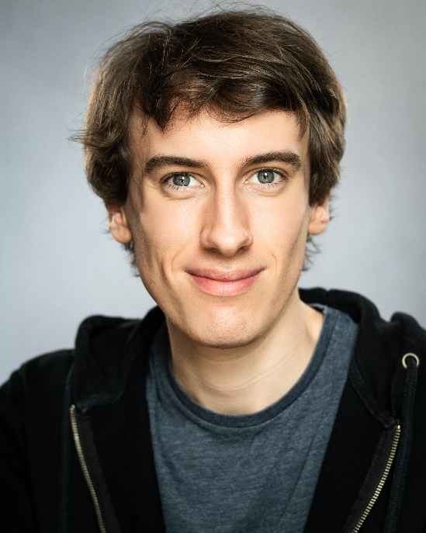**Height**: 6’ 0”

**Eyes**: Hazel

**Weight**: 9.8st/137.2Ibs

**Hair**: Brown

**Range**: 20-25 years

**Accents and Dialects:**

British Upper Class, West Country

**Stage Combat:**

Martial Arts (Taekwondo), Street Fighting

**Music:**

Piano, Ocarina

**Dance:**

Freestyle, Street Jazz, Modern Stage

**Production Credits:**

Around the Bay Lead – Cornish Waiter Tacchi-Morris Arts Centre

Eventually Lead – Corwin Student Production

Doctor Who: Banished Supporting – Doctor Plague Alliance Cinema Production

Taking Flight Supporting – Till Student Production

Doctor Who: The Hider In The House Lead – Bryan Marsh Josh221 Production

Prizefighter: TLOJB Extra – Upper Class Camelot Films

The Gold Extra – Young Visitors BBC

Sex Education Season 4 Extra – U.S. University Student Eleven Film

The Winter King Extra – Christian Monk Bad Wolf Productions

Panto All Over the World Supporting – Fairy Godfather, CUDOS

Genie, Good Fairy

The Bridge Extra – Influencer Bad Wolf Productions

Dracula Lead – Renfield Yeovil Civic Players

Rivals Extra – Audience Member Happy Prince

The Salt Path Extra – Waiter Elliott & Harper Productions

Industry Series 3 Extra – Ayahuasca Ceremony Bad Wolf Productions

Beamount Extra – Protestor FX Productions

Doctor Who: The Ringleader Lead – The Ringleader PlanetZero Productions

The Game’s Afoot Supporting – Simon Bright Ilminster Entertainments Society

**Education & Training:**

**12 Week ‘Real World’ Acting Intensive, London**  **January 2022 – April 2022**

**Bath Spa University, Weston-Super-Mare September 2017 – July 2019**

**Foundation Degree in Performing Arts**

Pass with Merit

**The SPACE, Taunton September 2015 – June 2017**

**BTEC Level 3 Extended Diploma: Performing Arts**

Distinction* Distinction* Distinction*

**Somerset School of Performing Arts (SSPA), Yeovil September 2016 - July 2017**