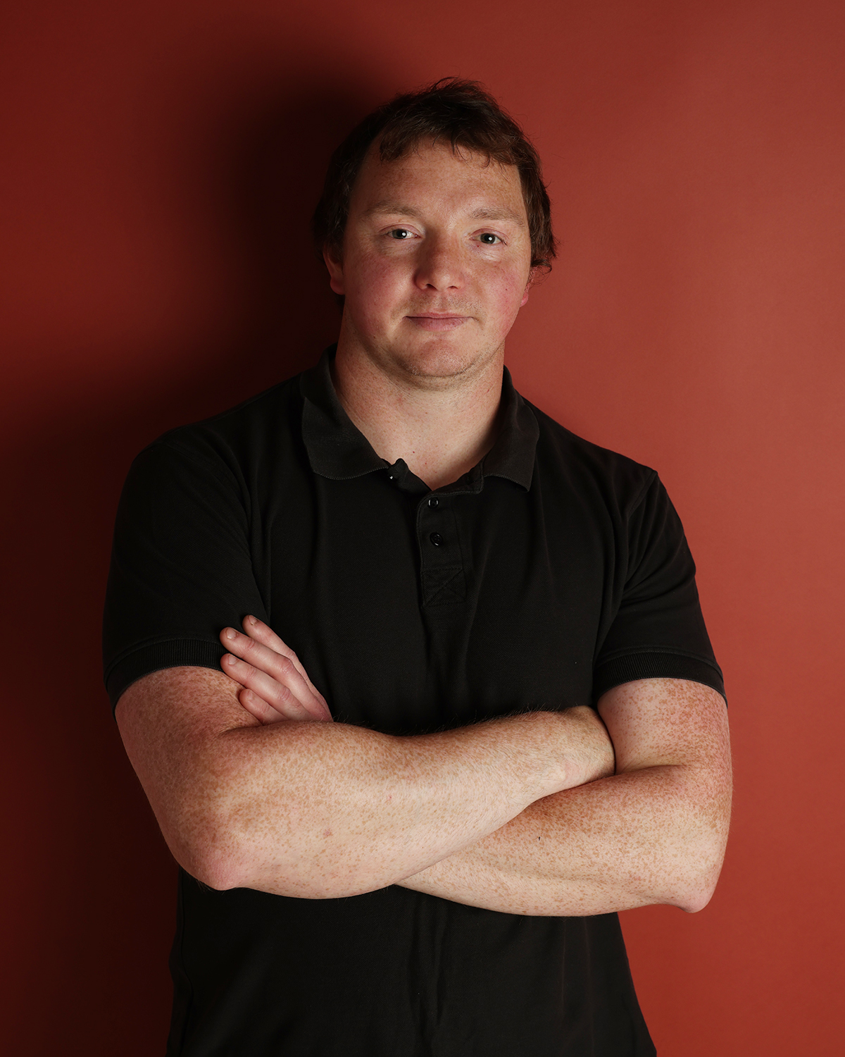 Samuel Russell Burgess DOB: 26/10/1990 Hair colour: Dark brown Eye colour: Hazel

Height: 5’10 Ethnicity: British

Email: [drazic13@hotmail.co.uk](mailto:drazic13@hotmail.co.uk)

Mobile contact: 07955379705 (Text only)

Spotlight: <https://www.spotlight.com/interactive/cv/5650-9056-0039>

Mandy Actors: <https://www.mandy.com/actor/profile/samuel-burgess-1-2?_ga=2.18248249.16529631.1564170750-1823037521.1539026411>

StarNow:

<https://www.starnow.com/u/ds/>

**Theatre Role Agency/Location**

*Macbeth­* Porter and Siward Chippenham College

*Mr A’s Amazing Maze Plays* Neville and Narrator Chippenham College

*Macbeth* Macduff Chippenham College

Monologue *Eight* Jude Chippenham College

*The Tempest*  Drunken Sailor Bath Spa University

TIE: *Seeds Don’t Grow In the Snow* Leddy Bath Spa University

(CANCELLED PRODUCTIONS):

*Modern Prometheus* Data Rate N/A

*Happy Birthday Son* Sam N/A

*Oliver and Olivia* Oliver N/A

**TV series**

Star Wars Pilgrims 2 – 2022 Extra – Rebel technician\engineer Talent Talks

**Short/student film**

Relinking – 2024 Zack University of Gloucester, Cheltenham

Time to Shine – 2023 Stepdad UWE, Bristol

It’s Just a Mask? – 2023 Attacker Salisbury University

D Day – 2023 Private (SA) Ashley Porniuncula - Director

Shot In the Dark – 2023 Cinema goer Uni of Bath

Big Bass – 2023 Sean UWE

Make Every Easy Shot – 2023 Cain Salisbury University

Bravest Thing Ever – 2023 Alex Mandy Actors

*Darkness Rising* – 2021 Right Wing Phoenix Casting

*True Love - 2020* NathanSalisbury University

(Mockumentry) *Chavs* Prison Guard Bath Spa University

*Love Factually* New Man Bath Spa University

*S.I.D.* DS (Deaf Sam) – Myself Bath Spa University

*Fairy Tale Friends*  Brian London University

*The Uninspired Businessman* - 2018 New Employee Bath Spa University

*The Painter­* – 2018 Painter Bath Spa University

**Feature film**

*Down in London* - 2023 Hostage StarNow

*Prize Fighter* - 2021Extra Maddog2020

*Just Drive* - 2017KirkFox and Chips Productions

**Documentary**

*World’s Greatest Palaces* - 2019Jacobean (John Vanbrugh) Woodcut media

**Music video:**

Jeshi – Generations – 2021 Dad Phoenix Casting

**TVC**

Diekirch Beer – 2022 Extra Epoch Design

McDonald’s – 2022 Extra Talent Talks

Premier League – 2022 Extra Talent Talks

**Photo shoot**

Landmarc – 2023

**YouTube**

Life insurance awareness Single Male Bristol

**Skills**

Animal Handling

Accents: Scottish, Welst, Irish, Australian, Russain, GAM, Cockney,

Northern, Somerset, Indian, French, RP, Asian

Poet

Lyricist

Martial arts: Ninjutsu

Basic stage combat

Artist

Drums

Gym Weight lifting

Comedy

Improvisation