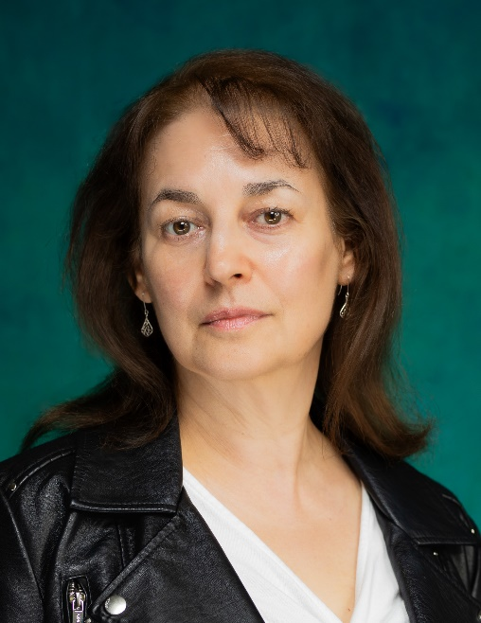
Stephanie Weston
6 Worrall Place, Worrall Road, Clifton, Bristol BS8 2WP
07808 960826 home@stephanie-weston.com

Equity No: 00117578 Spotlight no: PIN 7117 9084 9636
Training: Academy of Live and Recorded Arts
University of London, University of Kent
Height: 5’5” Build: Medium
Hair: Brown Eyes: Brown
Full, clean driving licence Playing age: 47-57
I am the Artistic Director of Instant Wit, the professional comedy improvisation company, performing regularly throughout Bristol & the South West.

2024 Dot - Dot, the Faun & the Elfin Child - Rondo Theatre, Bath and tour
2023 Leah - Ark (dir. Chris Gregory) - Alternative Stories Audio Drama
2023 Melusine - Mayhem! Georgian Kings - T.V., One Tribe TV
2023 Cordelia - Entangled (dir. Philip Douch) - reading, Alma Tavern Theatre
2022 Margot - Set Adrift (dir. Felicity Peries) - Lightship Theatre, Bristol
2022 Dawn - Training film for Mental Health Practitioners - Fluellen Theatre
2022 Sharon - Kirsty’s Promise (dir. Jeff Notton) - film
2022 Mum - Cry, Baby (dir. Lara Czernecki) - short film
2022 Dr Andrews - Pity Parade (dir. Joana Pinto) - short film
2021 Mum - A Hand in the Grass (dir. Will Mead) - short film
2021 Henge Architect - Neolithic Nuisance Neighbours - A Word in Your Ear (reading)
2021 Barbara - End of Life Care (dir. Claire Novelli) - Fluellen Theatre (training film)
2020 Mum - A Deafening Quiet (dir. Adrian Harris) - Brass Works Theatre (video)
2020 Meteorologist - Whirlwind Romance (dir. Olly Langdon) - Story Friday Online (video)
2019 Janey - Bolthole (dir. Kyle Pryke) - Bristol Old Vic Open Stage
2019 Schulz - Checkpoint (dir. Amanda Horlock) - Scratch Night II (script in hand)
2018 Sophie - Sophie Scholl (dir. Kyle Pryke) - Scratch Night I (script in hand)
2018 Clare - Real Fun (dir. Kyle Pryke) - Scratch Night I (script in hand)

