DEB CORDON
07977198619

www.spotlight.com/profile/9131-7833-0301

Represented by Southwest Talent
contact@southwesttalent.co.uk
01392 703805

FILMING experience includes

Marie Threads Lily Brittain Falmouth Uni
Mrs Wilcox Mr and Mrs Wilcox Donovan Wardrope Portsmouth Uni
Delilah Burnt Offering Deb Cordon DCFilms
Mrs. Walters Fruitcake Remi Madge Flicker Films
Nanna House of Sheol Nicola Bailey Merdeka Film
Tracy @Lucky Remy Madge Prego Productions
Helen To Whom It May Concern Orson Cornick Cornick Films
Sarah Grant 4 Balloons and a Funeral Nina Vukovic ffpnewmedia
Midwife The Spanish Princess Emma Frost All3 Media

THEATRE experience includes

Mother Courage Mother Courage excerpts Kevin Johnson The Wheel/Plymouth
The Nurse/Ageus Medea (Ensemble movement) Amanda Collins The Wheel/Plymouth
Rita Educating Rita Tess Brown Durham Theatre Group
Bessie Bogtrotter Tales from the Muck Heap Julie Ward Jack Drum Arts (tour)
Titania Midsummer Night’s Dream Kate Lawrie Durham Shakespeare Group
Luciana Comedy of Errors Kate Laurie Durham Shakespeare Group
Mary Magdelene Jesus Christ Superstar Laurence Sach Durham Theatre Company

TRAINING experience includes

2020 – 2021 Actor training course The Wheel Amanda Collins
Kev Johnson
June 24 Meisner Training Exeter Mark Cassidy
August 23 Shakespeare Bootcamp ICAT Si Trinder
July 23 Day player training ACI Danny Steele May 23 Self-tape course ACI Jenn mars
March 23 Cue-Based Shakespeare Shake-Scene Shakespeare L. Conrad Hughes
May 2022 Jacques Lecoq Clowning Bristol Physical Theatre I. Barkauskaite
May 2021 Laban training ICAT Mike Alfreds
March 2021 Screen skills masterclass x 3 ICAT Sarah Jane Potts

ICAT – Independent Centre for Actors Training ACI – Actor Coaching International

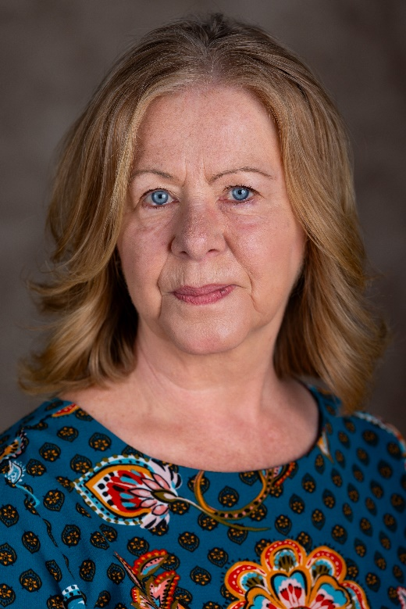
Photo Credit – Emily Louise Vulpix Appleton

