BLINDER 4 IP
（WW+CW）

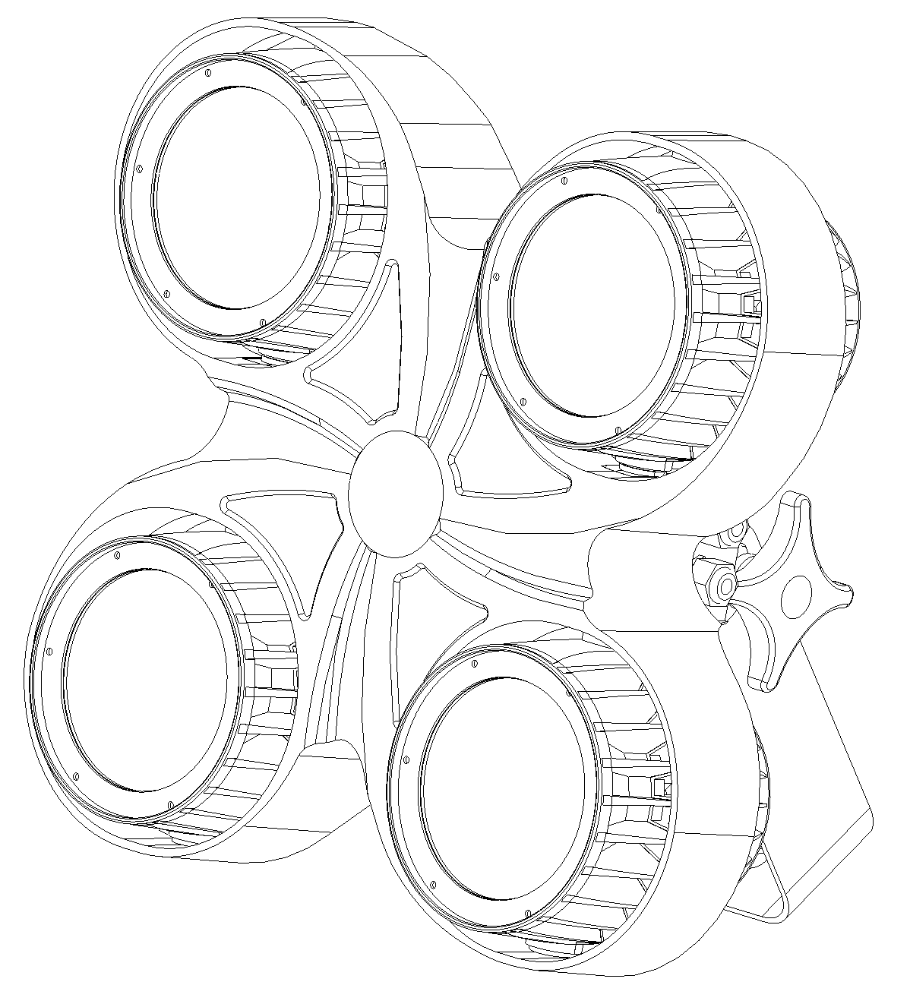

USER MANUAL

KEEP THIS USER MANUAL FOR FUTURE NEEDS

MENU：

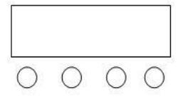
A B C D

A． Menu
B． Up
C． Down
D． Enter

Operation instructions: Press the function key A to circulate 10 different function effects, the first two digits of the digital tube represent the current function (refer to the function table). The last two digits represent the location of the function. Address code, or speed, parameters. Press B or C to change its parameter value. Press D to confirm.

DMX DISPLAY （Press D to confirm all functions selected）

NO. | DISPLAY | DETAIL
1 | A001 | DMX address，（001—512）  B 、C Key to add or subtract address values
2 | 6/12/8 /4/2CH | Multiple channel modes to choose
3 | CC00 | Jumping （00—12）  B 、C to change effect
4 | LL50 | Jumping speed （00—12）  B 、C to change effect speed
5 | CP 99 | fade，（01—99）  B 、C fade,pulse speed
6 | DE99 | Strobe（01—99）  B、C to change fade,pulse speed
7 | BEBE | Sound
8 | o255 | WW color, （000—255）  B 、C change
9 | Y255 | CW color，（000—255）  B 、C change
10 | n255 | Strobe，（000—255）  B 、C change
11 | ON/OFF | Display saver on/off

FUNCTION DISPLAY (D to save)
NO. | DISPLAY | DETAIL
1 | R235 | COB1 WW current 20-255,B、C to change
2 | G235 | COB1 CW current 20-255,B、C to change
3 | B235 | COB2 WW current 20-255,B、C to change
4 | o235 | COB2 CW current 20-255,B、C to change
5 | Y255 | COB3 WW current 20-255,B、C to change
6 | P235 | COB3 CW current 20-255,B、C to change
7 | A235 | COB4 WW current 20-255,B、C to change
8 | n235 | COB4 CW current 20-255,B、C to change
9 | T080 | DMX dimmer speed 0-255,B、C to change
10 | C-60 | Temperature control sets the temperature 40-70 degree,B、C to change

DMX512 CHANNEL (6CH)

NO. | FUNCTION | DETAIL
1CH | Dimmer | COB dimmer,liner dimmer,from the dark to bright
2CH | Strobe | Strobe from slow to fast
3CH | Function | 0-5 Null  6--20： Jumping 1；  21—35: Jumping 2；  36—50: Jumping 3；  51—65: Jumping 4；  66—80: Jumping 5；  81—95: Jumping 6；  96—105: Jumping 7；  106—110: Jumping 8；  111—125: Jumping 9；  126—140: Jumping 10；  141—155: Jumping 11；  156—170: Jumping 12；  170—185: Jumping 1；  186—200: Jumping 2；  201—215: Jumping 3；  216—230: Strobe ;  231—255: Strobe by sound
4CH | Function  Speed | Function speed, from slow to fast
5CH | WW color  dimmer | WW color dimmer,liner dimmer,from the dark to bright
6CH | CW color  dimmer | CW color dimmer,liner dimmer,from the dark to bright

DMX512 CHANNEL (12CH)

NO. | FUNCTION | DETAIL
1CH | Dimmer | COB dimmer,liner dimmer,from the dark to bright
2CH | Strobe | Strobe from slow to fast
3CH | Function | 0-5 Null  6--20： Jumping 1；  21—35: Jumping 2；  36—50: Jumping 3；  51—65: Jumping 4；  66—80: Jumping 5；  81—95: Jumping 6；  96—105: Jumping 7；  106—110: Jumping 8；  111—125: Jumping 9；  126—140: Jumping 10；  141—155: Jumping 11；  156—170: Jumping 12；  170—185: Jumping 1；  186—200: Jumping 2；  201—215: Jumping 3；  216—230: Strobe ;  231—255: Strobe by sound
4CH | Function  Speed | Function speed, from slow to fast
5CH | WW 1 color  dimmer | WW 1 color dimmer,liner dimmer,from the dark to bright
6CH | CW 1 color dimmer | CW1 color dimmer,liner dimmer,from the dark to bright
7CH | WW 2 color  dimmer | WW 2 color dimmer,liner dimmer,from the dark to bright
8CH | CW 2 color dimmer | CW 2 color dimmer,liner dimmer,from the dark to bright
9CH | WW 3 color  dimmer | WW 3 color dimmer,liner dimmer,from the dark to bright
10CH | CW 3 color dimmer | CW 3 color dimmer,liner dimmer,from the dark to bright
11CH | WW 4 color  dimmer | WW 4 color dimmer,liner dimmer,from the dark to bright
12CH | CW 4 color dimmer | CW 4 color dimmer,liner dimmer,from the dark to bright

DMX CHANNEL (8CH)

NO. | FUNCTION | DETAIL
1CH | WW 1 color  dimmer | WW 1 color dimmer,liner dimmer,from the dark to bright
2CH | CW 1 color dimmer | CW1 color dimmer,liner dimmer,from the dark to bright
3CH | WW 2 color  dimmer | WW 2 color dimmer,liner dimmer,from the dark to bright
4CH | CW 2 color dimmer | CW 2 color dimmer,liner dimmer,from the dark to bright
5CH | WW 3 color  dimmer | WW 3 color dimmer,liner dimmer,from the dark to bright
6CH | CW 3 color dimmer | CW 3 color dimmer,liner dimmer,from the dark to bright
7CH | WW 4 color  dimmer | WW 4 color dimmer,liner dimmer,from the dark to bright
8CH | CW 4 color dimmer | CW 4 color dimmer,liner dimmer,from the dark to bright

DMX CHANNEL (4CH)

NO. | FUNCTION | DETAIL
1CH | Dimmer | COB dimmer,liner dimmer,from the dark to bright
2CH | WW dimmer | WW dimmer,liner dimmer,from the dark to bright
3CH | CW dimmer | CW dimmer,liner dimmer,from the dark to bright
4CH | Strobe | Strobe from slow to fast

DMX CHANNEL (2CH)

NO. | FUNCTION | DETAIL
1CH | WW dimmer | WW dimmer,liner dimmer,from the dark to bright
2CH | CW dimmer | CW dimmer,liner dimmer,from the dark to bright

RDM

NO. | FUNCTION | DETAIL
1 | Feedback (address code) | Can be changed freely
2 | Feedback (channel mode) | Can be changed freely
3 | Feedback(device temperature) | Can’t be changed freely

TECHNICAL PARAMETER
Voltage: AC100~240V,50/60HZ
Power consumption: 400W
Light source: 4pcs 100W WW+CW
LED control: individual controllable
DMX channels: 6/12/8//4/2CH
Color temperature:3200K~7000 Adjustable
Dimmer: 16bit 0~100% linear dimmer
Beam angle: 38 degree
Work temperature: -30degreee~50degree
Control model: DMX512,Auto,Master-Slave,Sound active
Strobe: 1~30HZ
House: Metal,black
Connection model: DMX in/out, Power IN/OUT
IP grade: IP65
Size: 394*245*392
Weight: 17kg

FIXTURE SIZE
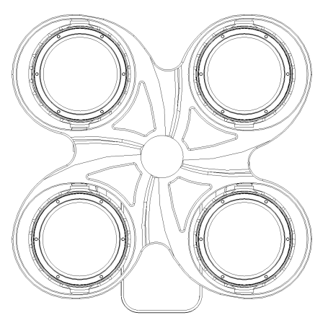
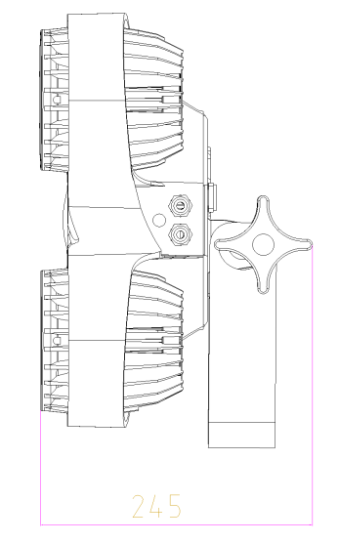
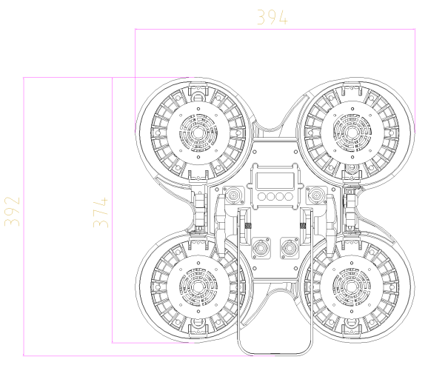

REMARK
The product has perfect performance and intergrity packing. All users should be strictly comply with the warning
and operating instructions as stated. Or we aren’t in charge of any result by misusing.
Any damage resulting by misuse is not within the Company’s warranty.
Any fault or problem caused by neglecting the manual is also not in the charge of dealers.
Errors and omissions for every information given in this manual excepted.
All information is subject to change without prior notice.

Thank you again for your patronage!
We will be offering sincere service as always,
Wish you have a good lighting journey!

