BLINDER 2
(WW+CW)

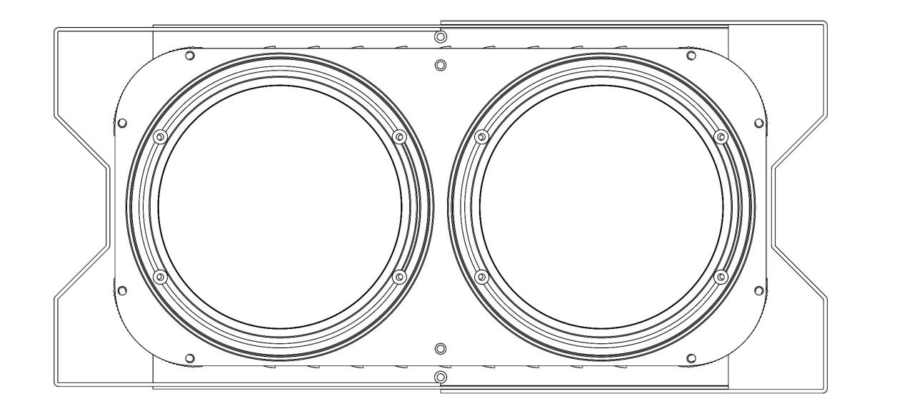

USER MANUAL

KEEP THIS USER MANUAL FOR FUTURE NEEDS

MENU
1.Keystroke diagram
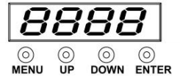

MENU： function key
UP： additional key
DOWN： Subtract key
ENTER： Confirmation key

2. Button Description MENU function key:
Press the function key MENU will loop out of the table (1) function, digital tube in front of 1-2 to represent the current function. The latter 2-3 digits represent the speed, effect and other parameters of the function; the parameter values can be modified by pressing UP or DOWN key; and the parameter value can be confirmed by pressing ENTER key.
UP additional key:
Press the key can be added, the length of more than 2 seconds if added continuously;
DOWN Subtract key:
According to the invention, the key can be reduced, and the length can be reduced continuously for more than 2 seconds;
ENTER Confirmation key:
Press the key to save the currently set parameter function, the next boot automatically run the save function.

NO | DIS | VALUE | FUNCTION
1 | d001 | 001- 512 | DMX512 Address code setting -4 channel mode
2 | A001 | 001- 512 | DMX512 Address code setting -8 channel mode
3 | U255 | 000 - 255 | Cold white dials, from dark to bright.
4 | C255 | 000 - 255 | Warm white dials from dark to bright.
5 | FH99 | 01 - 99 | Stroboscopic, from slow to fast.
6 | CC99 | 01 - 99 | Jump, from slow to fast.
7 | DE99 | 01 - 99 | Gradient, from slow to fast.
8 | CP99 | 01 - 99 | Pulse change, from slow to fast.
9 | S0UD | - | Sound control

CHANNEL LIST
CH 8 | FUNCTION | DESCRIPTION
CH1 | Dimming | dimming， From dark to bright
CH2 | CW1 dimming | WW1 dimming， From dark to bright
CH3 | WW2 dimming | WW2 dimming， From dark to bright
CH4 | CW1 dimming | WW1 dimming， From dark to bright
CH5 | WW2 dimming | WW2 dimming， From dark to bright
CH6 | Total strobe | Total strobe, slow to fast
CH7 | Function | 0-50:DMX dimming; 51-100: common color output (8); 101-150: jump;  151-200: gradual; 201-250 pulse;  251-255: voice control
CH8 | Function speed | Functional speed, from slow to fast

CH 4 | FUNCTION | DESCRIPTION
CH1 | CW1 dimming | WW1 dimming， From dark to bright
CH2 | WW2 dimming | WW2 dimming， From dark to bright
CH3 | CW1 dimming | WW1 dimming， From dark to bright
CH4 | WW2 dimming | WW2 dimming， From dark to bright

TECHNICAL PARAMETER
Voltage: AC100~240V,50/60HZ
Power consumption: 200W
Light source: 2pcs 100W Warm white
LED control: individual controllable
DMX channels: 4/8CH
Color temperature:3200K~7000 Adjustable
Dimmer: 16bit 0~100% linear dimmer
Beam angle: 38 degree
Work temperature: -30degreee~50degree
Control model: DMX512,Auto,Master-Slave,Sound active
Strobe: 1~30HZ
House: Metal,black
Connection model: DMX in/out, Power IN/OUT
IP grade: IP20
Size: 375*301*180MM
Weight: 3kg

FIXTURE SIZE

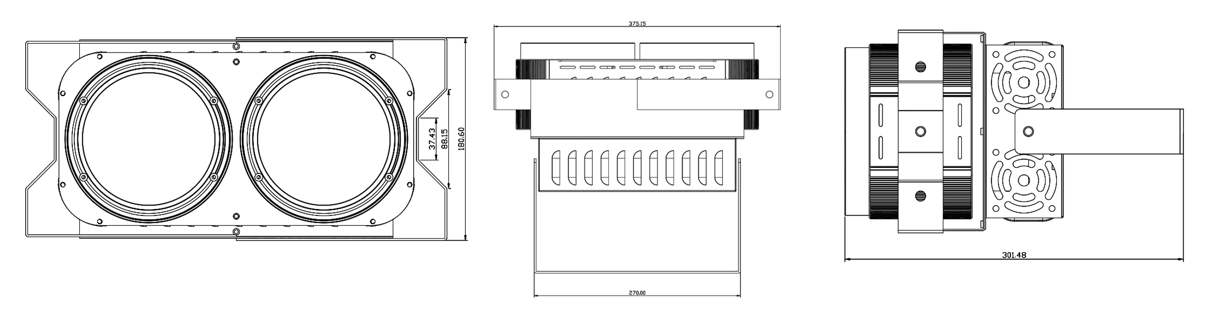

REMARK
The product has perfect performance and intergrity packing. All users should be strictly comply with the warning
and operating instructions as stated. Or we aren’t in charge of any result by misusing.
Any damage resulting by misuse is not within the Company’s warranty.
Any fault or problem caused by neglecting the manual is also not in the charge of dealers.
Errors and omissions for every information given in this manual excepted.
All information is subject to change without prior notice.

Thank you again for your patronage!
We will be offering sincere service as always,
Wish you have a good lighting journey!

