BLINDER 4
（WW+CW）

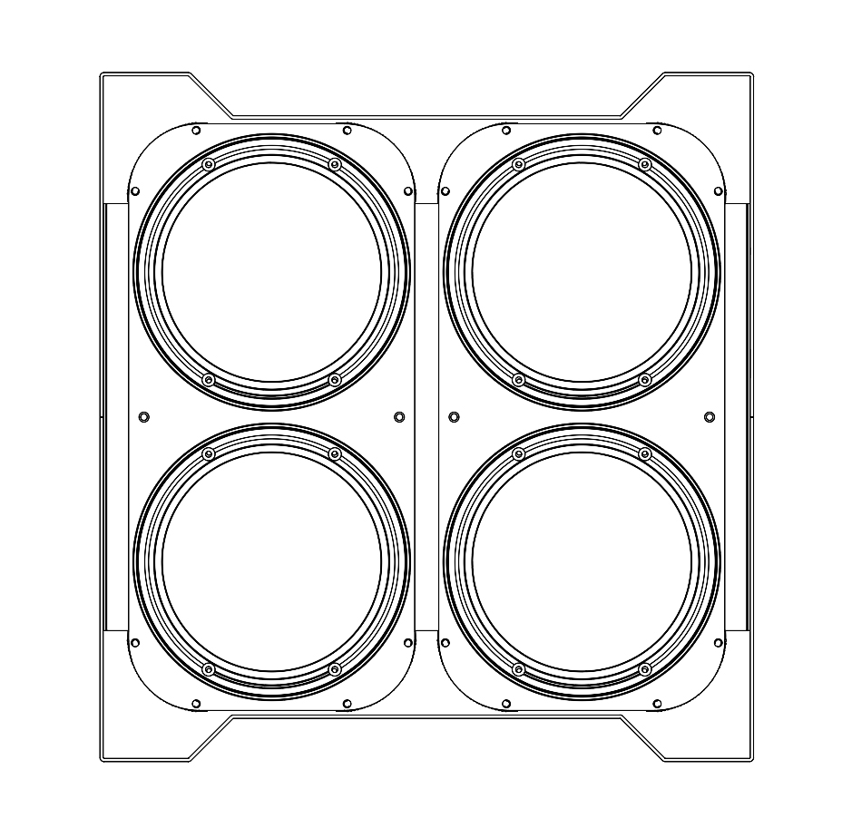

USER MANUAL

KEEP THIS USER MANUAL FOR FUTURE NEEDS

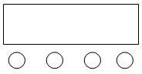
DISPLAY MENU

A．Function key B．UP key C．Down key
D．Enter key

A B C D
Operate introduce: Press function key “A” will circulate seven different function effects, The line of words upside LCD stand for the present working function ( please refer to the function table.), the under line stands for LCD shows what address code or speed parameter of this function is at.

DISPLAY MENU FUNCTION ( Press D key to confirm after choosing certain function)
NO. | DISPLAY | FUNCTION
1 | A002 | 12 channel address code, UP/DOWN key selects the address code (A001 ~ A512), press the confirmation key (ENTER key) to save the address code
2 | L001 | 4 channel mode, UP/DOWN key selects the address code (L001 ~ L512), press the confirmation key (ENTER key) to save the address code
3 | d002 | 2 channel mode, the UP/DOWN key selects the address code (d001 ~ d512), press the confirmation key (ENTER key) to save the address code
4 | M000 | macro
5 | S000 | Functional mode speed
6 | P000 | The frequency flash is from slow to fast
7 | R255 | (r000-r255) up, manually modify the bulb 1 cold white brightness
8 | G255 | (G000 - G255) upward, downward manually modify the lamp bead 1 warm white brightness
9 | B255 | (B000 - B255) upward, manually modify the lamp bead 2 cold white brightness
10 | W255 | (w00-w255) upward, downward manually modify the lamp ball 2 warm and white brightness
11 | Y255 | (y000-y255) upward, downward manually modify the bulb 3 cold white brightness
12 | I255 | (i000-i255) upward, downward manually modify the bulb 3 warm white brightness
13 | F255 | (F000 - F255) up and down manually modify the bulb 4 cold white brightness
14 | H255 | (H000 - H255) upward, downward manually modify the bulb 4 warm white brightness

CHANNEL LIST

12CH Description
NO. | FUNCTION | DESCRIPTION
1CH | 000-255 | The total dimming
2CH | 000-255 | 0-9 no stroboscopic  10-255 strobes speed from slow to fast
3CH | 250-255 | macro
4CH | 000-255 | Built-in mode speed adjustment
5CH | 000-255 | R - light bulb 1 cold white linear dimming, from dark to light
6CH | 000-255 | G - light bulb 1 warm white linear dimming, from dark to light
7CH | 000-255 | B-lamp 2 cold white linear dimming, from dark to light
8CH | 000-255 | W - bulb 2 warm white linear dimming, from dark to light
9CH | 000-255 | Y - light bulb 3 cold white linear dimming, from dark to light
10CH | 000-255 | I - light bulb 3 warm white linear dimming, from dark to light
11CH | 000-255 | F - bulb 4 cold white linear dimming, from dark to light
12CH | 000-255 | H - bulb 4 warm white linear dimming, from dark to light

4CH Description
NO. | FUNCTION | DESCRIPTION
1CH | 000-255 | Tuned light
2CH | 000-255 | R/G/Y/F brightness is adjusted from dark to light
3CH | 000-255 | B/W/I/H brightness is adjusted from dark to light
4CH | 000-255 | 0-9 no stroboscopic  10-255 strobes speed from slow to fast

2CH Description
NO. | FUNCTION | DESCRIPTION
1CH | All Dimmer | From dark to bright
2CH | 000-255 | 0-9 no stroboscopic  10-255 strobes speed from slow to fast

TECHNICAL PARAMETER

Voltage: AC100~240V,50/60HZ
Power consumption: 400W
Light source: 4pcs 100W Warm white
LED control: individual controllable
DMX channels: 12/4/2CH
Color temperature:3200K~7000 Adjustable
Dimmer: 16bit 0~100% linear dimmer
Beam angle: 38 degree
Work temperature: -30degreee~50degree
Control model: DMX512,Auto,Master-Slave,Sound active
Strobe: 1~30HZ
House: Metal,black
Connection model: DMX in/out, Power IN/OUT
IP grade: IP20
Size:36x38x20CM
Weight: 9.0K

FIXTURE SIZE

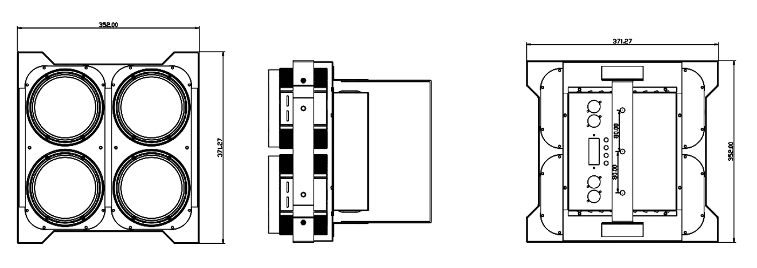
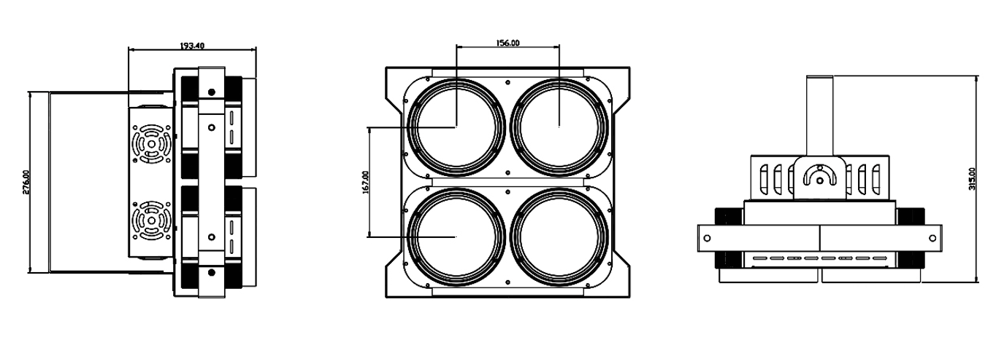

REMARK
The product has perfect performance and intergrity packing. All users should be strictly comply with the warning
and operating instructions as stated. Or we aren’t in charge of any result by misusing.
Any damage resulting by misuse is not within the Company’s warranty.
Any fault or problem caused by neglecting the manual is also not in the charge of dealers.
Errors and omissions for every information given in this manual excepted.
All information is subject to change without prior notice.

Thank you again for your patronage!
We will be offering sincere service as always,
Wish you have a good lighting journey!

