MINI P1 IP

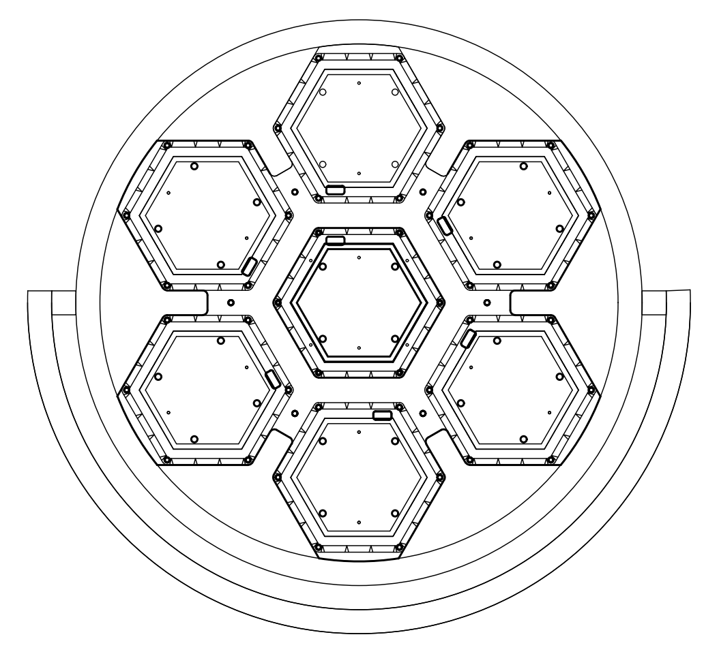

USER MANUAL

KEEP THIS USER MANUAL FOR FUTURE NEEDS

DISPLAY

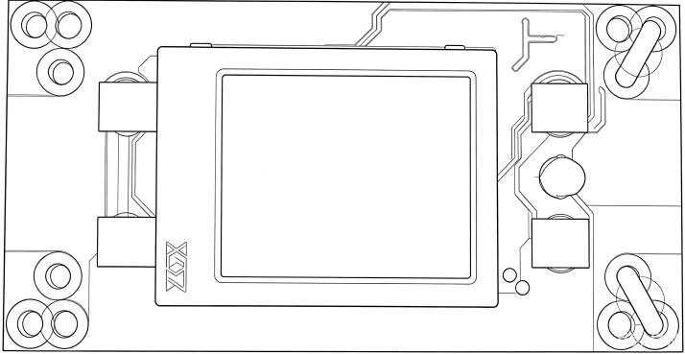

A．Function
B．UP
C．DOWN
D．ENTER

Function list

MAIN MENU | SUBMENU | MENU FUNCTION DESCRIPTION
System settings | 1. DMA  address | Modify the DMA address code up or down (optional range of address codes 001-512), confirm to save, default to 001.
System settings | 2. Encoder | Modify encoder on/off up or down, confirm key to save, default to on.
System settings | 3. X reversal | Modify X up or down to reverse on/off, confirm to save, default to off.
System settings | 4. Y reversal | Modify Y up or down to reverse on/off, confirm to save, default to off.
Operating mode | 1. Operation mode | Select the operating mode up or down, such as MAX/voice control/automatic, and press the confirm button to save. The default mode is MAX.
Operating mode | 2. Channel selection | Select channel CH4. CH16. CH22. CH28. CH40 up or down to save
Manual | 1. Dimming | Modify the dimming value up or down (adjustable range 000-255), confirm and save, default to 255.
Manual | 2. RGB dimming | Modify the RGB dimming value up or down (adjustable range 000-255), confirm to save, default to 000.
Manual | 3. RGB strobe | Modify the RGB flicker value up or down (adjustable range 000-255), confirm to save, default to 000.
Manual | 4. Red | Modify the brightness of the red light bead up or down (adjustable range 000-255), confirm to save, default to 128.
Manual | 5. Green | Modify the brightness of the green light bead up or down (adjustable range 000-255), confirm to save, default to 128.
Manual | 6. Blue | Modify the brightness of the blue light bead up or down (adjustable range 000-255), confirm to save, default to 128.
Manual | 7. RGB mode | Modify the RGB mode values up or down (adjustable range 000-255), confirm and save
Manual | 8. RGB speed | Modify RGB speed values up or down (adjustable range 000-255), confirm and save
Manual | 9. Background color | Modify the background color parameter value up or down (adjustable range 000-255), confirm to save, default to 000.
Manual | 10. Background color tone light | Modify the background color tone light parameter values up or down (adjustable range 000-255), confirm to save, default to 000.
 | 11. W strobe white | Modify the brightness of the white light beads up or down (adjustable range 000-255), confirm to save, default to 128.
 | 12. W strobe | Modify the W strobe value up or down (adjustable range 000-255), confirm and save
 | 13. W mode | Modify the W mode value up or down (adjustable range 000-255), confirm and save
 | 14. W speed | Modify the W speed value up or down (adjustable range 000-255), confirm and save
 | 15. RGBW mode | Modify the RGBW mode value up or down (adjustable range 000-255), confirm and save
 | 16. RGBW speed | Modify the RGBW speed value up or down (adjustable range 000-255), confirm and save
Display Settings | 1. Language selection | Select Chinese/EN (English) up or down, confirm to save, default to Chinese.
Display Settings | 2. Inverted Display  Settings | Select up or down to turn off/on the inverted display setting, confirm to save, default to off.
Display Settings | 3. Screen saver | Select up or down to turn off/on screen saver, confirm to save, default to on.
Display Settings | 4. Software version | G45A program identification code, cannot be modified.
Factory settings | Display, please enter password! Change up or down to 138, then press the confirm button  to enter the  factory settings. | 1. Red | Modify parameters up or down (range 000-255), confirm to save, default to 255.
Factory settings |  | 2. Green | Modify parameters up or down (range 000-255), confirm to save, default to 255.
Factory settings |  | 3. Blue | Modify the red light bead current (032-255) up or down, confirm and save, default to 255.
Factory settings |  | 4. White | Modify the green light bead current (032-255) up or down, confirm and save, default to 255.
Factory settings |  | 5. Direction | Modify direction up or down
Factory settings |  | 6. LED | LED sequence selection
Factory settings |  | 7. Logo | Select 000/001 up or down, confirm to save, default to 000.
Factory settings |  | 8.  Temperature | Select 000-070 up or down, confirm to save, default to 060.
Factory settings |  | 9.  Temperature - Fan | Temperature Fan Control

CHANNEL LIST
(After power on, set the address codes for all lighting fixtures. Connect all lighting fixtures in parallel with a three core signal wire to the DMX512 console. The address code will stop flashing, indicating that the DMX512 console signal has been sent to the lighting fixtures. Use the DMX512 console to control the relevant functions according to the instructions of each channel.)

CH4Channel Description：
CH | VALUE | FUNCTION
1 | 000-255 | R
2 | 000-255 | G
3 | 000-255 | B
4 | 000-255 | W

CH16Channel Description：
CH | VALUE | FUNCTION
1 | 000-255 | Total dimming
2 | 000-255 | RGB overall dimming
3 | 000-255 | R
4 | 000-255 | G
5 | 000-255 | B
6 | 000-255 | RGB strobe
7 | 000-255 | RGB mode
8 | 000-255 | RGB speed
9 | 000-255 | Background color
10 | 000-255 | Background color tone light
11 | 000-255 | white
12 | 000-255 | W strobe
13 | 000-255 | W mode
14 | 000-255 | W speed
15 | 000-255 | RGBW mode
16 | 000-255 | RGBW speed

CH22Channel Description：
CH | VALUE | FUNCTION
1 | 000-255 | Total dimming
2 | 000-255 | RGB overall dimming
3 | 000-255 | R
4 | 000-255 | G
5 | 000-255 | B

6 | 000-255 | RGB strobe
7 | 000-255 | RGB mode
8 | 000-255 | RGB speed
9 | 000-255 | Background color
10 | 000-255 | Background color tone light
11 | 000-255 | White 1
12 | 000-255 | White 2
13 | 000-255 | White 3
14 | 000-255 | White 4
15 | 000-255 | White 5
16 | 000-255 | White 6
17 | 000-255 | White 7
18 | 000-255 | W strobe
19 | 000-255 | W mode
20 | 000-255 | W speed
21 | 000-255 | RGBW mode
22 | 000-255 | RGBW speed

CH28Channel Description：
CH | VALUE | FUNCTION
1 | 000-255 | R1
2 | 000-255 | G1
3 | 000-255 | B1
4 | 000-255 | R2
5 | 000-255 | G2
6 | 000-255 | B2
7 | 000-255 | R3
8 | 000-255 | G3
9 | 000-255 | B3
10 | 000-255 | R4
11 | 000-255 | G4
12 | 000-255 | B4
13 | 000-255 | R5
14 | 000-255 | G5
15 | 000-255 | B5
16 | 000-255 | R6
17 | 000-255 | G6
18 | 000-255 | B6
19 | 000-255 | R7
20 | 000-255 | G7
21 | 000-255 | B7
22 | 000-255 | White 1
23 | 000-255 | White 2

24 | 000-255 | White 3
25 | 000-255 | White 4
26 | 000-255 | White 5
27 | 000-255 | White 6
28 | 000-255 | White 7

CH40Channel Description
CH | VALUE | FUNCTION
1 | 000-255 | Total dimming
2 | 000-255 | RGB overall dimming
3 | 000-255 | R1
4 | 000-255 | G1
5 | 000-255 | B1
6 | 000-255 | R2
7 | 000-255 | G2
8 | 000-255 | B2
9 | 000-255 | R3
10 | 000-255 | G3
11 | 000-255 | B3
12 | 000-255 | R4
13 | 000-255 | G4
14 | 000-255 | B4
15 | 000-255 | R5
16 | 000-255 | G5
17 | 000-255 | B5
18 | 000-255 | R6
19 | 000-255 | G6
20 | 000-255 | B6
21 | 000-255 | R7
22 | 000-255 | G7
23 | 000-255 | B7
24 | 000-255 | RGB strobe
25 | 000-255 | RGB mode
26 | 000-255 | RGB speed
27 | 000-255 | Background color
28 | 000-255 | Background color tone light
29 | 000-255 | White 1
30 | 000-255 | White 2
31 | 000-255 | White 3
32 | 000-255 | White 4
33 | 000-255 | White 5
34 | 000-255 | White 6

35 | 000-255 | White 7
36 | 000-255 | W strobe
37 | 000-255 | W mode
38 | 000-255 | W speed
39 | 000-255 | RGBW mode
40 | 000-255 | RGBW speed

TECHNICAL PARAMETERS
Voltage: AC100~240V 50/60HZ
Power: 350W
Lamp beads: 63 pieces 5050-RGB 0.3W
Control mode: DMX512, self-propelled, master-slave, voice control, with RDM function
Channel: CH4.CH16.CH22.CH28.CH40
Dimming: 16bit 0-100% linear dimming
Features: auxiliary lighting+dyeing+flash+running horse
Working temperature: -30 ° C~50 ° C
Strobe frequency: 1-30Hz
Appearance: Metal, black
Connection method: DMX512 input/output
Power input and output.
IP level: IP67
Size: 550*121*510MM
Net weight:

FIXTURE SIZE

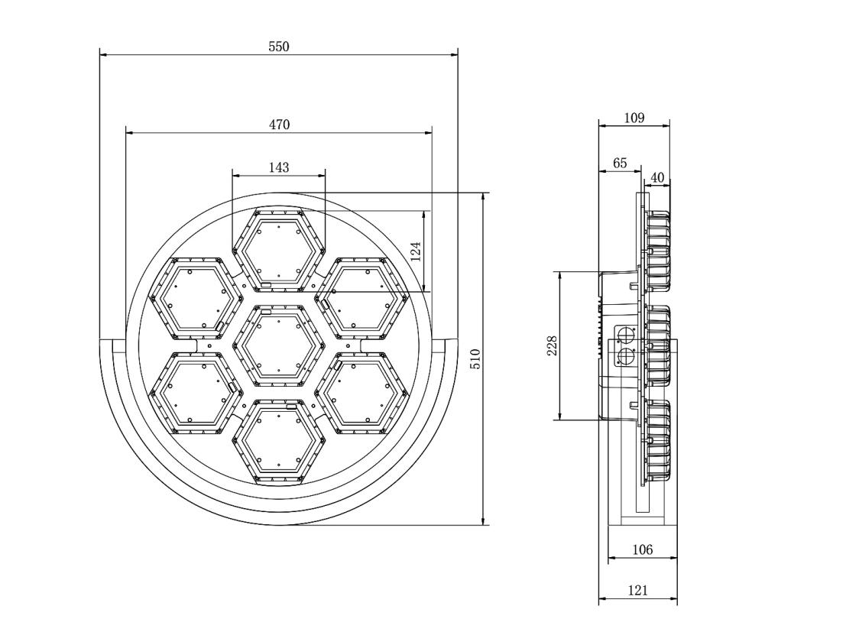

REMARK
The product has perfect performance and intergrity packing. All users should be strictly comply with the warning
and operating instructions as stated. Or we aren’t in charge of any result by misusing.
Any damage resulting by misuse is not within the Company’s warranty.
Any fault or problem caused by neglecting the manual is also not in the charge of dealers.
Errors and omissions for every information given in this manual excepted.
All information is subject to change without prior notice.

Thank you again for your patronage!
We will be offering sincere service as always,
Wish you have a good lighting journey!

