Murray Robinson-Boulton
Photographer

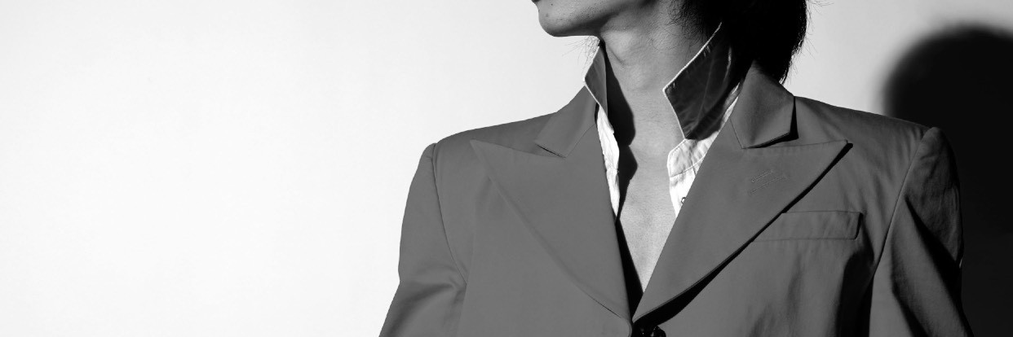
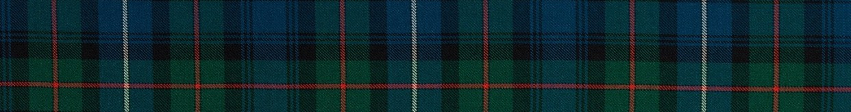
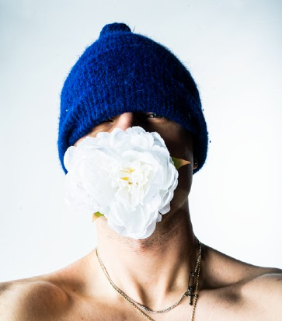

Professional Skills
- Adobe creative suite
- Photography both DSLR and SLR
- Dark room
- Blender animation and creation
- Editing and retouching both photo and video
- Set creation
- Painting and drawing
- Social media campaign
- Website design
- Location scouting

Personal Interests
- Sustainability
- Rural locations (E.G Highlands )
- Hiking mountains
- Tartan and Tweed
- British tradition and Culture
- Set creation
- Camping
- Part time Mixologist
- Travel
- History

Contact Details
Lets work together

Tel: 07738606066
Email: murray.boulton@gmail.com Socials:
Instagram: murrayboulton_photography Facebook: murrayboulton_photography Tik-Tok: @murrayboulton
More about me
Residing in London while deeply rooted in the Highlands of Scotland, I unearthed my passion for photography during my teenage years, employing self- portraiture to encapsulate the essence of my surroundings. Influenced by Scottish and British history, my work delves into themes of heritage and surrealism within the fashion realm, exploring the profound connection between the human form and nature.
Central to my artistic vision is a steadfast commitment to sustainability, ensuring that every facet of my creative process minimises environmental impact and employs fully traceable materials. Armed with a BA in Fashion Photography from UAL’s LCF and a foundation diploma in Fashion Communication from CSM, I seamlessly blend concepts from these disciplines to construct innovative narratives that push the boundaries of creativity within the fashion industry

Past experience
- Social media campaigns for London cocktail club
- Collaboration with Adam Jones studio
- Underground England shoes campaign for social media
- Video creation of short film Skin and Linked
- Creator of Tweed zone and Sgàil
- Multiple calibrations with UAL Stylists and Designers
- Work shown on West Ham stadium as part of promotion
- Runner up of young Scottish photographer award

Education
- Central St Martins- Fashion Communication Diploma- Merit
- London Collage Of Fashion- Fashion Photography BA - awaiting award

