**SIS Course Selection and Registration Quick Guide**

Log into the [Student Information System (SIS).](https://sisuva.admin.virginia.edu/psc/ihprd/UVSS/SA/s/WEBLIB_HCX_GN.H_SPRINGBOARD.FieldFormula.IScript_Main)

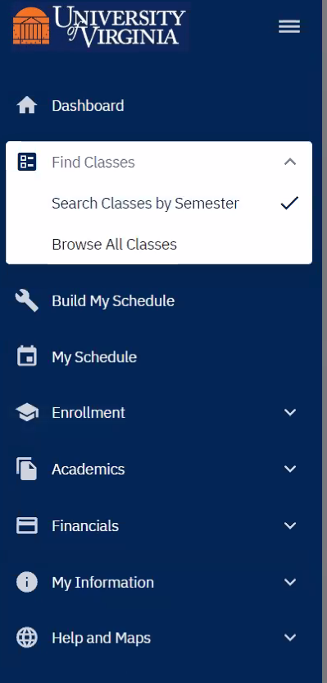Select the TERM: **2020 Fall**

Select the Department: **Public Policy**

**Click Search.**

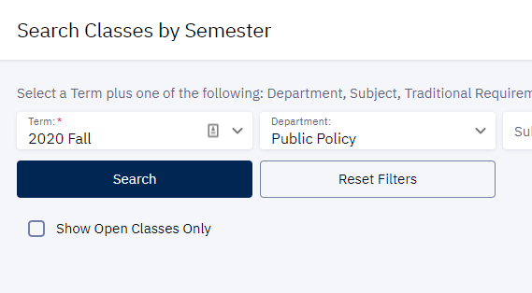

For each class, once you find the course/section in which you would like to enroll, click on the three dots to see your options. Click on “Add to Cart” as shown here.

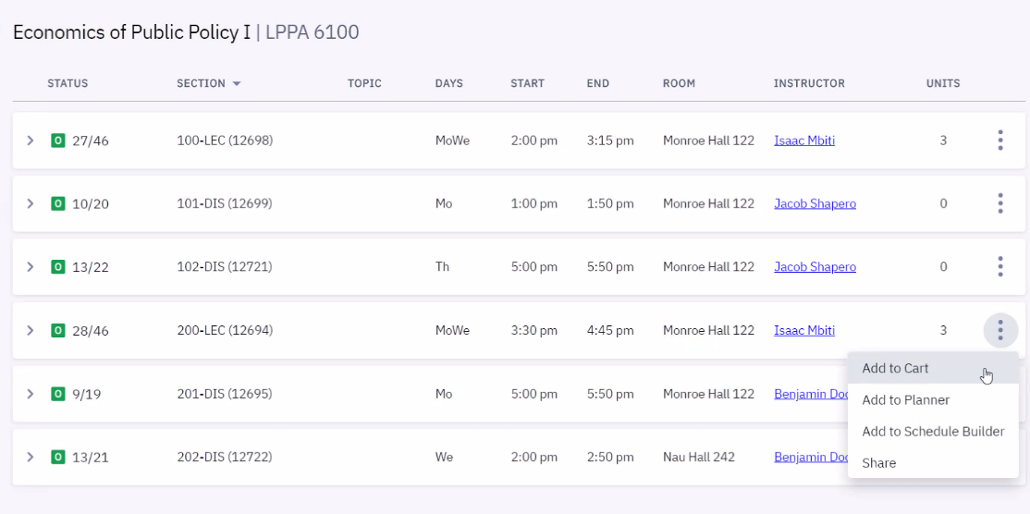

You should then see a pop up saying you have successfully added the course to your cart:

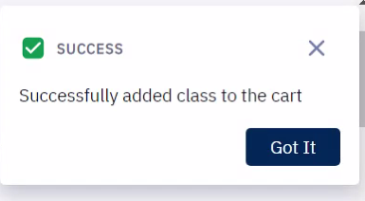

Once you have all your courses in your shopping cart, you can import them to the Schedule Builder [found under ‘Build My Schedule’], to look at your weekly schedule:

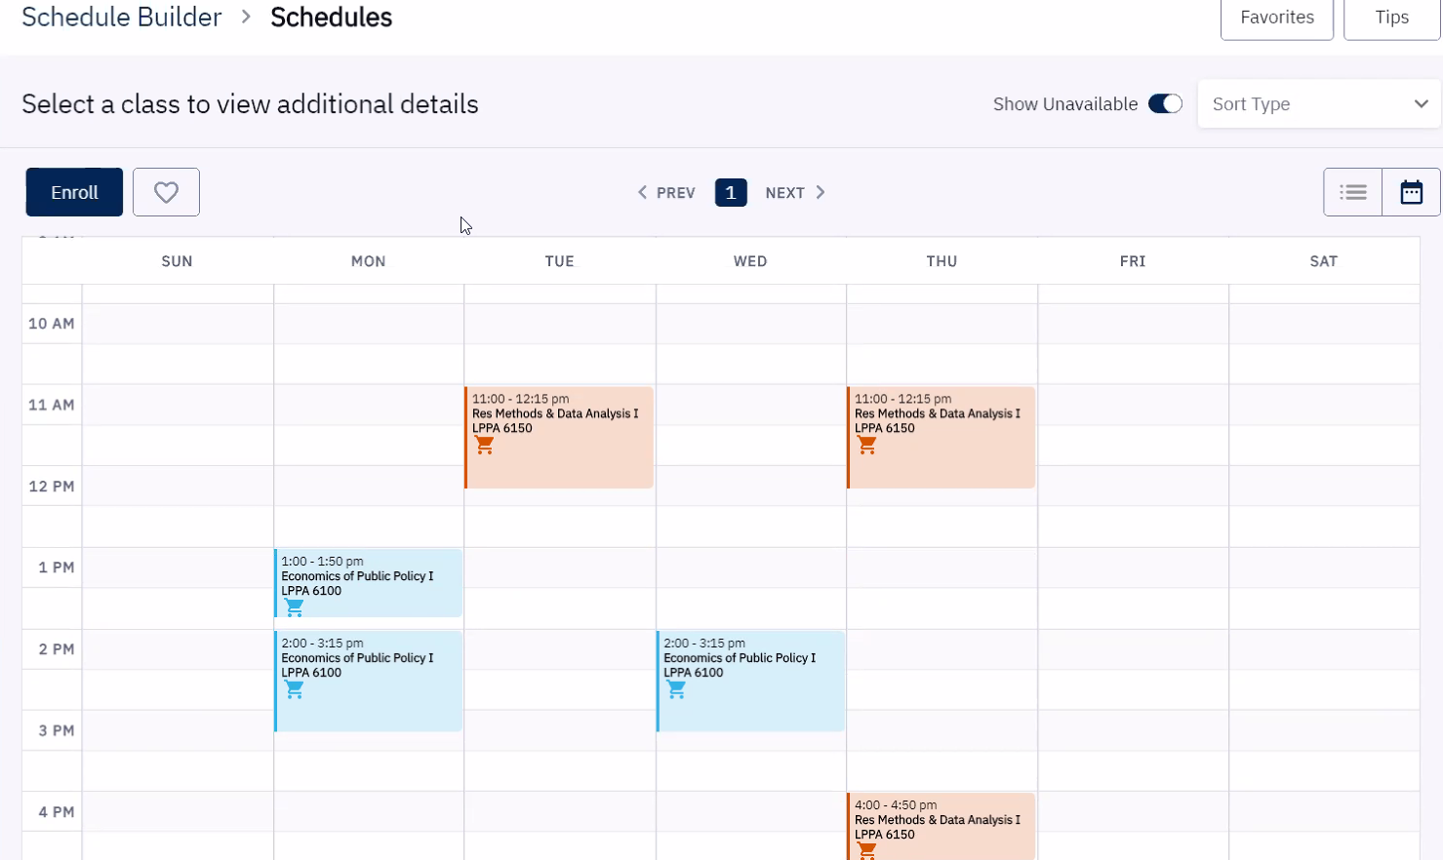

On or after July 1, 2020, you will log into SIS, go to your shopping cart, select all courses and click on the Enroll button. You can also Enroll from the schedule builder. See the Enroll button on the screen above.

Contact Kristine Nelson [knelson@virginia.edu] with any questions **after** you get into SIS and try to add courses to your cart.