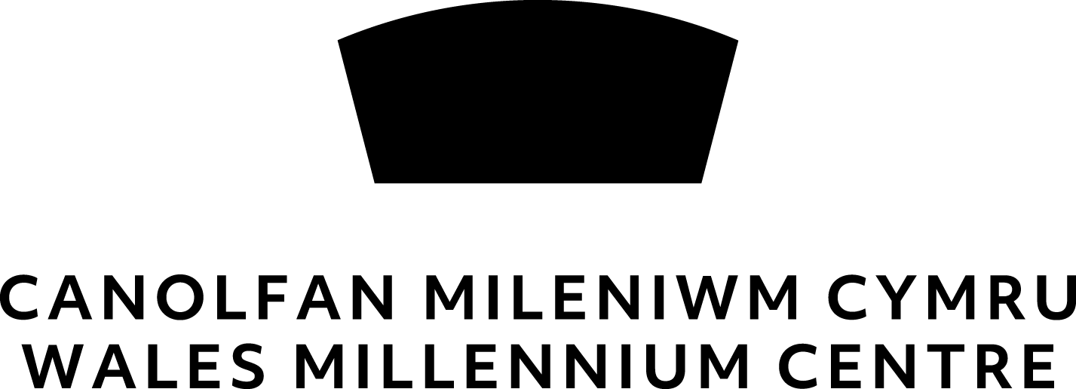 **Creative Learning Project Sign Up**

We require basic information to be able to contact you about the workshop/programme you/your child(ren) are taking part in and ensure you/they are safe as our duty of care. For this partnership between **Wales Millennium Centre** and **Voices From Care Cymru** your permission will be shared between both parties. Each party will be responsible for complying with General Data Protection Regulation 2016 and therefore will not be shared further.

**Name of Project : Sing Proud Cymru**

Today’s Date ______________________________________________________________________

Have you ever taken part in any activity run by the Centre before? ______________________________

If yes, please tell us which activities / projects _______________________________________________

**PARTICIPANT INFORMATION**

First Name ________________________________________________________________________

Surname ________________________________________________________________________

Address ________________________________________________________________________

Postcode ________________________________________________________________________

Date of birth ________________________________________________________________________

Mobile (if over 18) _________________________________________________________________

E-mail (if over 18) _________________________________________________________________

Emergency Contact Name & Mobile Number ________________________________________________

Do you have any specific access needs? ____________________________________________________

Do you have any dietary requirements? ____________________________________________________

Would you prefer us to communicate with you in Welsh or English? ______________________________

***(complete this section additionally if participant is under 18 years of age)*  
PARENT / GUARDIAN / CARER INFORMATION**

First Name ________________________________________________________________________

Surname ________________________________________________________________________

Address ________________________________________________________________________

Postcode ________________________________________________________________________

Contact No. ________________________________________________________________________

E-mail ________________________________________________________________________

Please tick this box if you would like to be contacted by Wales Millennium Centre about future creative learning opportunities by email

Yes please

How did you find out about this project/workshop? _________________________________

Participant data will be stored for a period of 7-years to be able to share opportunities with you, for auditing and to meet terms of funding. If you would like to withdraw consent to store your data at any time, please email [data-protection@wmc.org.uk](mailto:data-protection@wmc.org.uk)

**CONSENT FOR PHOTOGRAPH, FILM OR MEDIA RELEASE FOR NON-PROFIT USE**

During creative learning workshops we may be capturing content of participants to be able to document and then share the story of their journey and evidence any impacts the workshop/project has had.

Content captured may include photography, videography and vocal recordings and may be shared for the following purposes:

* Internal communication at Wales Millennium Centre and project partner organisations
* Press coverage / websites & social media platforms / publications & communication to the general public
* Reporting purposes including to funding bodies

To comply with the General Data Protection Regulations 2016, we need your permission before we can photograph or make any recordings of you or your child(ren) Please sign and date the form below to give permission.

I have read and understood the conditions of use:

Name (in block capitals) of parent/carer/guardian: _______________________________________  
  
Signature of parent/carer/guardian: ________________________________________________

Thank you very much for taking the time to fill out this form. We’re looking forward to seeing you at the next workshop. Please return this form to a Centre employee or via email to education[@wmc.org.uk](mailto:education@wmc.org.uk)