

**Gender pay gap report  
April 2021**

**Equality and diversity at Wales Millennium Centre**

As is required by law, this report reflects the gender profile of our employees in April 2021. This was within the Covid pandemic period and so the numbers and profile are unrepresentative, because the number of staff at this point in time was very small. In response to the pandemic, we had to make some difficult decisions to ensure the survival of the organisation. This included a decision to initially furlough most of our staff and subsequently to significantly reduce the size of our workforce.

When we are able to rebuild the team, we will aim to ensure that our staff represent the full diversity of the community in which we live. We have implemented a detailed action plan to ensure that our recruitment is diverse, equitable and inclusive as we believe this will ensure that this will attract the best talent.

We are committed to gender parity across the organisation. Whilst we currently employ equal numbers of men and women, this balance is not reflected in all functions. We aim to address these imbalances as we rebuild the organisation after reopening.

**Our commitment during the last year**

To achieve a balance of gender, ethnicity and to reflect a broad range of experiences amongst our staff requires vigilance and active management. We regularly review our policies and practices and monitor the profile of our workforce on an on-going basis to ensure that we are being fair and inclusive. We have implemented the following initiatives over the last year, to move the organisation forward.

* **Real Living Wage accreditation**

Wales Millennium Centre has paid the Real Living Wage for all entry level staff, regardless of age or gender, since April 2019, and became formally accredited in 2021.

* **Role evaluation and benchmarking**

We engaged an external consultant to review all roles across the organisation, and benchmark the salaries for these roles, with the intention of rolling out a role evaluation framework and salary guide in 2020/21. This was paused due to the pandemic. Having recently restarted this process, we aim to complete the roll out of a role evaluation framework by April 2022.

* **Continuous improvement initiatives**

We continue to drive equality and fairness through our policies and practices. All staff have received equality, diversity and inclusion training, as well as unconscious bias training. In areas where the workforce majority is male, such as our Security and Technical teams, we have arranged ACAS training with specific focus on behaviours in the workplace.

* **Implement consistently our processes for recruitment**

From January 2021, we implemented name and address anonymised recruitment to reduce unconscious bias, ensuring a fairer and more robust shortlisting process. We will also continue exploring agencies that support a diverse range of talent and ensure that new roles are advertised across a broad spectrum of platforms. We have partnered with organisations such as Stonewall and Citizens Cymru to review our own practices and grow from feedback.

* **Actively develop our talent pool**

All members of staff complete an annual review with their line manager. This is an opportunity for the individual to focus on developing their skills and experience. It is also an opportunity for the organisation to focus on succession planning and making the most of the talent available.

* **Actively encourage flexible working**

Our employee surveys highlight that our staff value flexibility and work-life balance, so we encourage agile working. In January 2021, we moved from a 39-hour working week to a 35-hour working week as well as introducing a flexi-time policy and a focus on outputs rather than inputs. Furthermore, the pandemic has accelerated agile working such as the ability to work from home where roles permit.

**Our gender pay gap**

Median Gender Pay Gap

-32.88%

Mean Gender Pay Gap

-7.19%

**Bonus payments**

Median Gender Bonus Gap

0%

Mean Gender Bonus Gap

0%

**Our gender pay quartiles**

|  |  |  |  |  |  |  |  |
| --- | --- | --- | --- | --- | --- | --- | --- |
| Total in Quartile = | 19 | Total in Quartile = | 19 | Total in Quartile = | 19 | Total in Quartile = | 19 |

**Our gender pay gap explained**

The gender pay gap is a measure of the difference in the average pay of all men and women across an organisation, regardless of the nature of their work. It can be confused with equal pay. However equal pay involves the direct comparisons of people who are performing work of equal value. In comparison, gender pay gap looks solely at the average pay for men and women, irrespective of their role or seniority.

Our analysis of our mean and median gender pay gaps of -7% and -33% respectively, based on snapshot information dated 5 April 2021, is largely driven by the following:

* A significant reduction of our workforce as a result of the pandemic, resulting in very few casual staff working for us at this time, and a significant reduction in permanent head count particularly in those areas related to venue management and theatre operations.
* The two middle quartiles reflect the general 50:50 gender split of the workforce.
* The retention of casual staff in security only, which is currently predominantly male, drove the predominantly male lowest quartile.
* The retention of the management structure across all functions, with a predominantly female management team, led to the predominantly female upper quartile, as well as the overall gender pay gap of -7%, and median gender pay gap of -33%.
* At the snapshot date, the Strategic Leadership Team consisting of 2 males and 3 females. Due to the pandemic and reliance on public funding, no performance-related pay bonus was paid in this period.

Some achievements this year which will contribute to decreasing our gender pay gap for 2022 and beyond include developing a consistent and fair pay framework and reviewing our recruitment practices to ensure fair and consistent recruitment (including anonymised applications).

We strive to pay in line with market conditions. We are aware that certain job functions attract more males than females, or sometimes more females than males. We are actively working to address this imbalance within individual functions.

We confirm that the data reported is accurate.

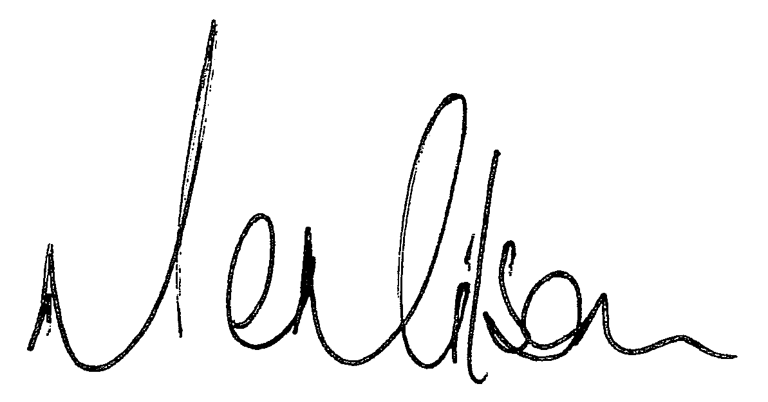

**Mathew Milsom**  
Managing Director

**We are Wales Millennium Centre. Fire for the imagination.**