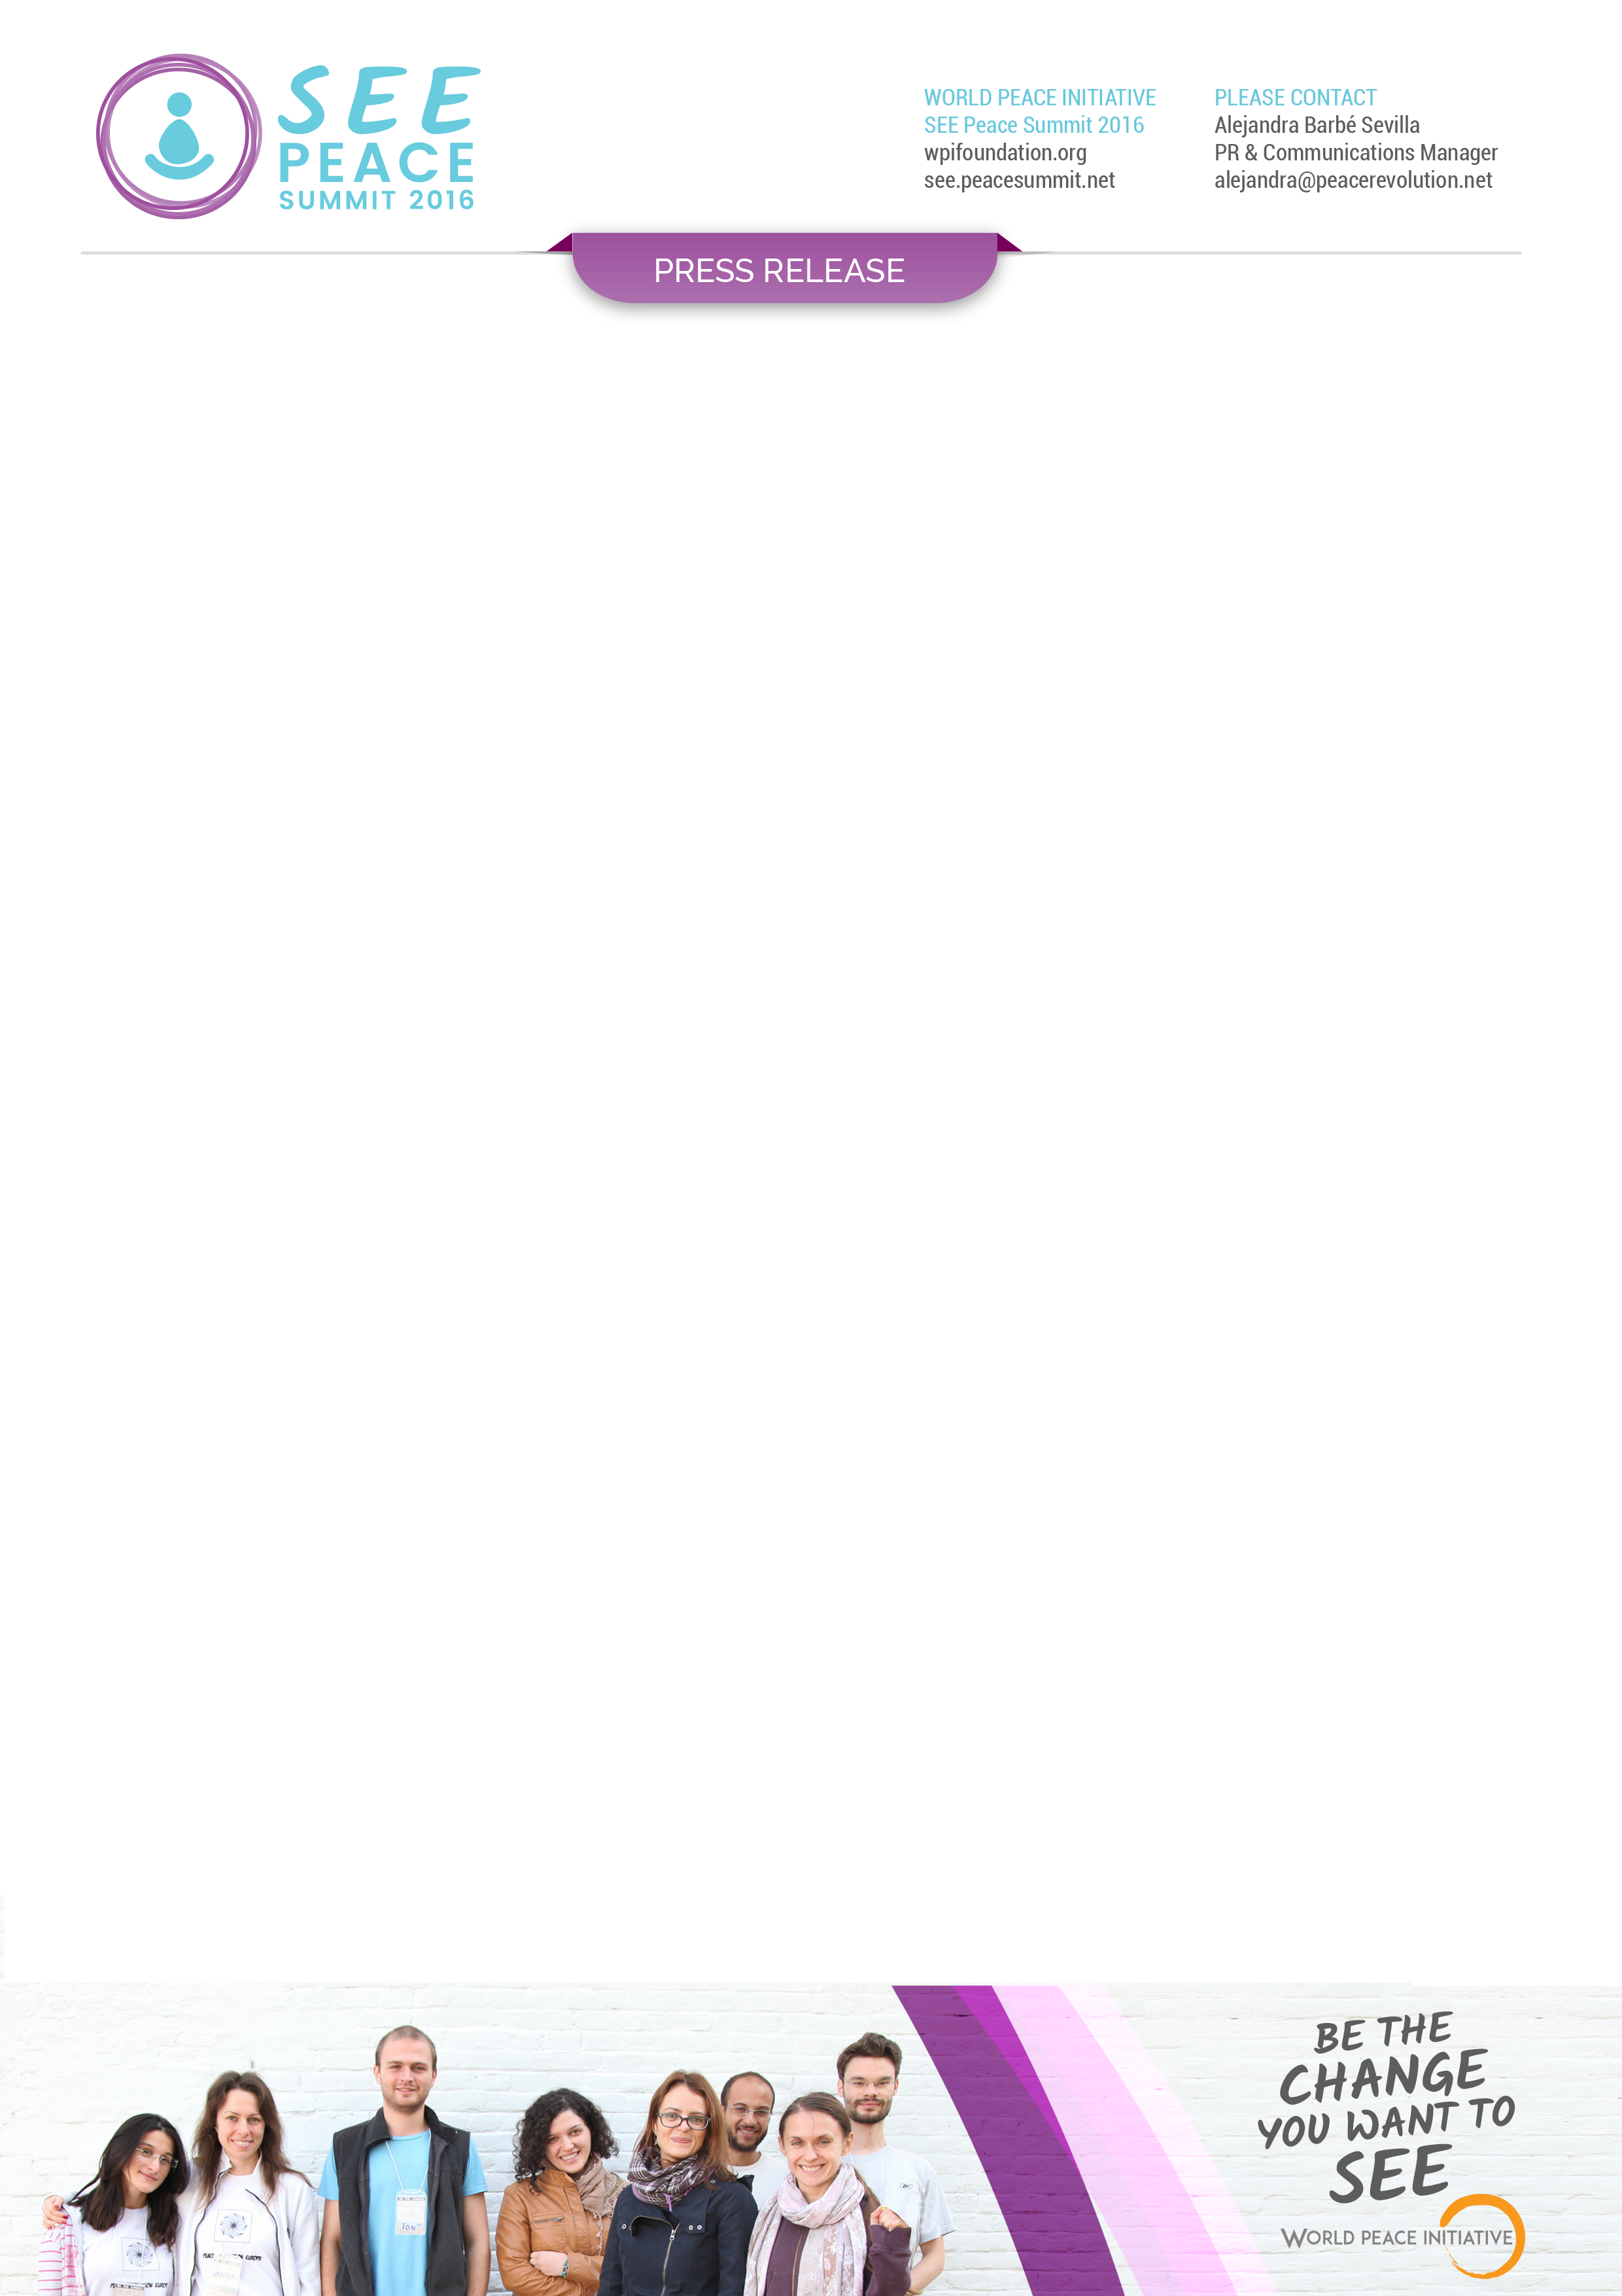

Looking forward to hearing from you soon,

Sincerely,

***Alejandra Barbé Sevilla***

***PR & Comunication Manager***

The [South East Europe Peace Summit](http://see.peacesummit.net/) is organized by [World Peace Initiative Foundation](https://wpifoundation.org/), an international NGO established in Thailand in 2010 and committed towards the goal of creating peace by empowering self-development of individuals globally, based on a firm belief that world peace can be achieved if each and everyone of us works on their inner peace first, and then shares it with family, friends and community at large.

The purpose of South East Europe (SEE) Peace Summit is to engage young open-minded leaders and support their growth as change makers to effectively contribute to the region’s sustainable and inclusive development, bringing the disruptive idea that world peace can be built through inner peace and self-development, confirming that individuals are responsible for and are capable of making a change in their communities.

The Summit will include engaging activities, meditation, yoga sessions, lectures and discussions providing the participants with new skills for non-violent resistance, peace education, enhanced creativity and stress-management. Participants will be able to learn meditation first hand from a Buddhist monk from Thailand.

The summit is a unique combination of a meditation retreat (Peace in) and a conference (Peace out), which will bring about the disruptive idea that world peace can be built through inner peace and self-development, confirming that individuals are responsible for and are capable of making a change in their communities.

**###**

***World Peace Initiative launches SEE Peace Summit***

**- FOR IMMEDIATE RELEASE -** 14 / 11 /2016