Corporate Climate Governance: Climate Risk Scenario Analysis, Action Plan (Transition Plan) and Initial Climate Risk Disclosure for CJSC Azerbaijan Caspian Shipping Company

Task 2. Assessment of climate related risks and opportunities

Draft Report - December 2024 - Confidential

Content of this report

Content of this report 2
List of figures 4
List of acronyms 5
Executive summary 6
I. Background information 7
II. Analysis of physical risks for a selection of ASCO’s assets 9
1. Methodological introduction, comments on climate scenarios used 9
A. Key steps and definition 9
B. Climate scenarios and time horizons 10
C. Sea Level Change methodology 12
D. Location and physical hazards 12
2. Physical climate-related risks universe for ASCO 15
3. Results of exposure analysis for physical risks 17
A. Sea Level Change 17
B. General exposure results for other climate risks 18
C. Focus results on high temperature and heat for ASCO’s assets 19
4. Analysis of the potential impact of perils 21
III. Analysis of transition risks 26
1. Methodological approach 26
2. Analysis a sub-risk level 27
a. Sustainability reporting mandates 27
b. Increasing pricing of GHG emissions 29
c. Regulatory mandates on low-carbon fuel use and energy efficiency 31
d. Limited biofuel of e-fuel availability 34
e. Reduction of oil and gas demand 36
3. Summary of transition risk impacts 41
4. Conclusion 44
Appendices 45
Appendix 1 - Definition of key concepts 45
Appendix 2 – Exposure analysis for the 5 selected assets 47
About EY 49

List of figures
Figure 1: Climate-related risks, opportunities, and financial impacts in TCFD recommendations (source: TCFD) 8
Figure 2: List of climate-related risk and opportunity categories defined by the TCFD 8
Figure 3: Key steps of a climate change analysis 10
Figure 4: SSP scenarios coupled with radiative forcing levels 12
Figure 5: Location of assets included in the analysis 14

List of acronyms

CAPEX: Capital expenditures
CSRD: Corporate Sustainability Reporting Directive EBRD: European Bank for Reconstruction and Development
EY CAP: EY Climate Analytics Platform
GHG: Greenhouse Gas
IMO: International Maritime Organization
ISSB: International Sustainability Standards Board
OPEX: operational expenditures
RCP: Representative Concentration Pathway
SSP: Shared Socioeconomic Pathway
TCFD: Task Force on Climate-Related Financial Disclosures
TPI: Transition Pathway Initiative

Executive summary

Maritime transport is a cornerstone of the global economy, handling 80% of global trade by volume and 70% by value, with continued growth projected. In Azerbaijan, maritime transport plays a crucial role in supporting offshore platforms in the Caspian Sea, facilitating the movement of equipment and personnel, as well as ensuring the efficient operation and maintenance of these platforms, critical to the nation’s strategic oil and gas sector. This sector not only supports Azerbaijan’s economy but also contributes to regional energy stability. ASCO (Azerbaijan Caspian Shipping Company) is a key operator in this domain, managing maritime logistics to meet the demands of offshore activities and the energy sector. The company also aspires to broaden its transport activities, extending its reach beyond the Caspian Sea. However, the maritime sector faces significant environmental challenges. It is responsible for 3% of global greenhouse gas (GHG) emissions globally, primarily from fossil fuel combustion. Over the past decade, emissions from international shipping have increased by 20%, with projections indicating a potential 130% rise over 2008 levels by 2050 without effective mitigation. To address these challenges, the maritime industry, including ASCO, is adopting decarbonization strategies aligned with the International Maritime Organization’s (IMO) goal of achieving carbon neutrality by 2050.
In this context, The European Bank for Reconstruction and Development (EBRD) is collaborating with the Closed Joint-Stock Company (CJSC) Azerbaijan Caspian Shipping Company (ASCO) to align its operations with both the need for decarbonization and the necessity of building climate resilience, in line with the Paris Agreement, aiming to contribute to keeping the global temperature rise under 1.5°C and supporting the transition toward net zero emissions by 2050. This dual approach recognizes that reducing greenhouse gas emissions and adapting to the physical impacts of climate change are complementary objectives for ensuring the long-term sustainability of maritime operations. As part of this collaboration, comprehensive climate risk assessments are conducted to identify vulnerabilities, mitigate potential impacts, and integrate adaptation measures into ASCO’s business strategies, alongside efforts to transition to low carbon solutions.
Physical climate risks exposure and impacts were assessed on a selection of ports and shipyards where ASCO has activities in the Caspian sea, focusing on sea level changes, temperature increases, heatwaves, and extreme weather events. The assessment was conducted with two climate scenarios up to 2050, defined by the IPCC (International Panel on Climate Change) and using most recent available scientific studies.
Caspian Sea level decrease appears as the most important risk for ASCO’s operations. A decrease of the sea level of up to 5 meters is expected in 2050, and up to 14 meters by the end of the century. This will severely impact most shallow areas of the Caspian Sea and pose serious threats to ASCO’s operations, driving important investments to maintain ports depth over time and adjustments to maritime trade routes.
Analysis of climate risks exposure for high temperatures and heatwaves present a moderate historical exposure, with expected increases in maximum temperatures by up to 5°C by 2050 under the worst climate scenario. Projections indicate a doubling of heatwave frequency by 2030 and substantial increases in maximum heatwave lengths by 2050, posing significant risks to ASCO’s assets’ lifetime and employees’ health. Theses impacts are expected to be gradual and increase over time.
Additionally, assessment of flooding presents a low exposure for all studied assets, while extreme weather events, including storms and high winds, show a moderate historical exposure with increasing risks, particularly under the worst climate scenario.
ASCO would benefit in implementing robust adaptation strategies to mitigate the most material identified physical risks. Key actions would require infrastructure upgrades to on the one hand, enable port access in a context of lower sea levels, and on the other hand, specific measures to ensure a cooler environment in exposed buildings in a context of higher temperatures. Operational adjustments could also be necessary, notably enhanced safety protocols to cope with higher temperatures and heatwaves to ensure resilience against the evolving climate-related challenges.
A targeted analysis of transition risks for ASCO has identified critical challenges to its operations through an in-depth examination of regulatory frameworks, technological advancements, policy developments, and market dynamics. The assessment incorporates benchmarking against CDP disclosures, offering a comprehensive perspective on ASCO's alignment with global decarbonization efforts.
Leveraging the Task Force on Climate-related Financial Disclosures (TCFD) framework, transition risks were systematically categorized into three primary domains: policy and legal, technological, and market-related. From this structured evaluation, five critical risks were identified and prioritized based on their likelihood and potential impact on ASCO’s operations and strategic objectives: (i) the increase of sustainability reporting mandates, (ii) increased pricing of GHG emission, (iii) mandates on low carbon fuel use and energy efficiency, (iv) limited biofuel or e fuel availability and (v) reduction of oil and gas demand.
The risks associated with increased reporting requirements and rising carbon prices have already materialized, driving necessary investments to ensure compliance. However, the likelihood of these risks intensifying remains low within ASCO’s operating region, as regulatory standards are not expected to tighten significantly in the near term (see section III.2.a and section III.2.b). In contrast, regulatory risks related to low-carbon fuels and energy efficiency in shipping are intensifying globally, particularly in Europe, demanding significant fleet renewal investments to comply with standards like the Carbon Intensity Indicator and Energy Efficiency Existing Ship Index (see section III.2.c). An underlying risk is the availability of low-carbon fuels, given that the maritime transport sector is not alone in facing ambitious climate targets. Low-carbon fuels, particularly biofuels, are subject to significant competition from other industries, such as aviation, which gives a competitive edge to early movers in the transition (see section III.2.d). Lastly, the risk of declining demand for oil and gas is moderate in the region, as energy demand scenarios do not yet indicate a consensus towards a decrease before 2050. Therefore, the short- and medium-term impact on ASCO's offshore activities remains limited.
ASCO faces multifaceted risks related to evolving decarbonization regulations, rising carbon pricing, and the transition to low-carbon fuels, requiring significant investments in emissions monitoring systems, fleet upgrades, and alternative fuel investments. Collaborating with regional players and suppliers like KazMunayGas or ASCOR to secure biofuels or e-fuels through long-term contracts can mitigate supply challenges and leverage early-mover advantages. While these initiatives will increase short-term operational costs and financial strain, particularly due to underdeveloped infrastructure and fuel competition, they offer long-term benefits. Early compliance can stabilize costs, reduce exposure to carbon price fluctuations, and align with stakeholder and market expectations for sustainability. These efforts will enhance ASCO’s reputation and competitiveness.
The analysis of physical and transition risks will guide the development of separate deliverables : a Climate Corporate Governance (CCG) Action Plan and a Sustainability-Linked Loan (SLL) Action Plan. These deliverables aim to close governance and capacity gaps, enhance ASCO's access to sustainable financing, and address climate mitigation and adaptation through a concrete set of actions spread over time. In addition, another deliverable will support ASCO in creating a IFRS S2-aligned disclosure, improving its transparency and external communication on climate risks and opportunities. Together, these efforts will strengthen ASCO’s resilience, sustainability, and ability to meet the expectations of external stakeholders.
Concrete climate risks mitigation actions will feature in the SLL Action Plan which would serve as a basis to guide and drive climate mitigation efforts of ASCO through a set of GHG emission trajectories with the ultimate objective to enable its access to sustainability-linked financing.

I. Background information

The shipping sector is inherently affected by climate change, both through its sensitivity to climatic conditions and physical climate change impacts as well as its contributions towards greenhouse gas (GHG) emissions. A growing number of corporations in this sector are developing plans to reduce carbon intensity of assets and low-carbon development strategies, aligning their corporate governance, and reporting with the IFRS S1 and S2 standards. This trend also shows that access to financial resources for such organizations for further development will require transparent and sustainable corporate climate policy. In this context, the European Bank for Reconstruction and Development (EBRD) is cooperating with the CJSC Azerbaijan Caspian Shipping Company (ASCO) to provide support in aligning its business model and operations with low-carbon and climate-resilient pathways, in line with the goals of the 2015 Paris Agreement. These objectives are highly relevant to ASCO’s business operations in the Caspian Sea region, as well as other regions such as the Black Sea and the Mediterranean, which are sensitive to the projected impacts of climate change (e.g., significant revenue stream comes from operations reliant upon oil and gas sector.
There is an increasing awareness of the implications of climate change for economies and businesses, and for the need to internalize information about climate change impacts in financial and business decision-making. These include low-carbon and climate-resilient transition and physical climate impacts. The shift is being reinforced by recommendations and emerging regulatory frameworks from influential bodies such as International Sustainability Standards Board (ISSB), the Network for Greening the Financial System (“NGFS”), the EU’s Sustainable Finance Action Plan and several national regulatory and supervisory bodies. Companies may need to adjust their business models and internal corporate governance by enhancing their corporate climate governance processes and related disclosures to align their business operations with low-carbon pathways (“LCP”) and climate-resilient pathways (“CRP”), in line with these emerging best practices.
ASCO has expressed strong interest in enhancing its standards of internal corporate governance, including in relation to sustainability, and is therefore well placed to pursue improvements in the area of corporate governance and risk assessment for climate action.
In this context, the bank intends to support ASCO in enhancing its corporate governance for effective climate action and develop a low-carbon and climate-resilient roadmap to support the Company in aligning its operations with the goals of the Paris Agreement. As the EBRD is offering Technical Cooperation to support clients in the structuring of sustainability-linked instruments, a concurrent goal of this assignment is to assist ASCO “the Company” in its first sustainability-linked loan (SLL) or sustainability-linked bond (SLB) by developing a Sustainability-linked Financing Framework (SLFF) in line with the relevant Principles. On that note, a technical assistance has been launched to support ASCO’s internal reforms, mainly aimed at:lBuilding awareness and capacity within the Company for understanding relevance of CCG, and the state of play in terms of current international best practice on CCG.
- Conducting a review of the Company’s exposure to key climate risks (transition risks and physical risks in line with TCFD/IFRS S2 guidelines).
- Undertaking the climate risk scenario analysis for the existing fleet and fleet development plans.
- Undertaking a review of current CCG practices against best practice (IFRS 2 and in line with the EBRD CCG Assessment Methodology) and advise on enhancement measures, summarised in a “CCG Action Plan” (Transition Plan) to be adopted by the Company.
- Advising on the most suited corporate level climate ambitions in the view of their operations and current market and industry trends.
- Performing an initial disclosure, in an appropriate publicly available medium, such as the Company Annual Report and/or Website.
- Providing training and implementation support to ensure successful integration of CCG priority enhancements into the Company’s business operations.
- Providing recommendations on potential future development roadmap aligned with EBRD CCG Matrix – in a form of “CCG Action Plan” (Transition Plan).
- Advising on sustainability linked financing instruments and provide ASCO with a clear roadmap to develop necessary frameworks and market such instruments via a “SLL/SLB Action Plan” and underlying SLFF.
After an Initial report drafting the initial findings of Company’s practices, the objective of this Interim Report is to set out to undertake a climate risk analysis of ASCO’s existing fleet and fleet development plans based on documentary review (internal and external) and use of internal EY CAP tool.
The content of this report will gather the following sections in line with the terms of reference of this assignment related to Task 2:
- Conduct a qualitative and semi-quantitative (where feasible) assessment of transition and physical climate related risks and opportunities (aligned with TCFD methodology) for the Company.
- Identify key climate risks for the company, describing the potential implications to the company in short, medium and long-term outlook (considering existing fleet and fleet development plans) and,
- Apply two climate change scenarios for identified risks and opportunities. This simplified approach should cover at least:
    - A 1.5°C scenario and,
    - A 4°C scenario.

II. Analysis of physical risks for a selection of ASCO’s assets

Methodological introduction, comments on climate scenarios used

Key steps and definition
Several steps are necessary to carry out a climate change-related risks analysis, from mapping risks and opportunities, to review exposure, assess vulnerability and finally to set an adaptation plan that can be disclosed to external stakeholders. The graph below provides an overview of key steps of a climate-risk strategy definition.

Figure 1: Key steps of a climate change analysis
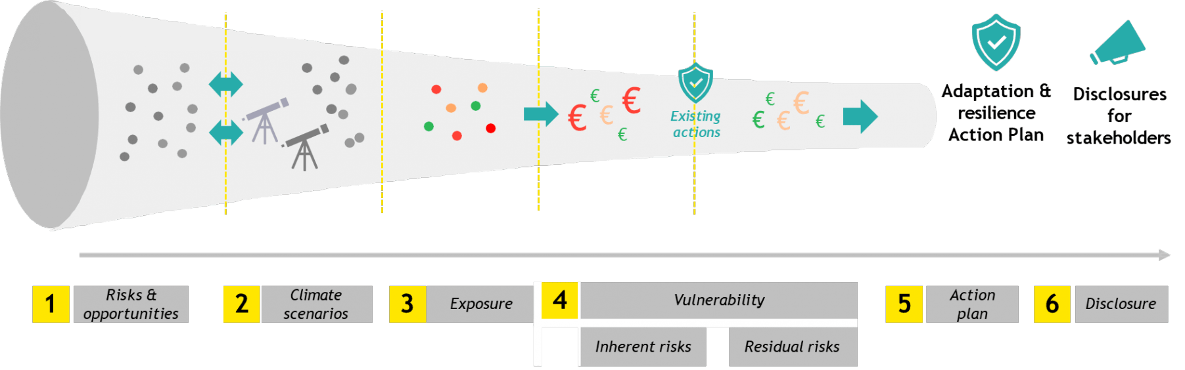
EY proposed a preliminary assessment of climate-related physical risks relevant for ASCO's operations by collating information from various sources:
- Insights from sectoral peers (annual reports, CDP responses)
- Expert contributions from EY professionals with experience within the sector
- Publicly available reports on climate exposure and adaptation, including those from the IPCC and TCFD.
From this literature review, ASCO, in collaboration with EY experts, has selected five physical risks deemed most critical to ASCO activities, thus establishing the framework for physical risk assessment (step 1). The list of identified risks along with associated indicators is presented in Table 2.
The following terminology needs to be defined before diving into next steps of the climate risk assessment methodology.
- Climate hazard: A physical process or event (hydro-meteorological or oceanographic variables or phenomena) that can harm human health, livelihoods, or natural resources.
- Exposure: The presence of people, livelihoods, species or ecosystems, environmental services and resources, infrastructure, or economic, social, or cultural assets in places that could be adversely affected by a hazard.
- Climate vulnerability describes the degree to which natural, built, and human systems are at risk of exposure to climate change impacts.

Climate scenarios and time horizons
Climate scenarios (step 2) are “a plausible description of how the future may develop based on a coherent and internally consistent set of assumptions about key driving forces and relationships. Note that scenarios are neither predictions nor forecasts but are used to provide a view of the implications of developments and actions.” (IPCC, AR6, 2021).
EY relies on an internal tool “EY Climate Analytics Platform” (EY CAP) which enables to provide climate-related information on the strategic location identified for ASCO’s activities. It provides the assessment of physical risks (acute & chronic) relying on IPCC climate scenarios. In EY CAP, these scenarios are the Shared Socioeconomic Pathways (SSP’s) derived from the IPCC AR6 report to compute EY in-house modelling indicators. These scenarios have been augmented with socioeconomic and macroeconomic attributes, considering climate policies implemented in the meantime as well as updated concentration pathways. For any given SSP, lower radiative forcing in 2100 implies greater mitigation stringency. A second key assumption in the framework is that different development pathways can lead to similar radiative forcing outcomes, i.e. that different SSP can be related to the same forcing outcome.

Figure 2: SSP scenarios coupled with radiative forcing levels
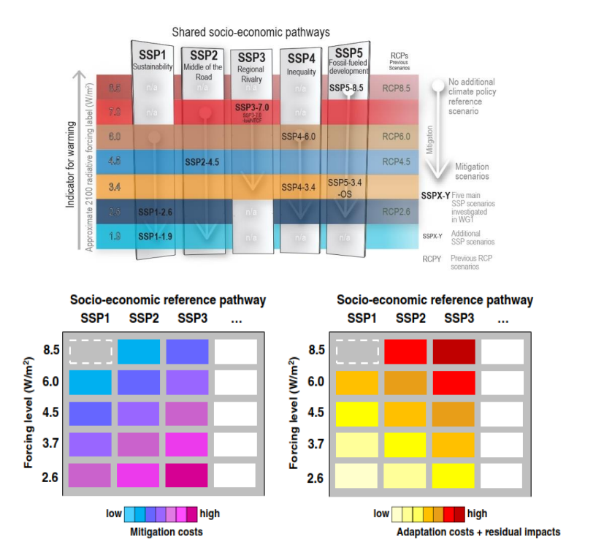
Each SSP is attributed a reference radiative forcing level (left side). The empty cell (dashed lines) illustrates that not all combinations of forcing levels and SSPs may be consistent (Source: Van Vuuren et al., 2014)

SSP2-4.5 is described by the IPCC as an intermediate scenario. GHG emissions peak around 2040, then decline. SSP2-4.5 can be seen of as the middle of the road scenario (no strong climate policies) taking into account the exhaustible character of non-renewable fuels. Current social, economic and technological trends continue, development and growth proceed unevenly depending on the country and the region. National and international institution work towards achieving sustainable development goals that progress slowly.
SSP5-8.5 projects the reasonable worst-case scenario and is widely used for climate risk assessment and stress-testing. SSP5-8.5 was specifically selected as a high-end baseline scenario and was not intended to be portrayed as the most likely “business as usual” no-policy outcome. It’s characterized by a development based on strong use of heavy fossil fuels and marked by high investments in health, education and new technologies. It’s also the adoption of resource – and energy – intensive lifestyles around the world. Finally, it’s a high economic growth and a rapid technological progress. It is important to note that climate variables values and impacts will only strongly differ with other scenarios in the long-term (2070 - 2100), while being close to others up to 2050.
In EY CAP, different time horizons have been defined by means of 20-year or 30-year timeframes following literature best practice. Indeed, climate change impacts and drivers are related to statistical long-term standing variations of climate drivers. Therefore, climate-related analysis does not address individual weather events (while meteorology does) but assess climate hazards frequency, intensity and special evolution shift along significant time periods. In the EY CAP application, each horizon gives an estimate of what could be the hazard value in the median year of the time period. In our case we selected 2030, 2040 and 2050, therefore to illustrate for 2030: 2021-2040 timeframe is used, for 2040 it’s 2031-2050, and for 2050 it is 2041-2070. Historical period is 1981 – 2010.

Sea Level Change methodology
Caspian Sea is an inland sea that is not related to global sea level rise of oceans due to glacier melting and thermal expansion and therefore requires a specific local climate analysis and model to represent the reality of the studied basin and accurately project future evolutions.
A recent study, overwide by the WCRP Working Group on Couples Modelling and published in a very reputable scientific journal Nature, was used in this report to analyze the Sea Level of the Caspian Sea. The study computed results from 15 multi-model CMIP6 approaches with different pathways scenarios: SSP2-4.5 and SSP5-8.5. Detailed methodology is available in the study Climate Driven 21st century Caspian Sea level decline estimated from CMIP6 projections.

Location and physical hazards
The analysis of exposure to physical hazards was performed on 5 different assets, chosen by ASCO, as presented in the table and map below. For each indicator and each point of the grid, the value displayed in EY CAP is computed by averaging the projections of several climate models for a given combination of {geography x scenario x horizon} and corresponds as such to the “median” value of the indicator for the given combination. The reason to use the median rather than the mean for climate indicators is that the mean can be heavily influenced by outliers or extreme values in the data set, while the median value is less sensitive to outliers and provides a better representation of the typical value in the datasets. To get a better understanding of the values’ distribution and to account for model variability, the minimum, maximum, 10th, 90th and 50th (median) of the indicator values across all climate models are computed. This way, EY CAP provides insights on the indicator distribution at a given grid point across the selected climate models, allowing a better understanding of the underlying uncertainty of the indicator value provided.

Table 1: List of assets included in the analysis
Asset Name | Asset Type | GPS Coordinates (Lat/Long)
Sangachal Terminal | Oil&gas specialized port | 40,2012 / 49,4812
Dubendi Terminal | Oil&gas specialized port | 40,4148 / 50,3393
Zygh Shipyard | Ship Repair and construction yard | 40,3522 / 49,9502
Aktau port | Commercial Port (outside ASCO assets) | 43,5975 / 51,1835
Turkmenistan Port | Commercial Port (outside ASCO assets) | 39,9843 / 53,0280

Figure 3: Location of assets included in the analysis
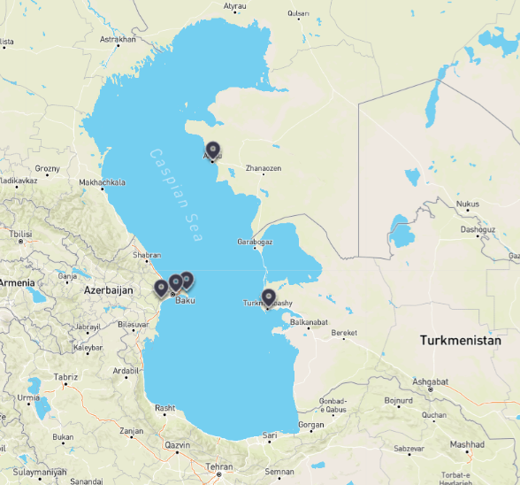
Figure 4 – Location of ASCO's assets included in the analysis
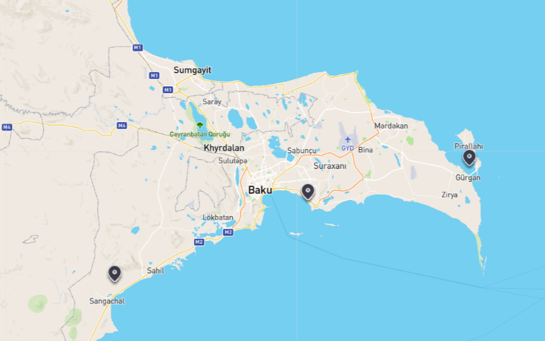
Additionally, as a request from the client, offshore platforms have been included as a general asset. Qualitative analysis of climate physical risks will be performed, mainly by desktop review, but the scope will not include quantitative analysis.
Initial results from our EY CAP tool and discussion with ASCO representatives regarding Azerbaijan and Caspian Sea climate and sectoral practices led to the following shortlist of risks for deep dive climate risk exposure assessment: Sea level change, flood, high temperature, heat and extreme weather. Sea level change is a particularly important climate risk as the Caspian Sea level has currently a decreasing trend and is threatening economic activity around the basin.

Limitations

Restrictions on report use
This report may be relied upon by the EBRD pursuant to the engagement agreement with EY. It should not be relied upon for any other purpose.
EY disclaims all liability to any party other than the EBRD for all costs, loss, damage and liability that the third party may suffer or incur arising from or relating to or in any way connected with the provision of the deliverables to the third party without our prior written consent. If others choose to rely in any way on the confirmation they do so entirely at their own risk. If the EBRD wishes to provide copies of our report to a third party, then our prior written consent must be obtained.

Basis of our work
EY has performed research and analysis using information and data made available by the EBRD and ASCO and information and data from a range of publicly available documents and reports.
We have not independently verified, or accept any responsibility or liability for independently verifying, any such information nor do we make any representation as to the accuracy or completeness of the information. We accept no liability for any loss or damage, which may result from your reliance on any research, analyses or information so supplied.
Any commercial decisions taken by the EBRD and ASCO are not within the scope of our duty of care and in making such decisions you should take into account the limitations of the scope of our work and other factors, commercial and otherwise, of which you should be aware of from the sources other than our work.
The client’s management shall be fully and solely responsible for applying independent business judgment with respect to the services and work products provided by us, to make implementation decisions, if any, and to determine further courses of action with respect to any matters addressed in any advice, recommendations, services, reports or other work products or deliverables.
The nature and content of any advice we provided have necessarily reflected the specific scope and limitations of our engagement, the amount and accuracy of information provided to us and the timescale within which the advice was required.

Physical climate-related risks universe for ASCO

Table 2: List of indicators relevant for the climate change analysis
Peril | Subperil | Hazard type | Indicator Long Name | Unit | Description
Sea level change |  | Chronic | Sea level rise | m | Mean local sea level change compared to the reference period baseline
Flood | Riverine flooding | Acute | Fluvial flooding (100-year return period) | m | Average riverine flooding elevation related to a 100-year frequency event
Flood | Coastal flooding | Acute | Tidal flooding (100-year return period) | m | Average coastal flooding elevation related to a 100-year frequency event
Flood | Surface water flooding | Acute | Pluvial flooding (100-year return period) | m | Average pluvial flooding elevation related to a 100-year frequency event
Temperature | Average temperature | Chronic | Air surface temperature | °C | Air surface temperature
Temperature | Maximum temperature | Chronic | Annual maximum daily temperature | °C | Annual maximum daily temperature
Heat | Heat wave | Acute | Heat wave frequency | Index | Number of heat wave events within a year. A heat wave occurs when daily minimum and maximum temperatures exceed 22 °C and 30 °C, respectively, over at least 3 days.
Heat | Heat wave | Acute | Heat wave maximum length | days | Longest series of at least 3 consecutive days with daily minimum temperature above22 °C and daily maximum temperature above 30 °C
Heat | Heat Stress | Acute | Wet bulb global temperature (extreme threshold) | days | Number of days per year with daily maximum WBGT>32
Heat | Heat Stress | Acute | Wet bulb global temperature (very high threshold) | days | Number of days per year with daily maximum WBGT>30
Heat | Heat Stress | Acute | Wet bulb global temperature (high threshold) | days | Number of days per year with daily maximum WBGT>28
Heat | Heat Stress | Chronic | Annual THI (temperature humidity index) load | °C | Annual temperature humidity index cumulative load above 70°C (very high threshold for livestock heat stress)
Heat | Heat Stress | Acute | Annual maximum of THI (temperature humidity index) | °C | Annual maximum of daily temperature humidity index
Extreme Weather | Atmospheric instability | Acute | Annual maximum Convective Available Potential Energy | J/kg | Annual maximum of the daily Convective Available Potential Energy
Extreme Weather | Wind gust | Chronic | Maximum wind gust speed (100-yearn return period) | °C | Annual maximum of daily wind gust speed (100-year frequency event)
Extreme Weather | Wind gust | Chronic | Maximum wind gust speed | m/s | Annual maximum of daily wind gust speed
Extreme Weather | Wind gust | Chronic | Maximum wind speed | m/s | Annual maximum of the daily maximum wind speed

Results of exposure analysis for physical risks

Sea Level Change
Caspian Sea is an inland sea located in a climatic semi-arid environment and is particularly vulnerable to climate change as its water budget is predominantly maintained by precipitation and evaporation fluxes and inflows by streams and runoffs. Even small variations in these fluxes over a long-term scale can affect the sensitive balance of the overall water quantity and therefore the sea level. Caspian Sea has previously experienced sharp changes in water level with a 3m decline in the 20th century followed by an increase until 1995. Recent observations of Caspian Sea indicate a drop in the water level by nearly 7cm/year for the period 1996 – 2015 and an intensification in recent years with a 10cm/year drop between 2006 and 2021.
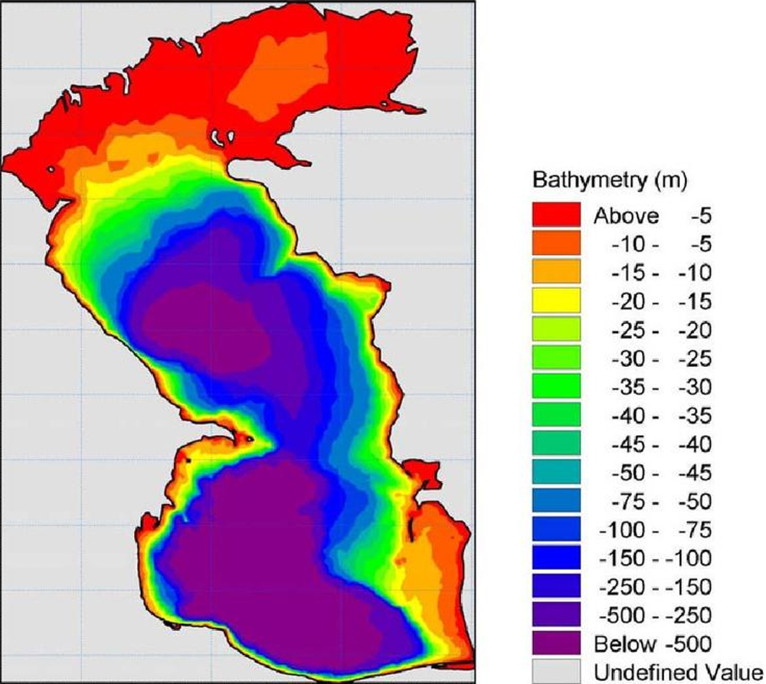
In all studied climatic scenarios, projected evaporation increase due to higher temperature and global warming is significantly larger than precipitation increase integrated over the Caspian Sea catchment basin, resulting in an increasingly negative water balance over the 21st century. The general sea level of the Caspian Sea is expected to decrease in 2050 by 3m under the SSP2-4.5 scenario and by 5 meters in 2050 under SSP5-8.5 scenario. By the end of the century, the water level is projected to have a drop by 8 meters compared with 2020 under SSP5-8.5 climatic scenario and up to 14 meters under SSP5-8.5 climatic scenario.
Figure 5 - Depth map of the Caspian Sea²

The red and orange area of the figure above (representing sea depth inferior to 10 meters) will dry up by the end of the century. In both climate scenarios and especially in the worst-case scenario, the SSP5-8.5 scenario, a large part of the northern Caspian Sea will dry up by 2050, leaving a large part of the Kazakhstan and Russia without direct access to the sea.
The depth of the Caspian Sea close to Baku, including the location of various offshore platforms such as Oil Rocks, is less than 15 meters and this area will therefore be strongly impacted by the predicted sea level change.

General exposure results for other climate risks
For each peril and asset, using our EY CAP tool, an exposure has been calculated and reflected according to 5 levels – from very low (1) to very high (5) – under two climate scenarios, for the historical period and for 2030s, 2040s and 2050s as described in the methodological note above.
At the peril level, the exposure has been aggregated by considering the maximum exposure of the peril’s indicators. The first table shows results for ASCO own assets while the second table display average exposure levels for selected main commercial ports in the Caspian Sea.
Details of exposure levels by asset are in appendix 2.
Table 3: AVERAGE RISK LEVEL AND EXPOSURE ANALYSIS FOR ASCO ASSETS
Category | Historical exposure | Trend vs. historical | 2030 risk level |  | 2040 risk level |  | 2050 risk level
Category | Historical exposure | Trend vs. historical | Scenario SSP2-4.5 | Scenario SSP5-8.5 | Scenario SSP2-4.5 | Scenario SSP5-8.5 | Scenario SSP2-4.5 | Scenario SSP5-8.5
Flood | 2 | Equal | 2 | 2 | 2 | 2 | 2 | 2
Temperature | 3 | Equal | 3 | 3 | 3 | 3 | 3 | 3
Heat | 3 | Equal | 3 | 3 | 3 | 3 | 3 | 3
Extreme Weather | 3 - 4 | Slightly  Increase | 4 | 4 | 4 | 4 | 4 | 4

Table 4: AVERAGE RISK LEVEL AND EXPOSURE ANALYSIS FOR OTHER PORTS
Category | Historical exposure | Trend vs. historical | 2030 risk level |  | 2040 risk level |  | 2050 risk level
Category | Historical exposure | Trend vs. historical | Scenario SSP2-4.5 | Scenario SSP5-8.5 | Scenario SSP2-4.5 | Scenario SSP5-8.5 | Scenario SSP2-4.5 | Scenario SSP5-8.5
Flood | 1 | Equal | 1 | 1 | 1 | 1 | 1 | 1
Temperature | 3 | Equal | 3 | 3 | 3 | 3 | 3 | 3
Heat | 3 | Increase | 3 | 3 | 3 | 4 | 4 | 4
Extreme Weather | 3 | Increase | 4 | 4 | 4 | 4 | 4 | 4

- Flood: Analyzed assets are subject to a low exposure to flood, either from precipitation or from a river. Zygh Shipyard is the only asset slightly exposed to a potential flooding due to high precipitation levels, but flooding levels remain very low, around 10 cm, and tend to decrease under both climate scenarios 4.5 and 8.5. This suggests that ASCO's assets are not very vulnerable to flooding.

- High temperature and heat: Baku area is located in an arid region and has historically been subject to summer high temperatures and heat. Heat exposure has historically been between moderate and is expected to increase in both climate scenarios. Maximum temperatures could increase by up to 5°C in 2050 under scenario SSP5-8.5. Additional details on evolution of temperature and heat conditions are detailed in the next section. To adapt to increasing temperatures and heatwaves, ASCO could implement measures such as optimizing cooling processes in buildings, using heat-resistant materials in infrastructure, adjust the color of the asphalt on the ground of the ports and develop an adaptation plan for workers safety in case of a heat wave.

- Extreme weather: The historical exposure to extreme weather is moderate. The extreme weather indicator is composed of two main risks: atmospheric instability (which is conducive to thunderstorms and storms) and high wind and gusts. While high wind and gust are expected to remain stable through the 2030s to 2050s under both scenarios, with moderate exposure, atmospheric instability is expected to increase and reach a high level of risk exposure by 2030 under scenario SSP5-8.5 and by 2040 under scenario SSP2-8.5. ASCO should keep the same standards and pursue its continuous improvement processes in term of preparedness to cope with extreme weather events, as they are likely to increase in the future, by reassessing periodically emergency plans for events that could disrupt operations in order to protect the welfare of employees.

Focus results on high temperature and heat for ASCO’s assets
While the exposure level for high temperatures, heatwaves and heat stress remains moderate (level 3) for all three ASCO assets through 2050, important increases are still expected. Graphs below present the main climate indicators of heat and high temperature.
The first graph represents the evolution of heatwave frequency and gravity through various times horizons and climate scenarios. A heat wave occurs when daily minimum and maximum temperatures exceed 22°C and 30°C, respectively, over at least 3 days. Heatwave frequency is therefore expected to almost double by 2030 in both studied climate scenarios while its maximum length, measuring the gravity of heatwaves, will increase by five times in 2050 under SSP5-8.5 scenario and by three times in SSP2-4.5 scenario.
The second graph represents the evolution of mean and maximum annual temperatures across the three ASCO assets analysed. Both indicators increase by an average of 4°C by 2050 in both scenarios.
Particularly high temperatures and extensive heatwaves are especially dangerous for employees and affect both their health and productivity. Safety guidelines should be in line with local regulations and strengthen with medical guidance to protect employees from high temperatures. Mitigation measure such as retrofitting grounds and roofs into lighter colors can also be considered by ASCO. For instance, painting rooftops in white could prove to decrease overall temperatures in buildings by 1 to 5°C and decrease the need for air conditioning to keep temperatures stables for employees in their workplaces. By setting the air conditioning by 1°C warmer could decrease the average amount of electricity used by 10%.
Figure 6 - Evolution of high temperature and heat indicators

4. Analysis of the potential impact of perils
The following table provides a comprehensive overview of the potential impacts that selected physical risks may have on the operations of ASCO. These risks, which range from sea level change to extreme temperatures and storms, can affect various aspects such as physical damage to assets, operational discontinuities and employee’s health condition. As all selected assets have been analyzed as subject to low exposure to flood, this risk was excluded from the following analysis.
The construction of this table is based on insights drawn from reports of similar enterprises and is rooted by our prior analysis regarding the exposure analysis and vulnerability of ASCO's assets. This structured approach enables us to anticipate challenges and strategically prioritize the course of action to ensure resilience and continuity in the face of evolving climate-related risks.
The various potential impacts do not take into account the different adaptation policies already implemented by ASCO or its clients.

Table 5: Potential impacts that identified physical risks could have on ASCO's operations.
Type | Category | Risk | Impacts (indicative)
Physical | Chronic | Sea level change | Operating conditions:  - Sea level decrease can lead to reduced accessibility to ports and harbors, requiring necessary adjustments in shipping routes and schedules weather temporarily to cope with port infrastructure upgrade or permanently. This could increase transit times and operational costs.  - Additionally, disruptions in shipping schedules could lead to delays in cargo delivery, affecting customer satisfaction and potentially leading to a loss of business.  Infrastructure Modifications and fleet adaptation:  - Ports and docking facilities may require modifications to accommodate the new water levels. Lower water levels could involve dredging to deepen channels and harbors, and adjusting or rebuilding docking infrastructure, potentially multiple times as water level decreases. This would generate significant capital expenditures.  - The company might need to consider investing in smaller or vessels with adjusted characteristics that can operate more effectively in shallower waters, which could entail significant investment in new ships or retrofitting existing ones.  Specific impacts for oil and gas offshore platforms:  - Operational adjustments: Lower Sea levels may expose additional hazards to navigation around the platform, such as previously submerged obstacles or changes in seabed topography, requiring alterations to operational procedures and safety measures and leading to logistical challenges and potential delays in operations.  - Infrastructure Strain: The design of offshore platforms is based on specific water depth conditions. A decrease in sea level could affect the structural integrity of the platform, potentially necessitating engineering assessments and reinforcement works.  - Drilling and Extraction Complications: Changes in water pressure and seabed conditions could impact drilling operations and the efficiency of oil extraction, potentially requiring modifications to equipment and techniques used in the extraction process.
Physical | Chronic and acute | High temperature and Heat | Operating conditions:  - Higher sea temperatures can decrease the efficiency of engines, leading to increased fuel consumption and higher operating costs, as well as greater greenhouse gas emissions depending on the engine fuel.  - Higher temperatures can lead to more rapid wear and tear on vessel components, necessitating more frequent maintenance to cope with accelerated deterioration and potentially leading to higher operational costs. Assets lifetime could be shorter leading to more capital expenditures and higher allowance to annual depreciation for a given asset.  - The need for additional cooling for both cargo and ship machinery to prevent overheating could strain existing systems and require upgrades or replacements, incurring further capital and energy costs.  - Certain types of cargo, especially those carrying perishables goods, are sensitive to temperature changes. Increased temperatures could compromise cargo integrity, leading to potential losses, insurance premium increase to insure the integrity and value of the goods and claims against the company.  Health and safety of employees:  - The elevated temperatures could pose serious health risks to employees, especially the ones working outdoors (crews of boats, at shipyards or at ports), including heat exhaustion and heatstroke, necessitating stringent heat safety protocols and potentially affecting manpower availability.  - Elevated temperatures could lead to a revision of the procedures in case temperatures hit a certain threshold. Specific protocols, shorter shifts or installation/upgrade of equipment could be necessary to protect the employee integrity and working conditions.  Specific impacts for oil and gas offshore platforms:  - Operational Efficiency Decline: Higher temperatures can lead to decreased efficiency of machinery and equipment due to overheating, necessitating additional cooling measures or causing more frequent shutdowns for maintenance, thus affecting overall productivity.  - Increased Cooling Requirements: The need for enhanced cooling systems for both the platform's machinery and the living quarters for the crew could result in significant additional energy consumption and operational costs, depending on the climate scenario.  - Increased evaporation rates: Higher temperatures could also lead to increased evaporation rates of any water used in the drilling process, potentially affecting water management practices and costs.
Physical | Acute | Extreme weather (storms and strong wind) | Operating conditions:  - Strong winds and atmospheric instability can lead to rough seas and hazardous navigation conditions, causing delays in shipping schedules, rerouting of vessels, and potential temporary suspension of services in affected areas.  - Vessels may need to consume more fuel to maintain schedules or navigate around severe weather, leading to higher operational costs. Additionally, the need for increased power to stabilize vessels in rough conditions can further elevate fuel consumption.  - The risk of cargo damage or loss increases with severe weather conditions, potentially leading to financial losses from damaged goods and liability claims from customers.  Infrastructure Damage:  - Port facilities and infrastructure may be at risk of damage from strong winds and storms, leading to costly repairs and operational delays. This includes loading and unloading equipment, storage facilities, and mooring structures.  Specific impacts for oil and gas offshore platforms:  - Operational Disruptions: Strong winds and severe weather conditions can lead to operational shutdowns or slowdowns for safety reasons. This could delay drilling and production activities, affecting the company's output and timelines. The logistics of transporting personnel, equipment, and supplies to and from the platform can also be severely impacted by adverse weather conditions, leading to additional delays and increased costs.  - Increased Safety Risks: The safety of personnel becomes a critical concern under such conditions. Evacuation procedures may need to be initiated in extreme cases, and additional safety measures would be required, potentially leading to increased operational costs.  - Infrastructure Damage: Offshore platforms and associated infrastructure, such as pipelines and support vessels, are at risk of damage from strong winds and rough seas. Repairing such damage can be costly and time-consuming, leading to further operational delays.  - Environmental Risks: Strong winds and rough seas increase the risk of environmental incidents, such as oil spills, which can have significant environmental and financial consequences, including cleanup costs, penalties and legal actions.

Key takeaways of the analysis of the potential impact of perils on ASCO’s assets and Caspian Sea ports and its clients for the studied risks
Sea level decrease: Significant operational challenges for maritime transportation companies, including reduced port accessibility, necessitating costly infrastructure modifications and potential adjustments in shipping routes. These changes could lead to increased operational costs and a need for fleet adaptation, ultimately impacting revenue negatively.
High temperatures and heat: Operational efficiency of engines may be decreased, additional cooling measures and more frequent maintenance of the vessels. Health risks for employees is also increased and workforce productivity is likely to be affected.
Extreme weather: Operational disruptions, increased fuel consumption, and potential damage to vessels and infrastructure. The safety of the crew and the integrity of cargo are at heightened risk, potentially resulting in financial losses from damaged goods and liability claims. Workforce productivity is also likely to be affected.
Key takeaways of the analysis of the potential impacts of perils on Oil & Gas offshore platforms
Sea level decrease: Safety concerns over the structural integrity of the platform and drilling and extraction complications as water pressure decreases.
High temperatures and heat: Decreased operational efficiency due to machinery overheating, necessitating additional cooling measures and potentially causing frequent shutdowns for maintenance. The health and safety of the workforce are at increased risk, potentially affecting productivity.
Extreme weather: Potential operational shutdowns and infrastructural damage to the platform. Necessity to revise the health and safety procedures, including to cope with emergencies having different characteristics.

Analysis of transition risks

Methodological approach
During society’s transition from a carbon-intensive to a more sustainable and climate-resilient economy, organizations encounter a spectrum of challenges known as transitional climate risks. As organizations are facing evolving climate-related policies, regulations, emerging technologies, and dynamic market conditions, they would benefit in strategically position themselves by anticipating them to thrive in a low-carbon future.
The TCFD delineates a comprehensive framework for categorizing transition risks associated with climate change, which encompasses four main categories:
- Technological
- Policy and legal
- Market
- Reputational
The following table showcases the 5 sub-risks selected by ASCO, which fall within three of the 4 categories mentioned hereabove.
Table 6: List of transition risks identified for ASCO
Category (TCFD) | High-level transition risks | ASCO-specific risks and opportunities
Policy and Legal | Increase of sustainability reporting mandates | - Possible use of consultancy firms to help enhance the competencies within the company  - Affects both HR (people that are specialized and have competencies) and technology: being able to track consumption per ship, per commercial route and be able to gather all that data and treat it
Policy and Legal | Increased pricing of GHG emissions | - Direct costs due to EU-ETS (scope 1 emissions)  - Potential direct cost on GHG emissions due to additional legislations  - Potential non-financial costs due to increased GHG emissions-related policies forcing clients’ to decarbonize their supply chain, and notably transportation segment.
Technology | Mandates on low carbon fuel use and energy efficiency | - Direct costs due to higher prices for alternative fuels or vessel retrofitting.  - Suppliers of low carbon might face higher demand from maritime companies, which might not be in a position to match the demand within the mandate compliance timeframe, and could increase prices.
Market | Limited biofuel or e-fuel availability | - Difficulties to secure enough alternative fuels may result in higher fuels prices and potentially fines due to non-respect of mandates.  - Difficulties to secure e-fuels in ASCO region that would match minimum sustainability requirements drawn from IMO guidelines or another relevant regulation
Market | Reduction of oil and gas demand | - Potential decrease in oil and gas demand may reduce exploitation and exploration activities within the Caspian Sea, affecting ASCO’s activities.  - Decreased demand from oil and gas clients might result in underused assets that would generate less revenue while amortization allowances would remain steady. Such assets’ value for resale might decrease because of less companies targeting such oil & gas maintenance activities.

Our analysis of these transition risks is based on our publicly available sources, knowledge of the company (interviews with key representatives and data provided by ASCO), the sector and the region, complemented by insights from reputable sources and frameworks such as the Task force on Climate-related Financial Disclosures (TCFD) and industry-specific climate resilience reports.
Transition risks are inherently less tangible compared to physical risks. Unlike physical risks, which often have clear, quantifiable impacts, transition risks involve shifts in policy, technology, legal and market dynamics that are less easily measured, because most impacts are indirect (e.g., pass through of carbon tax to purchased goods and services, long-term ban of operating assets, public policies shifting to greener industries, impacting turnover in the long term, a climate-related disaster that would become a reputational risks by generating an unusual focus of NGOs on the company activities with associated bad publicity and media coverage or reluctance from clients to engage business activities or from talents to apply to vacancies in a given company). Consequently, the quantification of transition risks is challenging and assessing their potential effects with the same precision as physical risks is not possible, but evaluating their potential impact and discussing mitigation solutions remain a necessity to improve long-term climate resilience and strengthen the risk matrix featuring in the company’s risks management policy.

2. Analysis a sub-risk level

Sustainability reporting mandates
The transition risk associated with sustainability reporting mandates presents a significant challenge for ASCO, as international regulations on GHG emissions in the maritime sector grow increasingly stringent. Both European Union and International Maritime Organization (IMO) regulations now require ship operators to rigorously monitor and report data on fuel consumption, GHG emissions, and carbon performance metrics like the Carbon Intensity Indicator (CII), the Energy Efficiency Existing Ship Index (EEXI), and emissions under the EU Emissions Trading System (ETS). Additionally, new environmental, social, and governance (ESG) reporting standards are being incorporated into law globally, necessitating robust plans for fuel management and decarbonization. For ASCO, failing to meet these mandates could result in substantial financial penalties, which are structured to increase with ongoing non-compliance.
- Investments needed in data technologies for tracking new indicators
To meet these evolving requirements, ASCO would benefit in investing in advanced technology to collect, verify, and report emissions data in compliance with regulatory standards. This will likely involve acquiring software systems for managing fuel consumption, emissions tracking, and integrating data across fleet, operations, and technology teams. Ensuring to collect the highest quality of data to comply with appropriate carbon performance metrics will require the implementation of real-time monitoring systems to track fuel consumption and emissions at the voyage, ship, and fleet levels.
ASCO will be required to report on several key performance indicators (KPIs) associated with GHG emissions and energy efficiency, as detailed below:
Table 7: Example of recently introduced or upcoming indicators impacting ship reporting
KPI to be reported | Application date | Coverage | Vessel threshold (gross tonnage)
Carbon Intensity Indicator - CII: GHG emissions per ton of cargo per mile traveled. | Annual reporting 2023, ratings in 2024 | Global | >5000 GT, all ships
Energy Efficiency Operational Indicator- EEOI: real-time tracking of CO₂ emissions per freight ton per mile | 2023 | Global | >400GT, existing fleet
Energy Efficiency Existing Ship Index - EEXI: CO₂ emissions due to fuel consumption by freight ton and mile in real time | 2023 | Global | >400GT, all ships
GHG emissions (MRV Maritime and EU ETS) : fuel consumption, distance traveled, and time at sea per voyage | 2024 and 2025 | EU/EEA journeys, 50% of emissions for EU-Non-EU routes | 2024: >5000GT cargo ships  2025: >400GT, offshore fleet and cargo ships
Emission intensity WTW (Fuel EU Maritime): GHG emissions from fuel extraction, production, refining, transport + direct emissions from fuel combustion / energy produced by fuel | 2025 | EU/EEA journeys, 50% of emissions for EU-Non-EU routes | >5000GT

These indicators are governed by detailed guidelines such as the Ship Energy Efficiency Management Plan (SEEMP) set by the IMO. To report effectively, ASCO must monitor and document key parameters, including fuel consumption, ship tonnage, distances traveled, and the methodologies used to calculate emissions. In addition, ASCO will need to provide a comprehensive plan outlining measures to achieve the required emissions reductions, along with self-evaluation and improvement processes. All supporting documentation must be made available to certification teams, including ship plans, engine specifications, propulsion system details, and performance test reports.
- Governance and team adaptation
To effectively track emissions data and ensure progress toward emissions targets, ASCO will need to establish a robust internal governance framework. This will likely involve recruiting additional team members or reassign tasks and responsibilities among its workforce. In addition, collaboration will need to be enhanced across data, strategy, regulatory, fleet, and operations teams. As an example, Maersk estimates that the costs of regulatory reporting, including hiring specialized engineers and system developers, could reach tens of thousands of euros annually, depending on fleet size. It is also crucial to regularly train staff on new regulatory requirements and best practices for emission reduction, ensuring that the entire organization is aligned with the latest standards and prepared to meet future challenges.
To support these efforts, ASCO will need to invest time and resources including hiring specialized consultants to navigate complex regulatory requirements and ensure ongoing compliance with international GHG regulations, particularly under the EU ETS. Verification teams will be essential for data validation, and ASCO can expect additional costs for third-party audits and compliance checks.
Furthermore, ASCO may need to invest in emission-reduction technologies (e.g., hull optimization, heat recovery systems) to comply with performance standards like the Carbon Intensity Indicator (CII). The capital expenditures for these technologies could reach several million euros per vessel, depending on the size of the fleet and the scope of retrofits required.

Increasing pricing of GHG emissions
Several regulations and public policies are implementing or considering carbon taxes to finance the transition to a low carbon future. Carbon taxes on GHG emissions are a direct additional cost for companies that needs to be considered for the annual budget review and therefore future policies on this topic may represent a significant transition risk for ASCO. This risk will be assessed in two different segments. for the first will cover ASCO current and future activity in the Mediterranean Sea, where legislation on carbon pricing already exists, while the second will focus on the Caspian Sea activities.
    - Mediterranean Sea GHG emission pricing
EU-ETS legislation for shipping sector came into effect on January 1st, 2024, and affect all cargo and passengers’ ships above 5000 gross tons. On a company level, CO2 emissions (and CH4 (methane) and N2O (nitrous oxide) emissions starting from 2026) of ships travelling to or from an EU port should be accounted for and equivalent allowances should be surrendered. Non-compliance may result in penalties such as fines and ship detentions. These allowances are tradable within the carbon market and their quantity is determined by a general cap that will progressively decrease in accordance with EU trajectory to a low-carbon future.
Currently, ASCO has a limited activity within the European boundary with approximately 14% of shipping turnover in the Mediterranean Sea and less than 3% of activity with European ports. For the 2023 year, if EU-ETS was effective and based on the data provided by ASCO, the impact would have represented approximately 1 600 tCO2 emissions and 130 000€ with an average price of 80€/tCO2 (excluding free allowances that ASCO could benefit).
As the cap of allowance of the EU trading system will decrease, the trading allowances will become less common, impacting the trading price of carbon. Several projections estimate an average price of a carbon ton to be between 70€ and 150€ for the 2025 – 2030 period and then to stabilize. However, the price remains highly volatile on a day-to-day basis as the market price is regulated by supply and demand.
Depending on ASCO’s international strategy development, carbon price to be paid due to EU-ETS cap and trade system could represent a significant expense in the future years. This expense could be charged to clients and therefore not be a direct additional fee, but will affect ASCO competitiveness. However, ASCO will remain the legally accountable entity for monitoring and reporting to the EU all emissions and allowances.
    - Caspian Sea GHG emission pricing
Currently, there is no legislation on carbon pricing in the countries surrounding the Caspian Sea basin, nor are there any discussions about the creation of such projects. Therefore, it is unlikely that any regulations taxing carbon will emerge in the coming years in this region, even though international pressure and rising concern over accelerating climate change could eventually change the situation.
However, it may be worthwhile to envision a low-carbon world that aligns with the Paris Agreement in order to estimate the effort ASCO would need to make and the economic impact it would entail. The EY CAP tool allows for projections into various future scenarios and estimates the potential carbon price in Azerbaijan by 2050 and its impact for ASCO’s activities. We have selected two NGFS scenarios to facilitate this projection:
- Net Zero 2050: This scenario limits global warming to 1.5°C through stringent climate policies and innovation, reaching global net zero CO2 emissions around 2050.
- Below 2°C: In this scenario, policies are gradually being tightened, allowing a 67% chance of limiting warming to less than 2°C. This scenario assumes that climate policies are introduced immediately and become gradually more stringent though not as high as in Net Zero 2050.
The EY CAP Tool projects under both scenarios ASCO’s emissions and the associated carbon costs the company would have had to pay for its scope 1 and 2 emissions. The table below presents the key findings of the study.
Table 8: ASCO's emissions and the potential carbon costs for Scope 1 and 2 emissions
Scenario | 2030 |  | 2040
Scenario | Carbon price | Cost for ASCO | Carbon price | Cost for ASCO
Net Zero 2050 | 260 $/tCO2 | 40 M$ | 490 $/tCO2 | 65 M$
Below 2°C | 65 $/tCO2 | 10 M$ | 115 $/tCO2 | 15 M$
These scenarios were selected as they would align with the objective of the Paris Agreement and because of the higher transition risks, including for carbon pricing, they entail for companies and the society. Even though they are unlikely, they enable us to acknowledge what it would take to commit to a low-carbon future. Specifically, for ASCO, 10 M$ represent 7% of annual turnover generated from shipping in 2023, which represent an important cost.
    - Pressure and opportunities for ASCO’s market share
ASCO, as a key contributor to its clients' Scope 3 emissions, is facing mounting pressure to deliver low-carbon maritime transport solutions. Initiatives such as the Science-Based Targets Initiative and the Transition Pathway Initiative are prompting companies to embed stringent sustainability criteria into their procurement processes. Without a proactive approach, ASCO risks being sidelined in critical tenders, particularly by clients committed to ambitious climate goals like Well Below 2 Degrees (WB2D).
In Europe, where ASCO seeks to expand, businesses are under increasing regulatory pressure to decarbonize their supply chains. A significant driver of this shift is the Corporate Sustainability Reporting Directive, which mandates that large companies disclose comprehensive data on their environmental and social impacts, including Scope 3 emissions. These emissions, encompassing the carbon footprint of logistics and transport operations, are becoming a focal point for clients aiming to achieve their own sustainability objectives.
This regulatory landscape compels companies to demonstrate meaningful reductions in emissions across their value chains, including choosing transport providers that offer low-carbon solutions. In many sectors, such as retail, mining, agriculture, energy, and electronics, maritime transport accounts for a significant share of scope 3 emissions, and contributes up to 10% of total emissions depending on the industry. For maritime carriers like ASCO, aligning with stricter environmental standards and supporting clients' decarbonization strategies is becoming increasingly important. Failing to adapt could result in the loss of critical contracts, as businesses increasingly favor partners who facilitate compliance with these regulations and advance their sustainability goals.
Conversely, ASCO has a significant opportunity to differentiate itself by anticipating these demands. By adopting ambitious decarbonization strategies and offering innovative, low-carbon transport solutions, ASCO could position itself as a preferred partner, capturing new market opportunities and strengthening its competitive edge in a rapidly evolving industry.

Regulatory mandates on low-carbon fuel use and energy efficiency
ASCO faces growing exposure to regulatory mandates aimed at reducing carbon intensity and improving energy efficiency across the maritime sector. The IMO’s revised greenhouse gas strategy, adopted in 2023, sets indicative targets to reduce international shipping's annual GHG emissions by at least 20% (aiming for 30%) by 2030 and at least 70% (aiming for 80%) by 2040, compared to 2008 levels, and aims for net-zero emissions by 2050. It also includes a new level of ambition relating to the uptake of zero or near-zero GHG emission technologies, fuels and/or energy sources which are to represent at least 5%, striving for 10%, of the energy used by international shipping by 2030 . Reaching these goals will require significant efforts to align corporates decarbonization strategies to shifts towards low-carbon fuels, such as LNG, biofuels methanol, and ammonia, as well as the adopt advanced energy-efficiency technologies. European regulations, including the EU Emissions Trading System (ETS) and FuelEU Maritime, impose additional pressures on ASCO to comply with stricter carbon reduction standards, particularly given its European fleet operations and planned expansions. Complying with these mandates is likely to result in increased fuel procurement costs for vessels transitioning to low-carbon fuels, as well as emissions-related expenses for vessels delayed in moving away from fuel oil. Additionally, retrofitting existing vessels with required energy-saving technologies—such as hull optimization and heat recovery systems— may incur significant costs. These improvements could require capital investments estimated at approximately $1-15 million per vessel, depending on the technology used, the scale and scope of modifications. These developments underscore the importance of strategic fleet renewal or adaptation and investment in new, low-emission ships to ensure regulatory compliance and optimize operational costs over the long term.
- Strengthening regulatory measures: a binding shift in global and European standard
The maritime sector is under increasing regulatory pressure to reduce carbon emissions and improve energy efficiency. Key frameworks, such as the Ship Energy Efficiency Management Plan (SEEMP), Energy Efficiency Design Index (EEDI), and Energy Efficiency Existing Ship Index (EEXI), along with the inclusion of maritime emissions in the EU ETS, underscore the sector's commitment to GHG reductions. The IMO's recent GHG strategy mandates a 40% reduction in emissions per transport work, as an average across international shipping, by 2030 (compared to 2008 levels), while EU initiatives like FuelEU Maritime and the expanded EU ETS introduce ambitious decarbonization targets specific to the European fleet.
From 2024, ASCO will be required to purchase carbon allowances for CO₂ emissions within EU/EEA ports, with emissions pricing extending to cover methane and nitrous oxide by 2026. FuelEU Maritime, set to take effect in 2025, will enforce annual reductions in well-to-wake (WtW) GHG intensity for vessels over 5,000 GT, further encouraging the adoption of low-GHG fuels, shore power, and wind-assisted propulsion. These standards aim to reduce fuel emissions intensity by 2% by 2025 and by 80% by 2050. Compliance with these increasingly stringent requirements compels ASCO to adopt advanced fuel-saving technologies and low-carbon fuels to keep pace with evolving emissions thresholds and remain competitive.
- Prospective investment options for ASCO
The tightening of energy efficiency and emissions regulations is expected to impact ASCO’s operational and maintenance expenses. To meet these standards while maintaining its growth strategy in European markets, ASCO will need to invest in five key strategies, each with varying levels of potential for reducing vessel energy intensity:
Table 9: key investment strategies for ASCO to achieve vessel energy efficiency standards
Measure | Potential for reducing the energy intensity of vessels
Logistics and digitalization: speed reduction, vessel utilization, vessel size, alternative routes | >20%
Hydrodynamics: hull coating, hull-form optimization, air lubrication, cleaning | 5-15%
Machinery: machinery efficiency improvements, waste-heat recovery, engine de-rating, battery hybridation, fuel cells | 5-20%
Energy: LNG, LPG, biofuels, electrification, methanol, ammonia, H2, wind power, nuclear | 0-100%
Ships exhaust post-treatment: Carbon Capture and Storage | 0-90%

Initial measures, such as optimizing operations and applying minor retrofits, could yield notable fuel savings with relatively low capital outlay. However, more extensive investments in alternative fuels and carbon capture systems will require a considerable amount of capital but offer the highest potential emissions reductions, from 0% to 100%.
The shift to renewable and low-carbon fuels is essential to comply with new carbon intensity standards, yet it involves costly adaptations or entirely new vessel designs. Key pathways include:
- Biofuels offering a straightforward transition as they work with many existing engines, allowing blends (20-30%) without major changes. Sourced from renewable materials like algae and waste, they are sustainable but costly, and higher blends may require engine upgrades.
- E-fuels (e.g., green hydrogen, ammonia): produced with renewable energy, offering low emissions but needing substantial modifications, including larger storage tanks, 2.3 to 4.3 times larger than those for traditional VLSFO. Therefore, new e-fuel-compatible vessels could cost about 11-16% more, while conversions of existing vessels range could from 10-16% (methanol) to 19-24% (ammonia), depending on pre-existing preparation. E-fuels are considered also 3 to 5 times more expensive than traditional fuels.
- LNG provides lower CO₂ emissions than heavy fuel oil (HFO) and works in dual-fuel engines for flexibility. However, it requires investment in storage and bunkering and offers only a partial solution toward decarbonization, making it suitable as an interim measure while other low-carbon options develop.
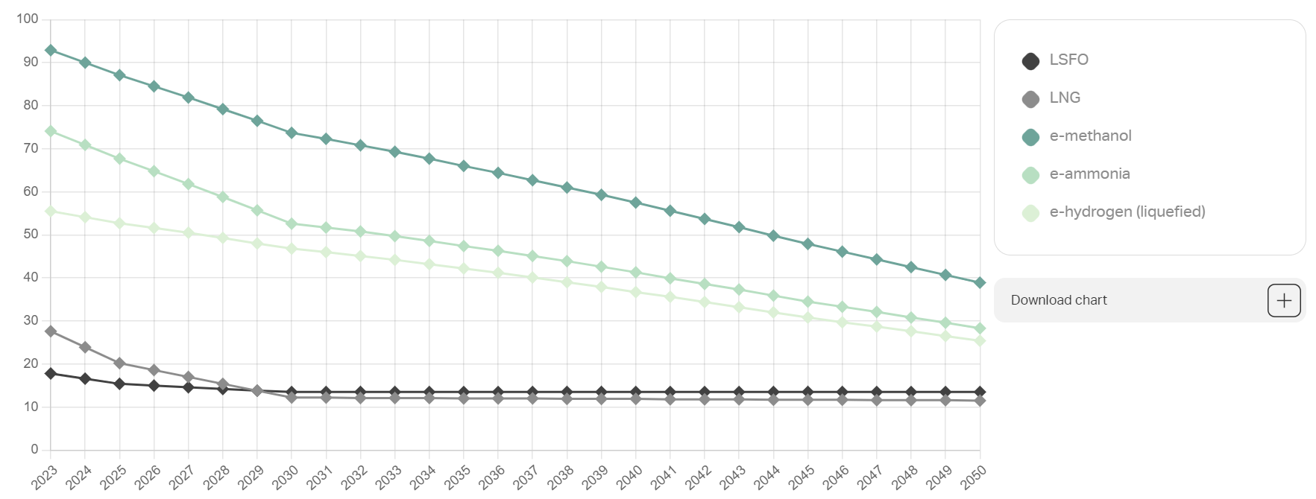
Figure 7: Evolution of the total cost of fuels in Asia (in USD/GJ)
Overall, adapting the fleet to meet decarbonization targets is expected to increase container costs by approximately 20% by 2030, between 60% and 100% by 2040, and 90% to 110% by 2050. These total costs include CAPEX (investments in ships and onboard technologies), OPEX (operational costs), the cost of CO₂ emissions, fuel expenses, and deposit fees for carbon capture and storage. The results of this analysis conducted by DNV on three segments, container vessels, bulk carriers, and tankers are presented in the graph below:
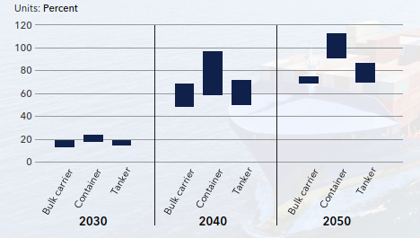
Figure 8: Range of increase in total costs per transport work (USD/DWT-nm for bulk and tank, USD/TEU-nm for containers) from decarbonization in 2030, 2040, and 2050 relative to a business-as-usual scenario.
Despite these costs, early adoption could position ASCO at the forefront among the industry players on the path towards sustainable maritime operations, aligning with industry benchmarks and meeting the increasing expectations of proactive clients active to decrease climate change impacts in their value chain.
For maritime stakeholders, investing in low-carbon fuels is becoming increasingly essential as the shipping industry's demand for these alternatives continues to grow. This rising demand, combined with limited production capacity, is likely to result in supply constraints and escalating prices, particularly as companies work to meet stringent compliance deadlines.
Between 2015 and 2022, biodiesel prices experienced notable surges due to increased demand and climate-related feedstock shortages. In Europe, rapeseed biodiesel prices climbed by 127%, soybean biodiesel prices in Argentina soared by 142%, and palm biodiesel prices in Indonesia rose by 101%. These price trends reflect the combined effects of intensifying global demand, climate-driven supply challenges, and policy-induced incentives.
Proactive investment in low-carbon fuel solutions can help mitigate these risks, ensuring access to sustainable supplies and positioning maritime companies as frontrunners in the industry's decarbonization efforts.

Limited biofuel of e-fuel availability
With international regulations, including those from the IMO and EU, increasingly mandating cleaner fuels, ASCO would benefit in securing a reliable, scalable supply of low-carbon options such as biofuels and e-fuels to remain compliant and get the first mover advantage. By 2030, demand for carbon-neutral fuels is projected to reach between 7 and 48 million tonnes of oil equivalent. However, production capacity remains constrained, especially given the maritime sector's large-scale requirements.
- Limited supply of biofuels and e-fuels and sector competition
To meet the IMO’s 2030 target of reducing CO₂ emissions from shipping by 20% relative to 2008 levels, significantly ramping up global carbon-neutral fuel production is essential. By 2030, it is estimated that 44 to 63 million tonnes of oil equivalent (Mtoe) of carbon-neutral fuels will be available across all sectors, yet the maritime industry alone may require between 10% and 100% of this supply to reach its targets in line with the deployment pace of other alternative fuels such as e-fuels.13
Among available options, biofuels—such as bio-methanol and bio-LNG—are currently the most accessible carbon-neutral fuels for shipping and therefore could be subject to primary focus by ASCO procurement strategy as a transition fuel. They can be produced from various feedstocks, including agricultural waste, algae, and animal fats. However, their scalability remains constrained due to the potentially intense competition for such resources, currently limited production capacity, and environmental concerns. Aviation, road transport, and various hard-to-abate industries are all competing for the same profile of biomass resources, which would place tremendous pressure on supply. By 2030, combined demand from these sectors is expected to absorb more than 75% of the projected increase in global biofuel production, according to the International Energy Agency (IEA). For the maritime sector specifically, meeting IMO targets would require between 7 and 48 million tons of oil equivalent (Mtoe) by 2030, yet the total capacity of ongoing and announced low-carbon fuel projects is estimated at only 44 to 63 Mtoe.In addition, expanding biofuel production comes with sustainability and regulatory hurdles. The use of agricultural lands for biofuel feedstock could lead to the rise of significant environmental consequences, including deforestation and carbon releases from soil, leading to a so-called "carbon debt" if environmental procurement rules are not integrated in the company’s procurement policy. Stricter sustainability requirements, such as those under the EU's RED-III directive, may further limit the availability of suitable resources. These constraints make it clear that first-generation biofuels, derived directly from food crops, are likely to be insufficient to meet demand. As an example, producing 1 Mtoe of biodiesel requires approximately 1.2 to 1.5 million hectares of farmland. Thus, meeting the maritime sector's potential demand of 48 Mtoe by 2030 would require 58 to 72 million hectares, an area comparable to the size of France. This highlights the need to diversify its biofuels procurement sources and progressively shift towards advanced biofuels derived from waste, residues, or algae and to reach a mix of biofuels that includes electrofuels.
Electrofuels such as green ammonia and hydrogen present a promising complementary solution for long-term decarbonization, but their deployment faces significant uncertainties. Producing e-fuels requires substantial renewable electricity and advanced technologies, particularly electrolysis. Decarbonizing just 10% of the fuel needs for aviation and shipping sectors by 2030 would require 330 GW of electrolyzer capacity for aviation and 130 GW for shipping, set aside the demand from other sectors. Currently, the announced manufacturing capacity for electrolysis is expected to reach only 155 GW per year by 2030, well below the required levels.21 Moreover, adopting e-fuels necessitates extensive infrastructure investments, including the construction of electrolyzer facilities and the development of compatible supply chains. In addition to these logistical hurdles, fleets must be partially renewed or retrofitted to use e-fuels effectively, further increasing costs and complexity. Finally, the production of e-fuels would place additional pressure on renewable electricity resources. For example, decarbonizing aviation and maritime transport with e-fuels by 2030 could consume over 20% of the global growth in low-emission electricity during this period.
Maritime transportation company will have to shift towards a new paradigm from fleet composed with vessels with one or two different types of fuels towards a fleet of vessels with multiple and complementary technologies to incorporate low carbon fuels and keep its activity to similar levels. ASCO would benefit in diversifying its fuel sources to reduce dependency on a single technology, establish strategic partnerships with producers and suppliers to secure access to advanced biofuels and electrofuels, and prepare its infrastructure and fleets to accommodate next-generation fuels. ASCO could also consider securing its procurement of biofuels by purchasing a company operating in this sector.

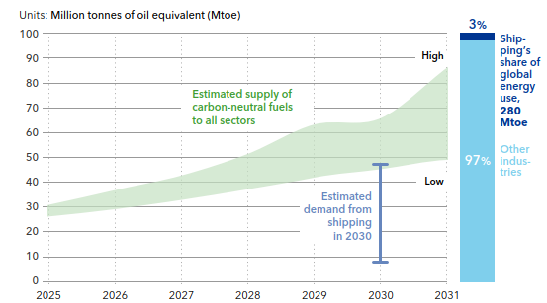
Figure 9: Estimated supply of carbon-neutral fuels to all sectors
ii. Costs and price volatility
Currently, biofuels and e-fuels are considerably more expensive than traditional marine fuels like heavy fuel oil (HFO) or marine diesel oil (MDO). This price disparity is driven by the costs of raw materials for biofuel production (such as oilseeds or waste products), the energy required for e-fuel production and the limited economies of scale in their production. Additionally, sectoral competition for these limited resources, driven by parallel decarbonization efforts in aviation, road transport and other industries, is likely to further inflate prices, compounding the financial challenges for shipping operators.
Price volatility in both raw materials and energy inputs exacerbates the situation, posing a significant financial risk for ASCO. A reliance on biofuels, which are affected by agricultural yield variability and geopolitical disruptions, or e-fuels, whose costs are tied to fluctuating electricity prices, could introduce unpredictable and escalating fuel expenses. If ASCO cannot secure a stable and affordable supply of these fuels, its operational costs may rise substantially, eroding profit margins and potentially affecting its competitiveness in an industry already under intense pressure to decarbonize.
- Infrastructure and technological challenges
As the shipping industry works towards decarbonization, there is a gap in the necessary infrastructure for the production, storage, and distribution of low-carbon fuels, notably e-fuels (see table below). This lack of infrastructure could lead to logistical challenges, such as delays in fuel availability or additional costs related to transportation. Several green shipping corridors and low-GHG energy hubs are under development, serving as critical pathways for decarbonizing maritime transport by connecting ports with access to sustainable fuels and infrastructure. However, their current network is limited and does not yet provide comprehensive global coverage. Furthermore, technological advancements in fuel production and retrofitting engines to be compatible with low-carbon fuels are still in the early stages. The slow pace of these innovations may fail to meet regulatory deadlines, placing pressure on ASCO to adopt new technologies that are still evolving and not fully commercialized.

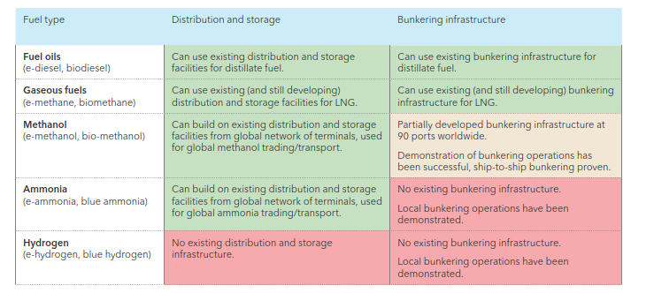
Figure 10: High level screening of the readiness level of distribution, storage and bunkering infrastructures for different fuel types at global level

Reduction of oil and gas demand
A significant portion of ASCO's revenue is linked to oil and gas activities in the Caspian Sea basin and neighboring countries. Whether through its freight transport operations or its specialized fleet for offshore oil and gas platforms in the Caspian Sea, ASCO positions itself as a key player in the supply chain between Asia and Europe. In a potentially low-carbon world where countries strive to reduce their dependence on fossil fuel emissions and transition towards a decarbonized industry, the demand for fossil energy such as oil and gas could decline over the coming decades. In the medium to long-term, this could pose a significant transition risk for ASCO, which could see its revenues significantly decrease, specifically in its specialized offshore fleet activity.
    - Evolution of the demand in oil
Historically, oil demand has been primarily driven by factors such as economic and population growth. Higher economic growth typically leads to increased industrial activity, transportation needs, and energy consumption, all of which drive oil demand. However, global climate policies are increasingly altering this trend. Energy and climate initiatives aimed at reducing greenhouse gas emissions are diminishing industrial reliance on oil, thereby impacting global demand. In Europe, stringent climate policies, energy efficiency improvements, and the adoption of renewable energy sources are particularly influential. The rise of electric vehicles and shifts in transportation behaviors, such as increased use of public transportation and cycling, are key factors contributing to the decline in oil demand.
The global landscape of oil demand is therefore evolving and is heavily influenced by public policies mitigating climate change with an important disparity across regions and countries.
According to the World Energy Outlook, the global oil demand will peak before 2030 in the Stated Policies Scenario before falling back to 2023 levels in 2035. In the Announced Pledges Scenario, the oil demand will decrease by 17% by 2035 while in the Net Zero Scenario, global oil demand will decrease by 40% compared with 2023 levels in 2035 and by 75% in 2050 with high integration of Electric Vehicles and high plastic recycling rates reducing dependence on oil products.
The global oil demand is however very heterogeneous across regions. As shown in the graph below from the IEA, Advanced Economies will see an acceleration in the decline in oil demand in the STEPs scenario while in emerging markets and developing economies, oil demand will continue to slowly grow.
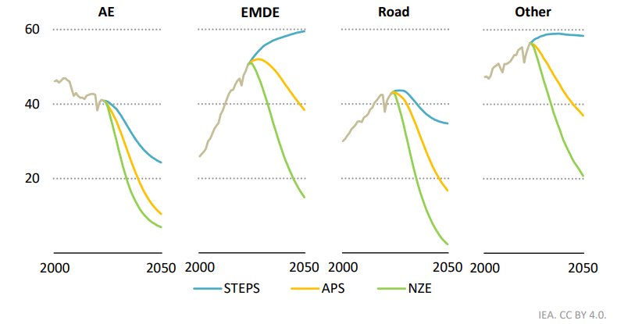
Figure 12: - Oil demand by region, sector and scenario - 2000 - 2050
Notes: unit is mb/d = million barrels per day; AE = advanced economies; EMDE = emerging market and developing economies; road = road transport.

Major global oil and gas producers developing their own energy outlooks such as BP or TotalEnergies are also expecting an overall decrease of oil demand after a peak around 2030, with high disparities across world regions. For example, BP develops projections of global energy demand for 2 scenarios, one Current Trajectory, comparable with the IEA STEPs scenarios, and a Net Zero scenario, where the energy transition is very stringent.
For the first period of its forecast, from 2025 to 2035, the projection of the demand is dependent on the scenario:
- An overall stable demand in the Current Trajectory scenario with a decrease in oil demand in Developed countries by 2035 and an increasing trend in other regions.
- A decreasing trend in the Net zero Scenario after a peak before the end of the decade.
For the second period of its forecast, from 2035 to 2050, both scenarios project an important decrease in global oil demand, driven by the declining use of oil in road transportation as the efficiency of the vehicle fleet improves and alternatives fuels are increasingly used.
On the long term and depending on the effective implementation of the energy transition across the world, ASCO could see an impact on its activities due to the decrease in oil demand, but on the short term and at least until the end of the decade, the fluctuation of the global oil demand should not negatively impact on ASCO business activities.
    - Evolution of the demand in gas
As for Oil, Gas demand has been traditionally driven by factors such as population and economic growth and expansion of industrial activity. However, energy and climate policies aiming at mitigating climate change have a double effect on natural gas demand balance.
On one hand, natural gas, like oil, is a fossil fuel, and climate policies are designed to reduce dependence on such fuels and decrease their demand. Energy efficiency improvements, the increasing adoption of renewable energy for power generation, and the electrification of industries and heating systems all contribute to a reduction in global gas demand. Additionally, increasing use of alternative fuels such as LNG and hydrogen, considered cleaner and less emissive, are replacing traditional use of natural gas and unfavorably impacting its demand.
On the other hand, natural gas is increasingly regarded as a transition fuel due to its convenience of use across various sectors and its significantly lower carbon emissions compared to other fossil fuels. For instance, natural gas is being utilized to replace coal and oil in power generation, thereby driving an increase in global gas demand. Additionally, the demand in emerging economies tends to increase as their industry and GDP grows.

Combining all those micro-economic and macro-economic drivers, the IEA World Energy Outlook projects a global increase in natural gas demand trough 2030-35 in all climate scenarios and then a stabilization of the demand in the STEPS scenario while projecting a sharp decrease in APS and NZE scenarios (-6% per year on average between 2035 and 2050 for the NZE scenario).
As for oil demand, regional disparity is important as shown by the graph below. European and North American markets will see their demand in natural gas decrease while the rest of the world will experience an increase in demand in the STEP scenario, with a slightly positive overall balance. In the APS scenario, a more important decrease is projected, with a decreasing overall trend.

Figure 13 - Change in average annual natural gas demand by selected regions and scenario, 2013 - 2050
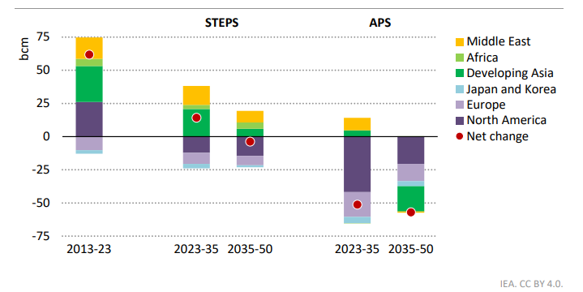
In the energy outlook developed by BP, the demand fluctuation is dependent on the speed of the energy transition and therefore on the scenarios: Current Trajectory and Net Zero, as described in the previous section.
In the Current Trajectory scenario:
- In developed economies, the demand remains stable in the first period of the projection from 2025 to 2035 and has a decreasing trend in the second period to 2050.
- The decreasing trend is however largely compensated on the global level by the increasing demand in other geographies. The global demand increases throughout 2050, majorly driven by the increase in demand in emerging markets.
In the Net Zero scenario, the trend is different, due to a rapid energy transition:
- In developed economies, the demand for natural gas decreases from 2025.
- In other geographies, the first period of projection (2025-2035) indicates a slight increase in demand, globally compensating the decreasing trend of developed economies until 2030. In the next decade, the demand in all geographies sharply decreases, to reach -50% compared with 2022 in 2050.
In addition to global trends, the usage and demand for natural gas in Europe must be closely monitored, as they are crucial for ASCO's business operations. The establishment of a direct pipeline between Azerbaijan and Europe has the potential to significantly enhance gas exploration and exploitation in the Caspian Sea. However, it is important to consider the political risks that could impact the demand for natural gas. Demand may experience a sharp decline due to climate and energy mandates and directives within the European Union.
    - Impacts of the fluctuation of the oil and gas demands on ASCO
It is important to frame the analysis by acknowledging its limitations, as it primarily relies on continental and global studies rather than regional analyses specific to the Caspian Sea area. Consequently, even though the global demand for oil and gas is expected to increase over the next decade, in almost all climate scenarios, which may not negatively impact ASCO's activities and revenues, predicting the regional distribution of demand and production remains challenging. This makes it difficult to estimate financial impacts for ASCO over the fluctuations of oil and gas demand.
The reserves of oil and gas in the Caspian Basin are sufficient, with substantial quantities remaining. Therefore, if ASCO remains competitive in its services, the overall activity for its specialized offshore platform service fleet should remain steady.
The primary uncertainty in this study lies in the unpredictability of climate and energy public policies and their potential changes in direction, with political unpredictability. Global demand for fossil fuels is constantly being changed, making it even more challenging to forecast its evolution on a more localized scale. To mitigate this potential transition risk, ASCO should closely monitor the climate and energy policies of the key countries to which it distributes oil and gas products. This would help anticipate regional demand trends more accurately and adapt its strategy.
Additionally, there is an opportunity for ASCO to explore the offshore renewable energy market for its fleet. Wind speed resources in the Caspian Sea area could give rise to offshore wind activities. With relatively low adaptation and modernization costs, ASCO could position itself in this emerging market within the Caspian Sea. This is exemplified by the engagement of SOCAR and potentially other countries and companies in the region.

3. Summary of transition risk impacts
As transition risks are not always tangible, it remains challenging to accurately predict their impact on a company’s business. It is however very important to analyze their potential impacts, by incorporating this new class of risks into the company risk mapping featuring into the risk management policy. As a second step, ASCO could estimate the financial magnitude of the impact and the probability of occurrence of the transition risk. The evaluation of the impact and especially of the probability may vary due to political, economical and social changes and it is therefore important to update the analysis on a regular basis. The table below presents the synthesis of studied transition risks.

Transition risk | Magnitude of the impact | Probability of the risk
Increase of sustainability reporting mandates | Medium | Very high
Increase of sustainability reporting mandates | Financial cost to remain compliant with increasing sustainability mandates can be important but OPEX are expected to remain reasonable compared to ASCO profits. | Sustainability mandates are already in place and most likely will be reinforced in future years, notably with ASCO aspirations to increase its activities in Europe.
Increased pricing of GHG emissions | High | Low
Increased pricing of GHG emissions | Financial cost for ASCO could be substantial and heavily affect profits and the business. | Except from the EU ETS legislative that is already effective, it is unlikely that new carbon price mechanisms emerge.
Mandates on low carbon fuel use and energy efficiency | High | Very high
Mandates on low carbon fuel use and energy efficiency | Regulations would directly affect operational costs and compliance. Premiums for low carbon fuels are expected to be significant. | Mandates on low carbon fuel and energy efficiency are already in place and the reduction targets are ambitious and binding.
Limited biofuel or e-fuel availability | Medium - High | Very high
Limited biofuel or e-fuel availability | Limited fuel availability could increase costs or hinder operations. | There is competition for low-carbon fuels, a lack of consensus on availability, and insufficient infrastructure.
Reduction of oil and gas demand | Medium | Low
Reduction of oil and gas demand | An important reduction of global and regional oil and gas demand could significantly affect ASCO’s activities of its specialized offshore fleet. New opportunities could however arise with offshore wind development, counterbalancing the financial effects on ASCO business. | Current climate scenarios on energy demand are not indicating a reduction of oil and gas in the future decade, and only an unlikely net zero scenario is expecting a significant change in demand before 2050 that could affect ASCO’s business.

In order to visualize the relative importance of transition risks analysed, the matrix below has been designed. Impact magnitude represents the potential financial and structural impact the risk may have on ASCO. The probability of occurrence reflects the potential of the risk to materialize in the future given current future scenarios.

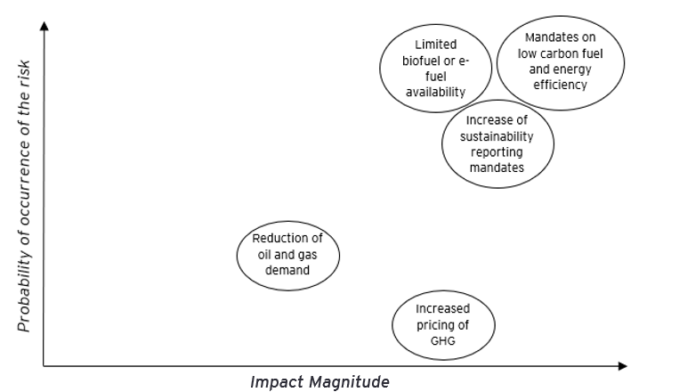
The most material transition risks identified for ASCO on which the company should regularly assess its magnitude are therefore the following:
- Mandates on low carbon fuel and energy efficiency
- Increase of sustainability reporting mandates
- Limited bio-fuel or e-fuel availability
The impacts and actions regarding transition risks are often considered less tangible, as they are linked to strategic decisions rather than specific adaptation actions. Businesses typically manage these risks similarly to physical risks by integrating them into their overall risk management systems. Several actions required to manage these transition risks are consistent across the various types identified.
ASCO has started to set up key actions towards the design, implementation and enforcement of a comprehensive strategy to address transition risks, focusing on regulatory compliance, technological advancements, and market adaptation. Developing a robust and long term decarbonisation strategy is crucial for mitigating transition risks.
- By engaging towards an ambitious pathway, ASCO is getting prepared for future market dynamics favoring lower carbon-intensive operations, reducing the risk of losing market share to competitors with greener alternatives.
- A well anticipated and designed strategy tailored to its activities and specificities involves selecting technologies that align with long-term sustainability goals, minimizing the risk of investing in irrelevant technologies. This strategy would align or anticipate international and regional regulatory frameworks.
- Although transitioning to lower emissions technology can bear an initial significant cost upfront, a strategic approach allows ASCO to plan and allocate resources effectively over time. This approach helps spread out costs, leverage financial incentives, and benefit from economies of scale as technology adoption increases. Additionally, highlighting the expected climate benefits when engaging with financiers should facilitate access to cheaper capital through public or private financing.
- By reducing greenhouse gas emissions, ASCO can mitigate the financial impact of carbon pricing mechanisms, fostering stability and predictability of operating costs.
- Regulatory compliance is a key aspect of ASCO’s strategy. By aligning operations with current and anticipated regulations, ASCO can avoid penalties and benefit from regulatory incentives, ensuring the company remains ahead or in line with regulatory requirements.
To further anticipate the impacts of transition risks and implement corrective actions, ASCO could:
- Conduct studies on the feasibility of implementing new technologies, such as procurement of biofuels and e-fuels, evaluating assets and infrastructure readiness, availability, and investment strategies for engines and technologies that enhance operational efficiency and reduce emissions.
- Track current and emerging regulations on greenhouse gas emissions and low-carbon fuel adoption, actively engaging with regulatory bodies to remain informed and participate in the evolving policy landscape.
- Implement an internal carbon pricing mechanism to accelerate investment in low-carbon solutions and regularly monitor prospective risk.
- Enhance transparency by regularly reporting progress towards decarbonization goals and managing transition risks, following international standards such as IFRS S2 (ISSB).
- Establish KPIs to track the effectiveness of mitigation actions and the progress of the decarbonization strategy.

Conclusion
Physical and transition risks are a class of risks that is sometimes not captured by risks management policies developed by public and private companies. Their relatively recent emergence and longer time horizon than the usual class of assets managed by risks managers increasingly attract the attention of Board members and Management teams of corporates and utilities. In order to transform findings into concrete steps, the design of a Corporate Climate Governance (CCG) Action Plan will focus on bridging identified governance and capacity gaps in the pillar of Governance, Strategy, Metric sand targets and reporting., In addition, a Sustainability-Linked Loan Action Plan will be set up to organize key steps to decarbonize ASCO activities and enable its access to sustainability-linked financing.
These interconnected activities and action plans will collectively empower ASCO to pursue a more resilient, sustainable business model and better meet the growing demands of climate-conscious stakeholders.

Appendices

Appendix 1 - Definition of key concepts

Concept | Definition (ISO/TS 14092:2021: Adaptation to climate change — Guidelines on vulnerability, impacts, and risk assessment)
Hazard | Potential source of harm  - Note 1: Potential harm may result in loss of life, injury, or other health impacts, as well as damage and losses to property, infrastructure, livelihoods, service provision, ecosystems, and environmental resources.  - Note 2: This term generally refers to physical phenomena and trends associated with climate or their physical impacts.  - Note 3: Hazards include slow-onset phenomena (e.g., long-term temperature rise) as well as rapidly evolving extreme weather events (e.g., heatwaves) or increased variability.
Exposure | Exposure: Presence of people, livelihoods, species, or ecosystems, environmental functions, resources, or services, infrastructure elements, or economic, social, or cultural assets in places that could be adversely affected  - Note 1: Exposure can change over time, for instance, as a result of land-use change.
Sensitivity | Sensitivity: Degree to which a system or species is affected, either adversely or beneficially, by climate variability or change  Note 1: This effect can be direct (e.g., a change in crop yield due to a change in average, range, or variability of temperature) or indirect (e.g., damage from increased frequency of coastal flooding due to rising sea levels).
Vulnerability | Propensity or predisposition to be adversely affected.  - Note: Vulnerability encompasses various concepts or components, including the notions of sensitivity or fragility and the inability to cope and adapt.
Risk | A climate change-related risk describes the potential impact of climate change on societies, economies, and the environment.
Impact | Effect on natural and human systems  Note : In the context of climate change, the term "impact" is primarily used to refer to the effects on natural and human systems of extreme weather and climatic phenomena and climate change. Impacts generally refer to effects on people's lives, livelihoods, health, ecosystems, economic, social, and cultural heritage, services, and infrastructure, resulting from their interactions with climate change or hazardous climatic events occurring over a given period, and the vulnerability of the exposed society or system. In this sense, the terms "consequences" or "incidences" are also used. The impacts of climate change on geophysical systems, including floods, droughts, and sea-level rise, are a subset of impacts called "physical impacts."
Impact chain | Impact chain: Analytical approach to understand how given hazards lead to direct or indirect impacts that propagate through a system at risk.
Terme | Definition (TCFD - Task force on Climate-related Financial Disclosures)
Physical risks | Physical risk: Physical risks resulting from climate change can be related to events (acute) or longer-term (chronic) changes in climate patterns.  Acute physical risks are those related to events, including increased severity of extreme weather events such as cyclones, hurricanes, or extreme flooding.  Chronic physical risks refer to longer-term changes in climate patterns (e.g., sustainably higher temperatures, sea-level rise, or chronic heatwaves).
Transition risks | Transition risk: The transition to a low-carbon economy may involve significant changes in policies, laws, technologies, and markets to meet mitigation and adaptation requirements related to climate change.  Depending on the nature, speed, and direction of these changes, transition risks can pose varying levels of financial and reputational risks for organizations.
Climate opportunities | Climate opportunity: Efforts to mitigate and adapt to climate change also offer opportunities for organizations, for example, through improved resource efficiency and cost savings, adoption of low-emission energy sources, development of new products and services, access to new markets, and enhanced resilience along the supply chain.

Appendix 2 – Exposure analysis for the 5 selected assets
Appendix 2.1 – exposure level per taxonomy-related hazard, SSP2-4.5
SSP2-4.5 - 2030 | Exposure level per taxonomy related hazard
Site Name | Flood | Temperature | Heat | Storm | Extreme wind
Sangachal Terminal | 1 | 3 | 3 | 3 | 3
Dubendi Terminal | 1 | 3 | 3 | 4 | 3
Zygh Shipyard | 2 | 3 | 3 | 4 | 3
Aktau port | 1 | 3 | 3 | 3 | 3
Turkmenistan Port | 1 | 3 | 3 | 4 | 3
SSP2-4.5 - 2040 | Exposure level per taxonomy related hazard
Site Name | Flood¹ | Temperature | Heat | Storm | Extreme wind
Sangachal Terminal |  | 3 | 3 | 4 | 3
Dubendi Terminal |  | 3 | 3 | 4 | 3
Zygh Shipyard |  | 3 | 3 | 4 | 3
Aktau port |  | 3 | 3 | 4 | 3
Turkmenistan Port |  | 3 | 3 | 4 | 3
SSP2-4.5 - 2050 | Exposure level per taxonomy related hazard
Site Name | Flood | Temperature | Heat | Storm | Extreme wind
Sangachal Terminal | 1 | 3 | 3 | 4 | 3
Dubendi Terminal | 1 | 3 | 3 | 4 | 3
Zygh Shipyard | 2 | 3 | 3 | 4 | 3
Aktau port | 1 | 3 | 3 | 4 | 3
Turkmenistan Port | 1 | 3 | 4 | 4 | 3
Appendix 2.2 – exposure level per taxonomy-related hazard, SSP5-8.5
SSP5-8.5 - 2030 | Exposure level per taxonomy related hazard
Site Name | Flood | Temperature | Heat | Storm | Extreme wind
Sangachal Terminal | 1 | 3 | 3 | 4 | 3
Dubendi Terminal | 1 | 3 | 3 | 4 | 3
Zygh Shipyard | 2 | 3 | 3 | 4 | 3
Aktau port | 1 | 3 | 3 | 4 | 3
Turkmenistan Port | 1 | 3 | 3 | 4 | 3
SSP5-8.5 - 2040 | Exposure level per taxonomy related hazard
Site Name | Flood¹ | Temperature | Heat | Storm | Extreme wind
Sangachal Terminal |  | 3 | 3 | 4 | 3
Dubendi Terminal |  | 3 | 3 | 4 | 3
Zygh Shipyard |  | 3 | 3 | 4 | 3
Aktau port |  | 3 | 3 | 4 | 3
Turkmenistan Port |  | 3 | 4 | 4 | 3
SSP5-8.5 - 2050 | Exposure level per taxonomy related hazard
Site Name | Flood | Temperature | Heat | Storm | Extreme wind
Sangachal Terminal | 1 | 3 | 3 | 4 | 3
Dubendi Terminal | 1 | 3 | 3 | 4 | 3
Zygh Shipyard | 2 | 3 | 3 | 4 | 3
Aktau port | 1 | 3 | 3 | 4 | 3
Turkmenistan Port | 1 | 3 | 4 | 4 | 3

About EY

EY refers to the global organization, and may refer to one or more of the member firms of Ernst & Young Global Limited, each of which is a separate legal entity. Ernst & Young Global Limited, a UK company limited by guarantee, does not provide services to clients. Information about how EY collects and uses personal data and a description of the rights individuals have under data protection legislation are available via ey.com/privacy. EY member firms do not practice law where prohibited by local laws. For more information about our organization, please visit ey.com.

© 2024 - EY & Associés
All rights reserved.
This material has been prepared for general informational purposes only and it is not intended to be relied upon as accounting, tax, or other professional advice. Please refer to your advisors for specific advice.
ey.com/fr

Nature, 2023, https://www.nature.com/articles/s43247-023-01017-8#data-availability ² Allahdadi, Nabi & Chegini, Vahid & Fotouhi, Neda & Golshani, Aliasghar(2004). Wave Modeling of the Caspian Sea.
https://climateactionaccelerator.org/solutions/white_roofs/
Résolution MEPC.350(78) – Directives de 2022 sur la méthode de calcul de l'indice de rendement énergétique des navires existants (EEXI) obtenu
31875b4f-39b9-4cde-a4e2-fbb8f65ee703_en
Resolution MEPC.346(78) – 2022 Guideline for the development of a ship energy efficiency management plan (SEEMP), available at this link: MEPC 346 78
Estimation based on provided data (transported weight and commercial route) and an average emission factor from ADEME
Average carbon price for EU-ETS in 2022 and 2023
Sources of projections of EU-ETS carbon price: Enerdata, Statistica
Network for Greening the Financial System
CDP, CDP Technical Note: Relevance of Scope 3 Categories by Sector, 2021, CDP-technical-note-scope-3-relevance-by-sector.pdf
DNV, Energy Transition Outlook 2024, Maritim Forecast 2050
Lloyd’s Register and UMAS Research
Fuel EU Maritime Initiative, Regulation on the use of renewable and low-carbon fuels in maritime transport, 25 July 2023
DNV, Energy Transition Outlook 2024, Maritim Forecast 2050
The royal institution of Naval Architects, Blending biofuel with conventional marine fuel shown to improve CII ratings, 3rd August 2023, available here: Blending biofuel with conventional marine fuel shown to improve CII ratings
Methanol Institute, Marine Methanol, May 2023, available here: methanol.org/wp-content/uploads/2023/05/Marine_Methanol_Report_Methanol_Institute_May_2023.pdf
IEA, The Role of E-fuels in Decarbonising Transport, December 2023
Fuel Cost Calculator, Maersk Mc-Kinney Molller Center for Zero Carbon Shipping
DNV, Energy Transition Outlook 2024, Maritim Forecast 2050
IFPEN, Tableau de bord des biocarburants 2023, Tableau de bord biocarburants 2023 | IFPEN
S&P, 2024, Aviation, maritime demand to fuel global biofuel feedstock race by 2030, Aviation, maritime demand to fuel global biofuel feedstock race by 2030 | S&P Global Commodity Insights
DNV, Energy Transition Outlook 2024, Maritim Forecast 2050
S&P, 2024, Key considerations in Financing Biofuels related investments, Financing Biofuels Related Investments | S&P Global
EU RED-III Guidelines, 2023
IEA Bioenergy, 2013, Bioenergy, Land Use Change and Climate Change Mitigation
DNV, Energy Transition Outlook 2024, Maritim Forecast 2050
DNV, Energy Transition Outlook 2024, Maritim Forecast 2050
IEA, 2024, World Energy Outlook 2024
STEPS: IEA scenario considering current policy landscape
Advanced economies in IEA: OECD regional grouping and Bulgaria, Croatia, Cyprus, Malta and Romania
IEA, 2024, World Energy Outlook 2024
BP, 2024, Energy Outlook 2024
IEA, 2024, Energy Outlook 2024
BP, 2024, Energy Outlook
Europe, North America, OECD Asia and other high income Asian countries
All geographies not included in developed economies
Global Wind Atlas
Flooding data are not available for 2040.

